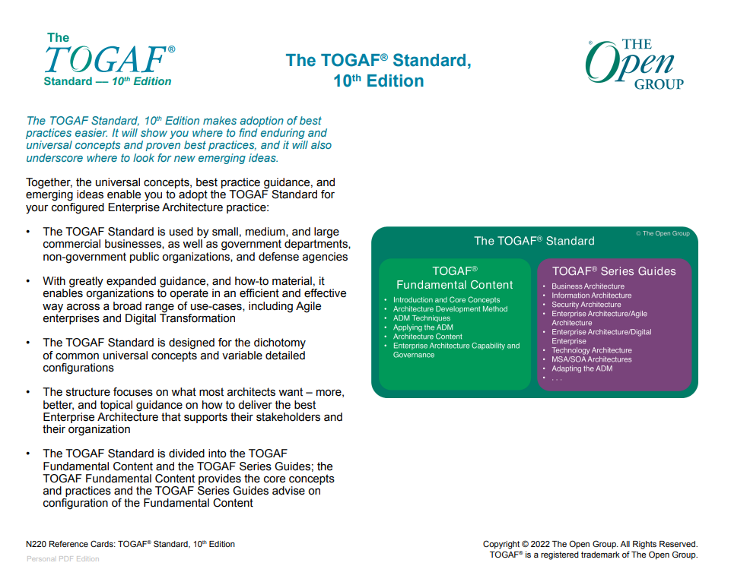

**Defnitions**

|  |  |
| --- | --- |
| **Enterprise Continuum:** | This provides a structured method for categorizing and **organizing architecture assets, such as reference models, patterns, and architecture descriptions, to support reuse across the organization**. It spans from generic to specific architectures and enables systematic evolution and integration.   * How architecture assets can be leveraged and specialized to support the requirements of an individual organization.) * Enterprise Continuum is not a repository but a classification model * The Enterprise Continuum helps organizations classify architecture artifacts based on abstraction levels—ranging from generic models (Foundation Architectures) to highly specific solutions |
| **Architecture Repository:** | While it stores **artifacts**, it does not provide the method for organizing them — that role is played by the Enterprise Continuum   * The Architecture Repository is where artifacts are stored. * The Architecture Repository provides a structured framework for storing and managing architecture-related artifacts. |
| **Architecture Development Method (ADM)** | A lifecycle method for developing architectures.   * “Product Lifecycle Diagram” as possibly one of the artifacts created in Phase B in **Business Architecture** * In TOGAF, **deliverables** are formals outputs of ADM phases. They are reviewed and approved as part of the governance process and may include architecture roadmaps, business capability models, and governance frameworks. |
| **Request for Architecture Work**  **Statement of Architecture Work** | A document that is sent from the sponsoring organization to the architecture organization to trigger the start of an architecture development cycle.  Statement of Architecture Work defines the scope and approach to complete an architecture development cycle. |
| **Viewpoint and View s** | A viewpoint defines the perspective, and a view is the representation of the system from that perspective. |
| **TOGAF Content Framework**: | This is a **conceptual structure** within TOGAF that helps organizations **classify, structure, and develop architecture artifacts** in a consistent and comprehensive manner. It defines the **types of artifacts**, their relationships, and the **building blocks** required across the ADM phases. |
| **Architecture Vision:** | Defines the high-level scope and objectives of a particular architecture engagement, not used for organizing assets. |
| **Architecture Capability Framework:** | * The Architecture Capability Framework provides a structured approach to establishing and operating an enterprise architecture practice within an organization. It includes roles, responsibilities, skills, and governance processes. * Refers to the capabilities needed (like people, processes, tools) to perform architecture work, not the organization of architecture artifacts. |
| **Gap Analysis:** | A key step in developing an architecture is to identify changes between the baseline and target architectures using Gap Analysis. |
| **ADM** | * Risks are identified in **Phase A** as part of the initial Business Transformation Readiness Assessment. * The risk identification and mitigation assessment worksheets are maintained as governance artifacts and are kept up to date in Phase G (Implementation Governance) where risk monitoring is conducted |
| **ADM Techniques** |  |

1. **Concepts**

**TOGAF**

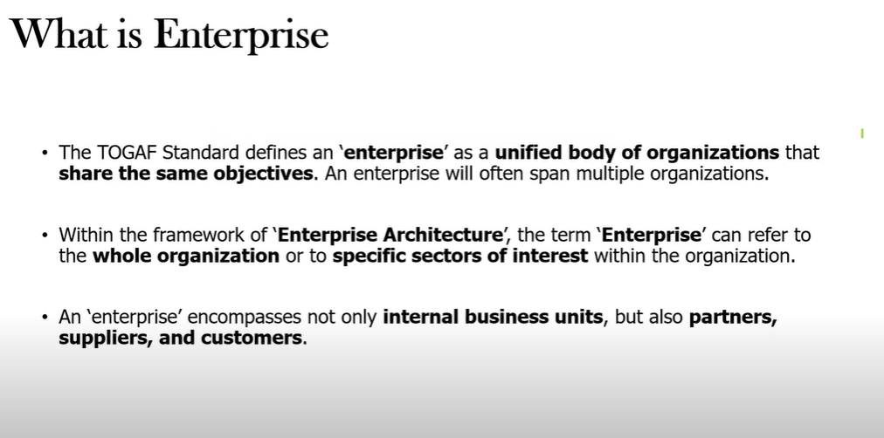

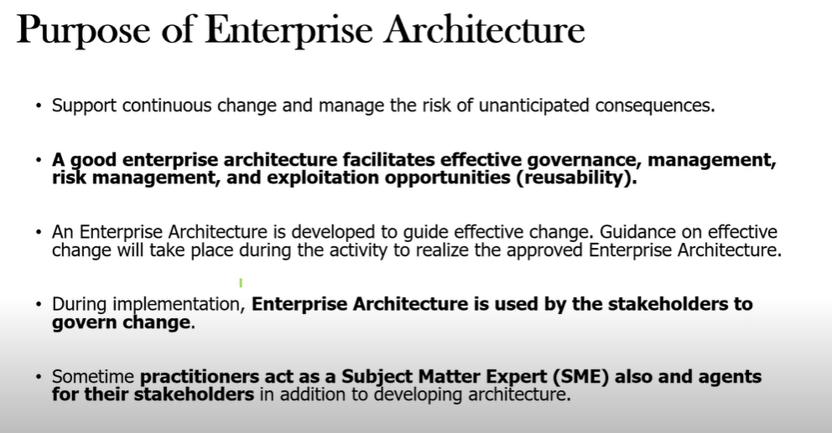

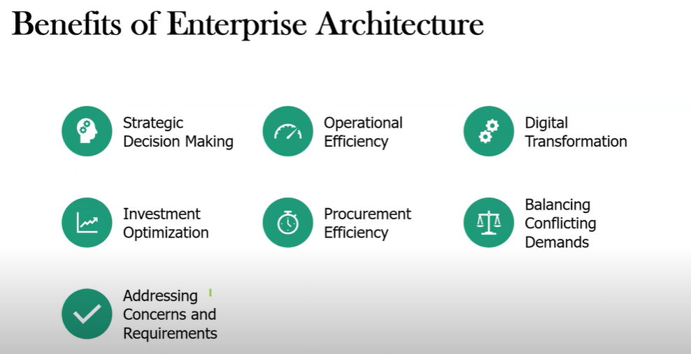

# 

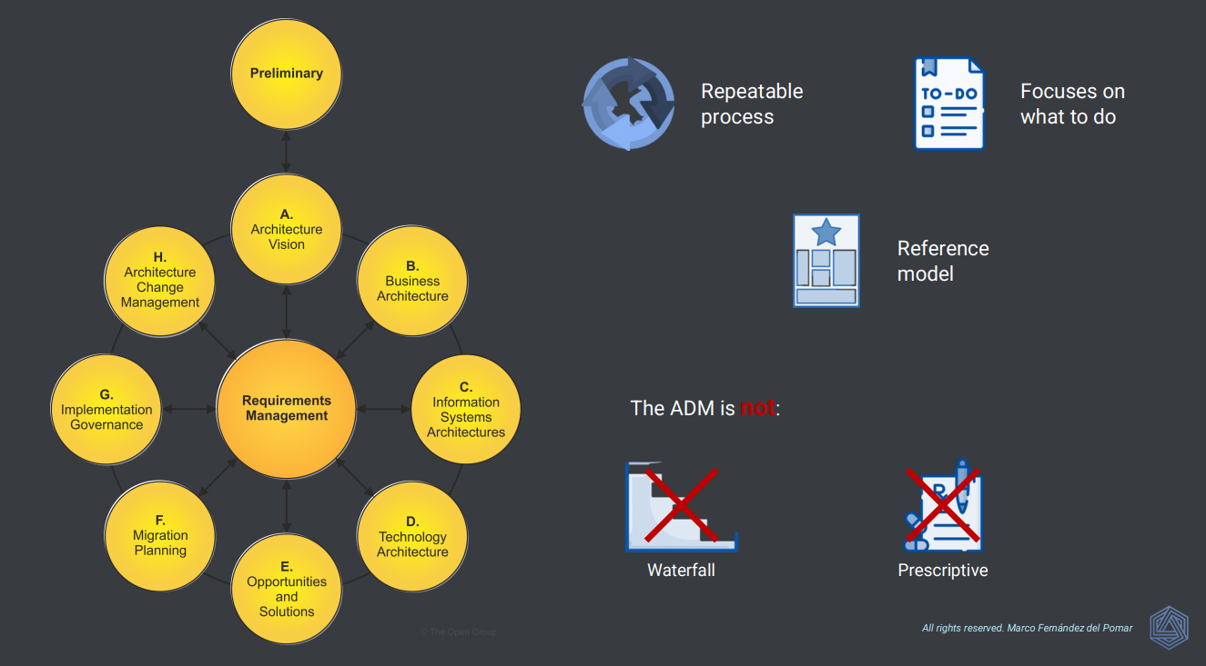

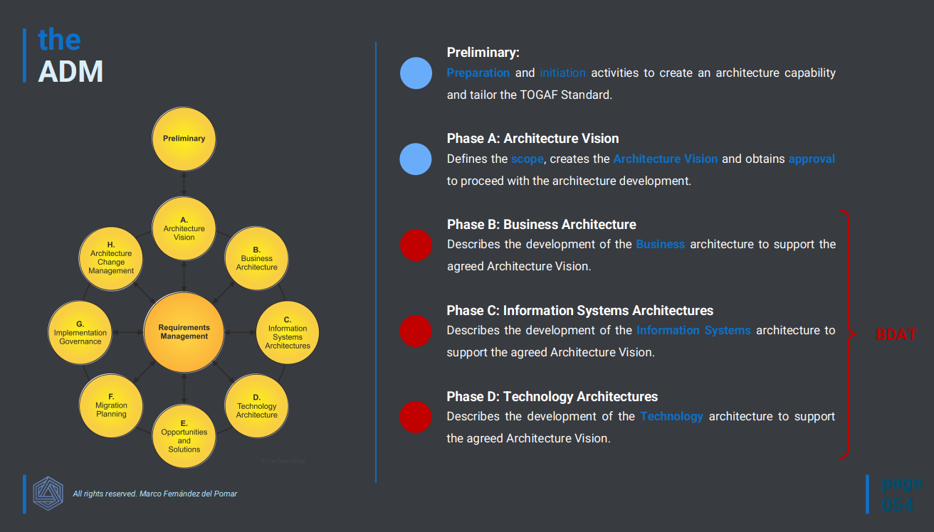

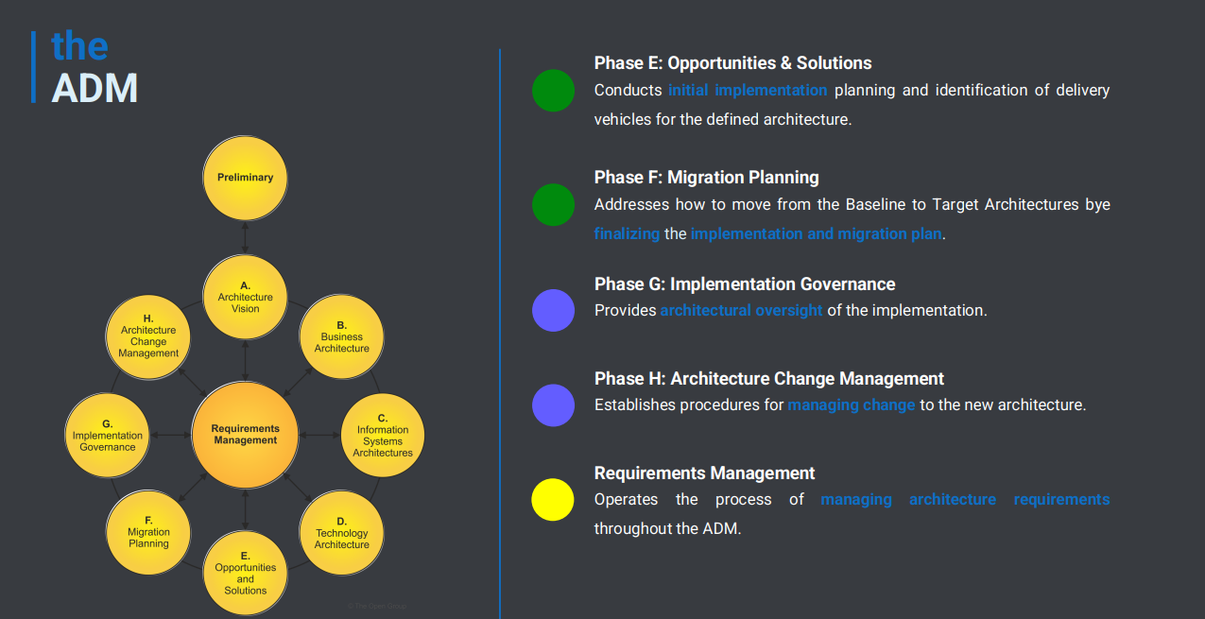

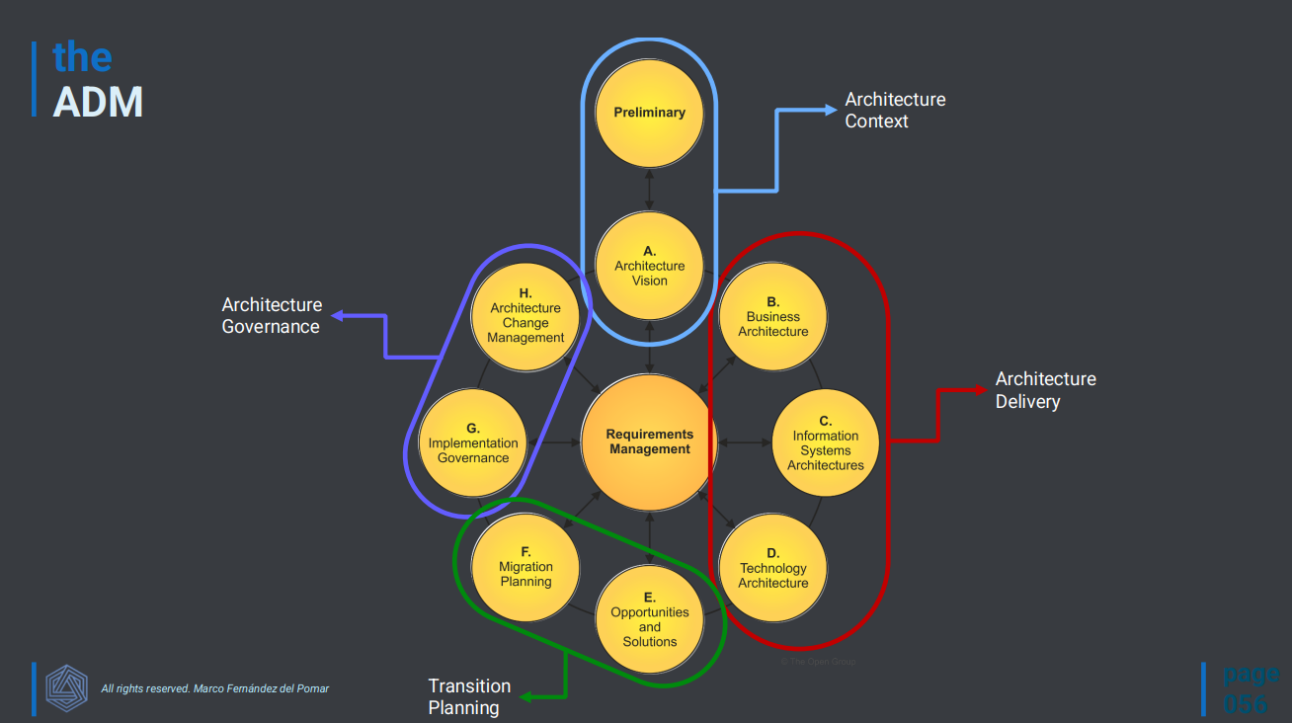

1. **Definitions**

|  |  |
| --- | --- |
|  |  |
|  |  |

1. **Introduction to ADM**

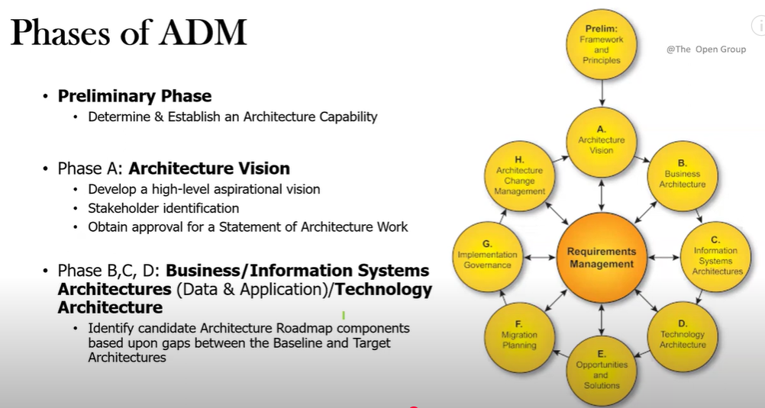

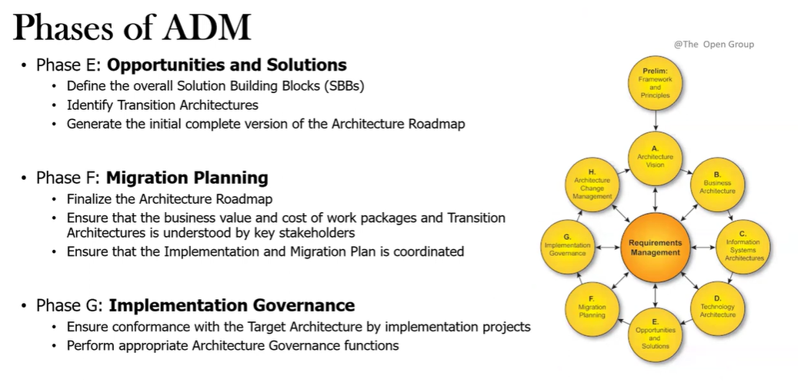

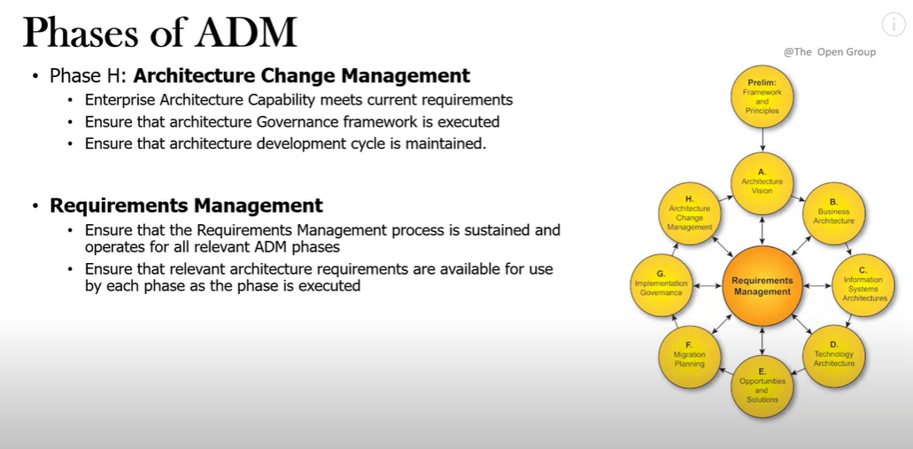

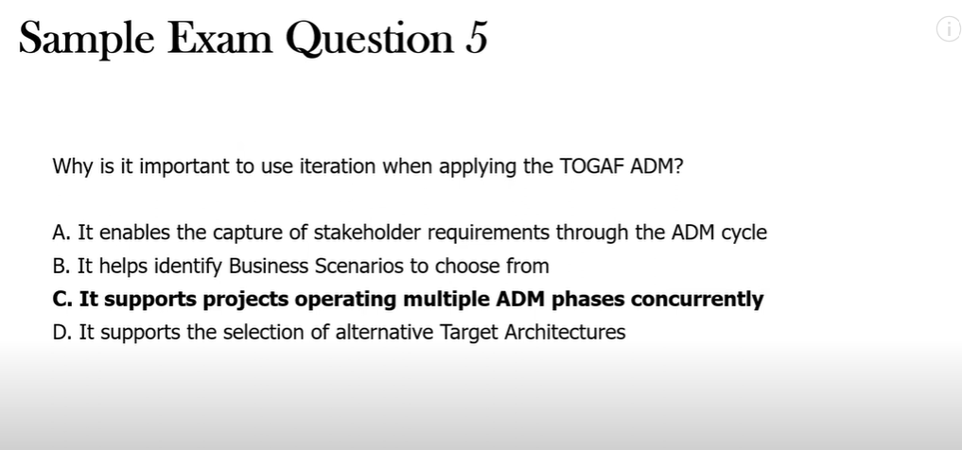

**Preliminary Phase:**

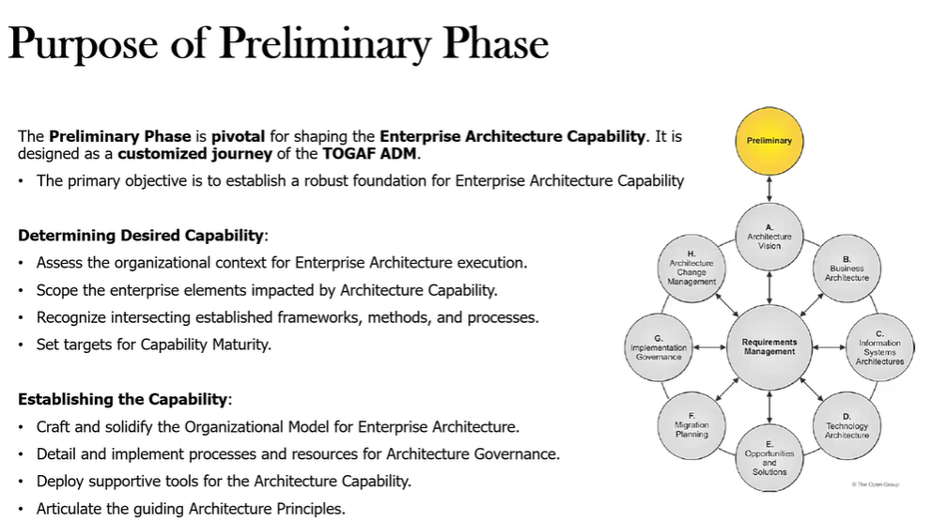

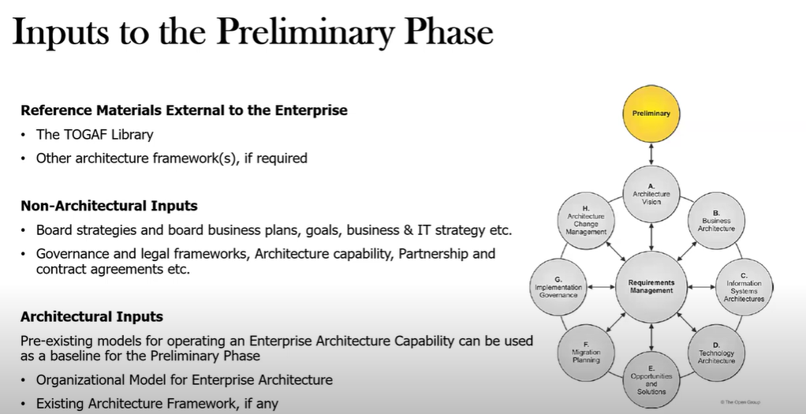

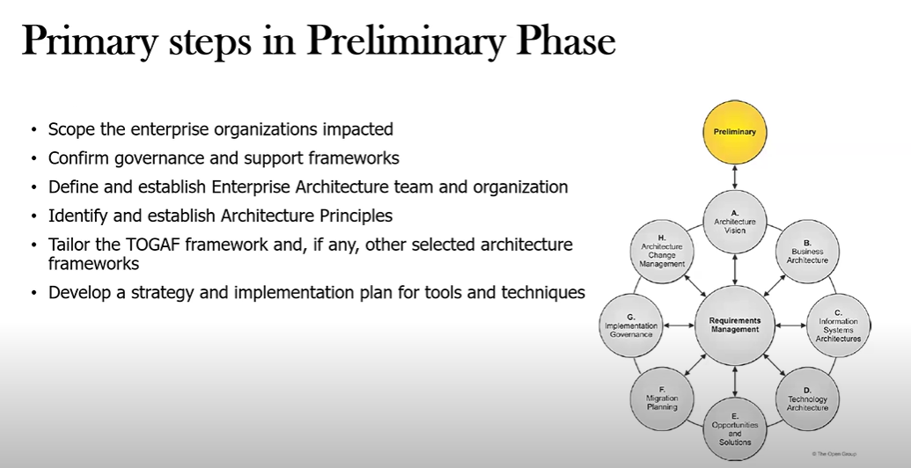

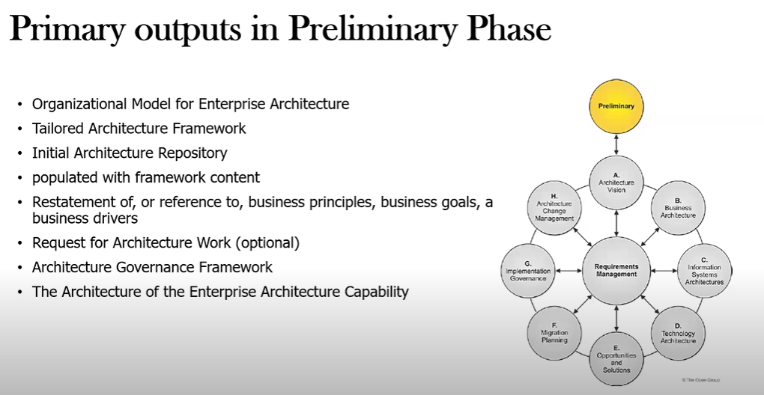

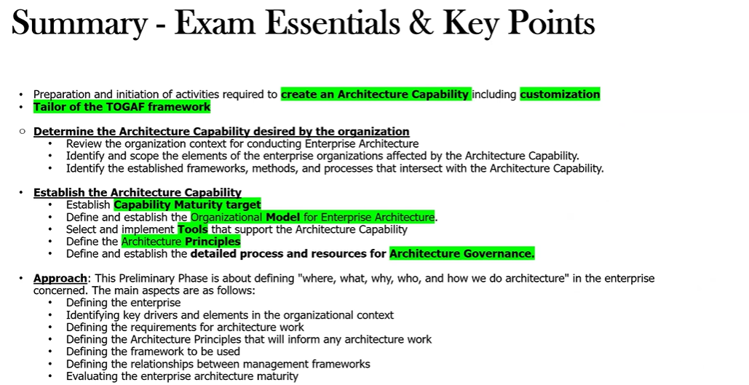

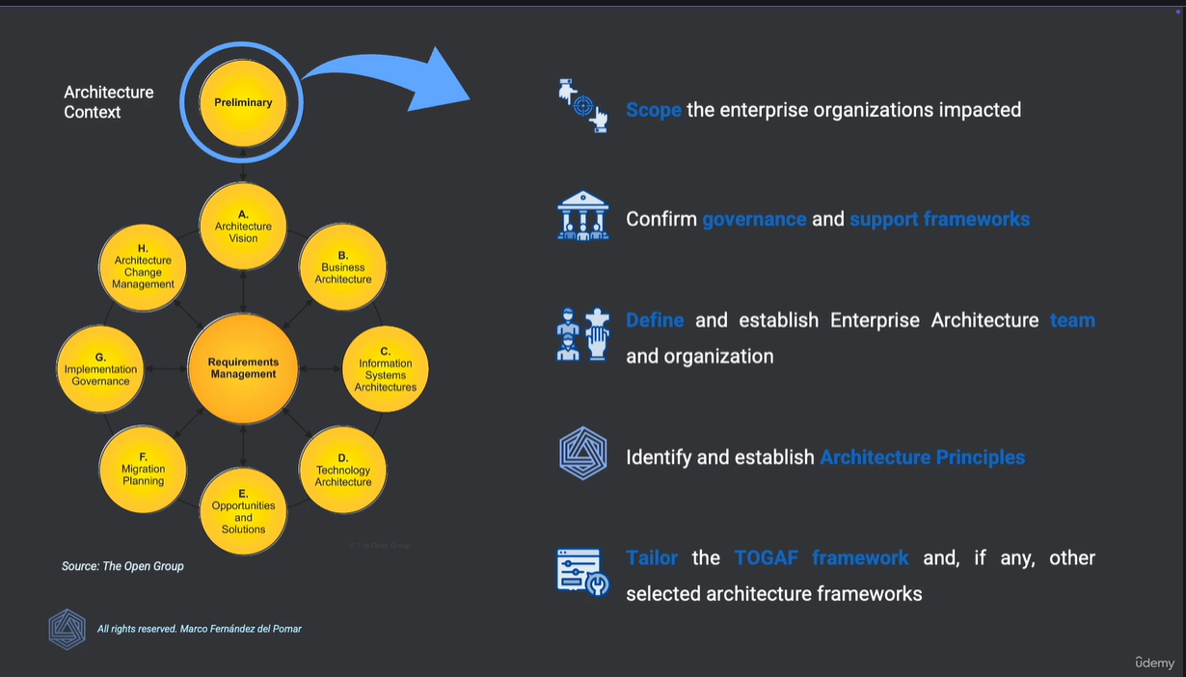

**Architecture Vision Phase:**

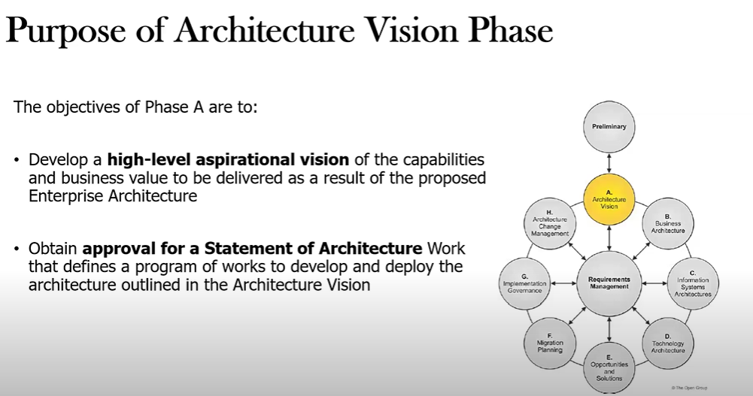

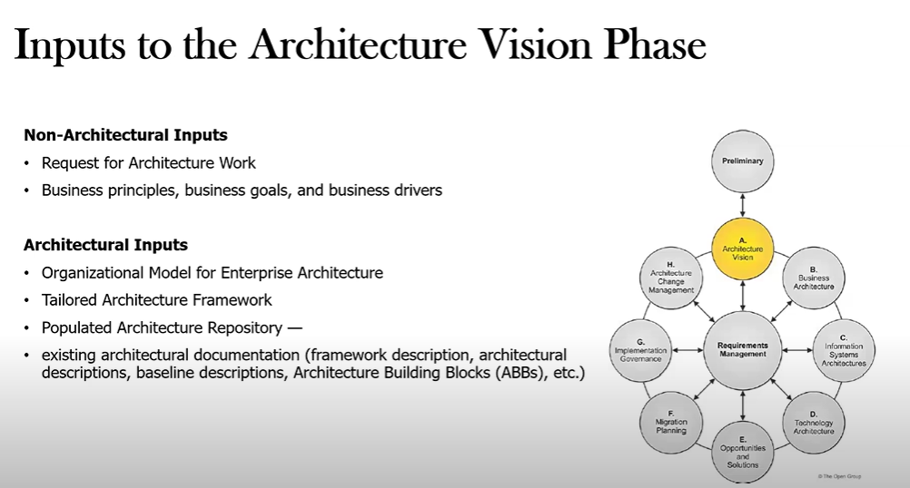

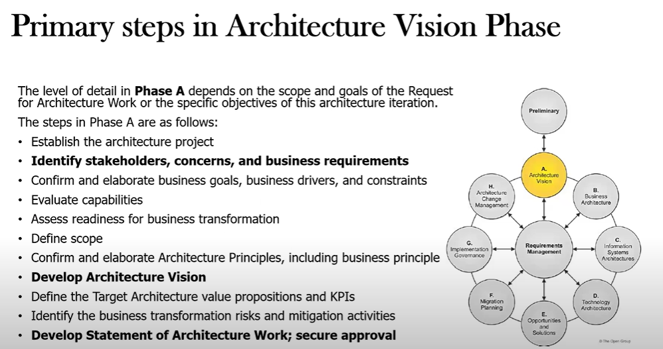

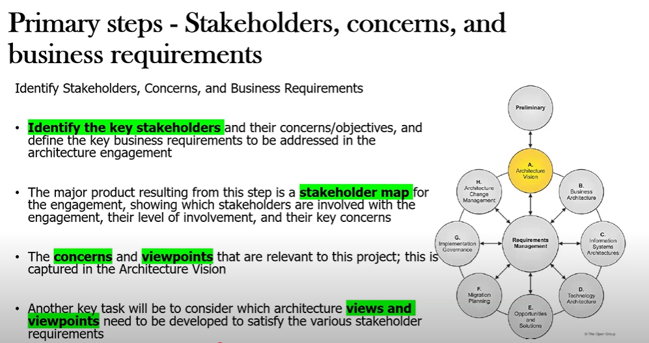

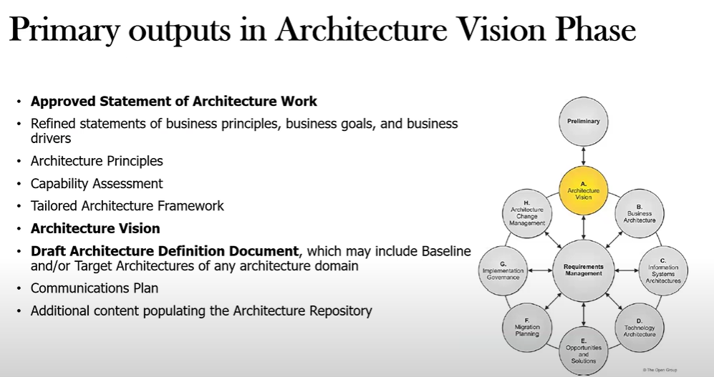

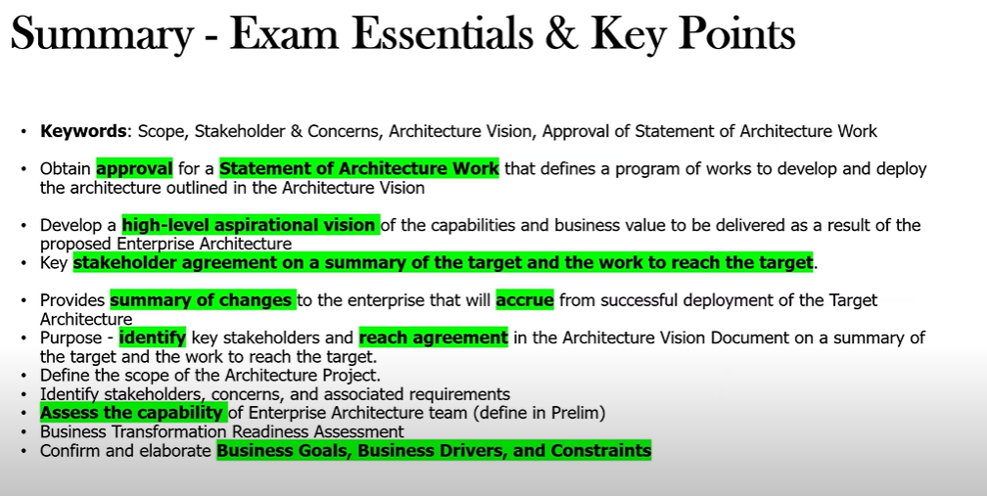

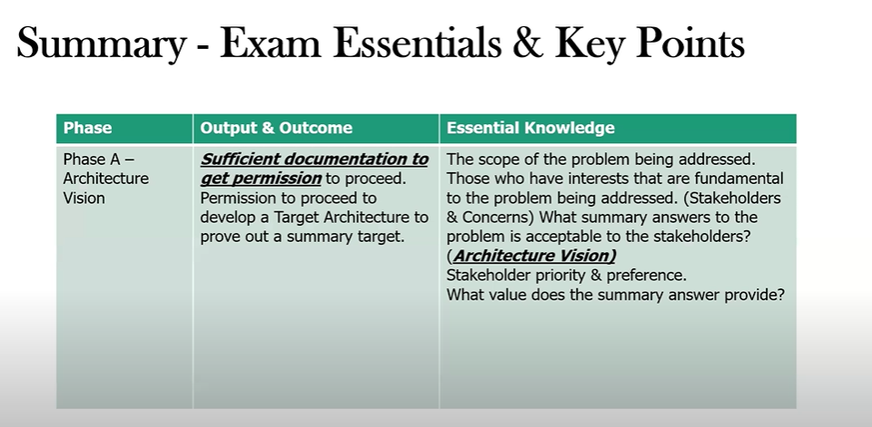

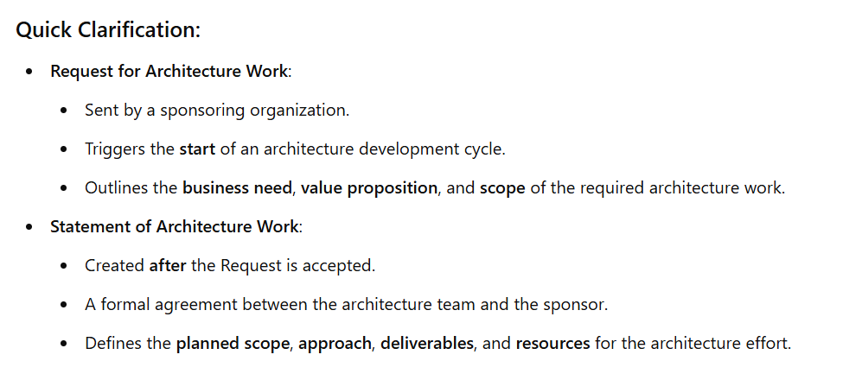

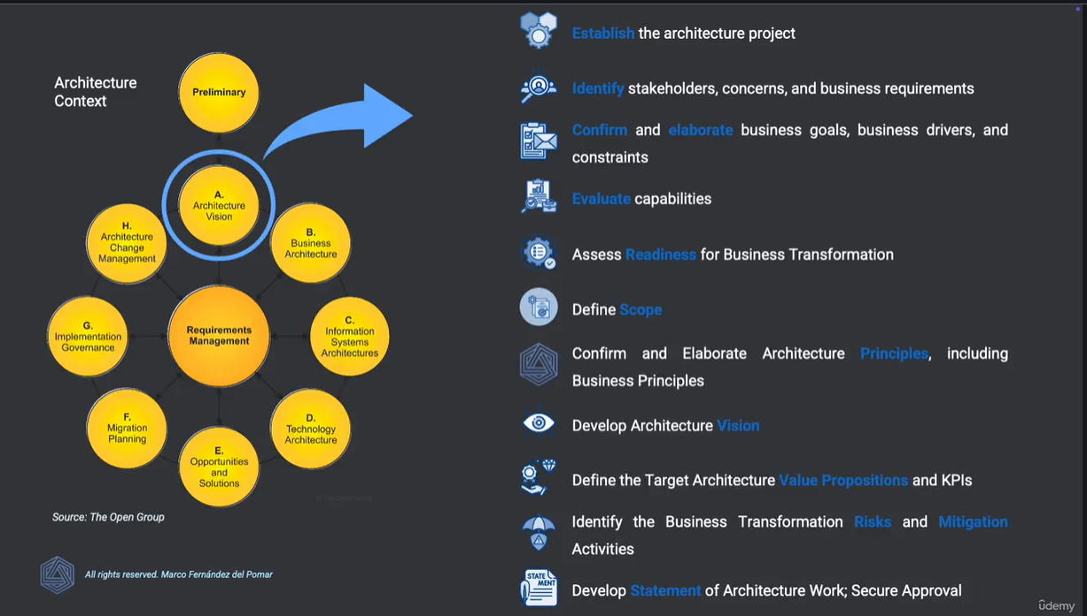**s**

**Architecture View and Viewpoints**

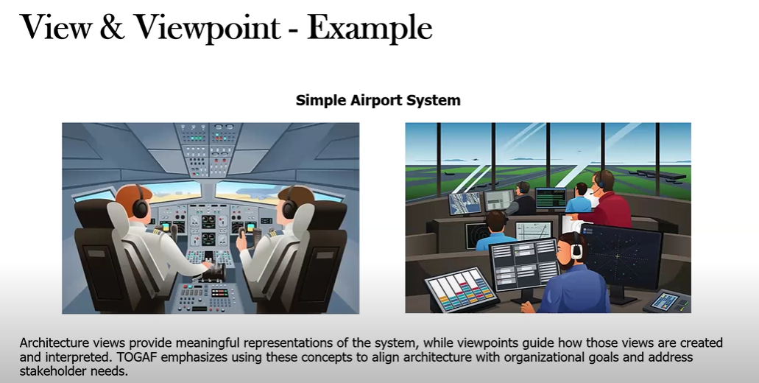

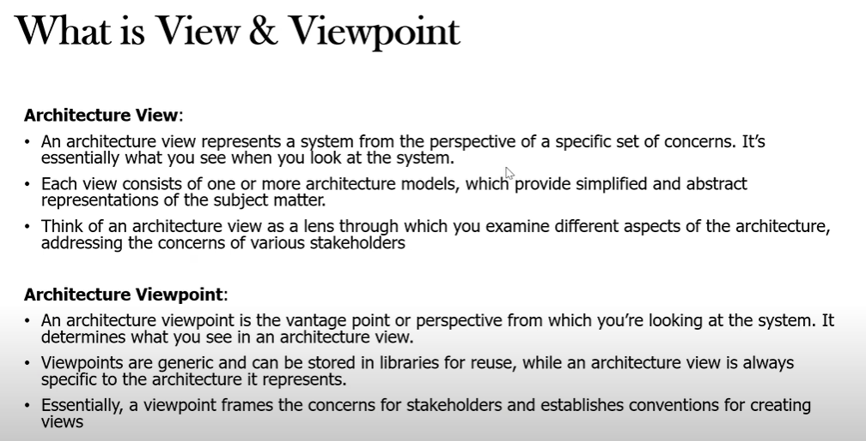

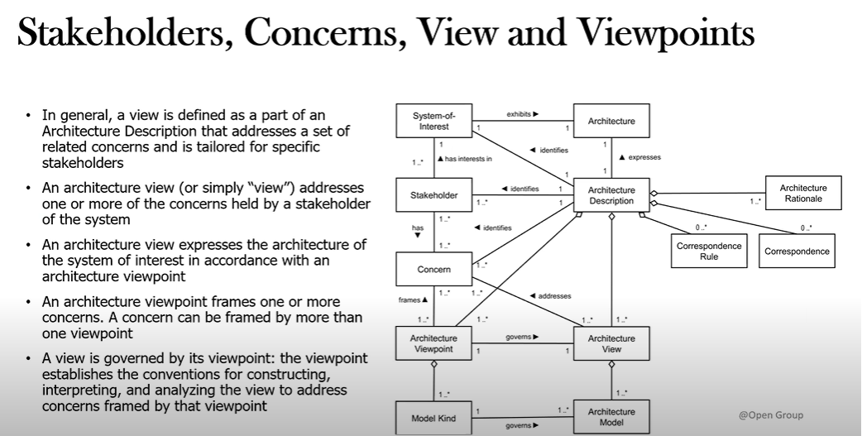

* **Architecture View address concerns**
* **Architecture Viewpoint frames concerns**
* **Architecture Viewpoint governs Architecture View**

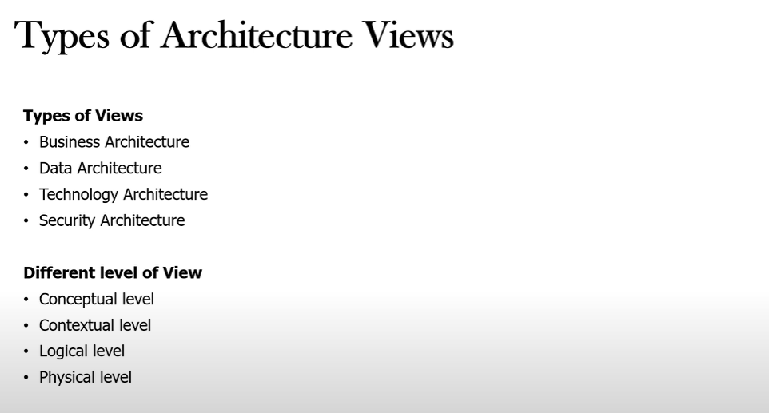

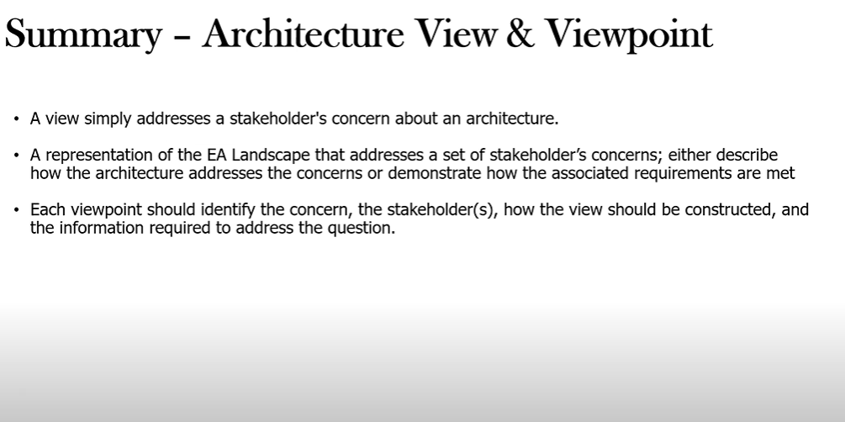

**Phase B C, D**

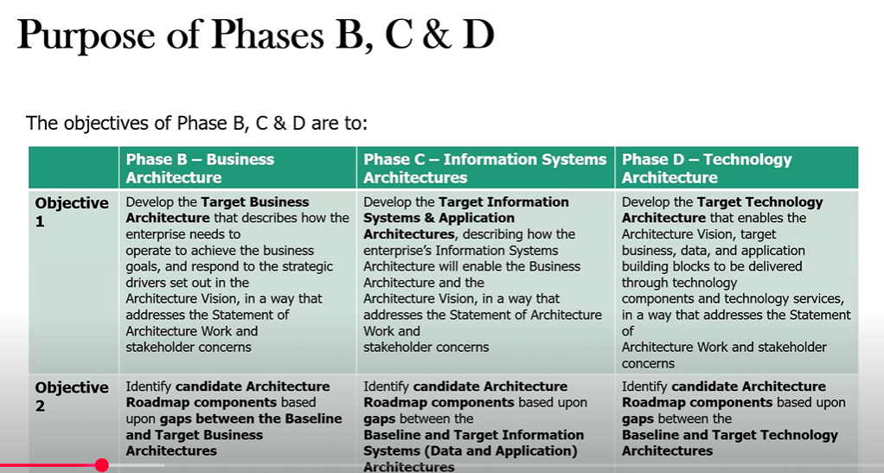

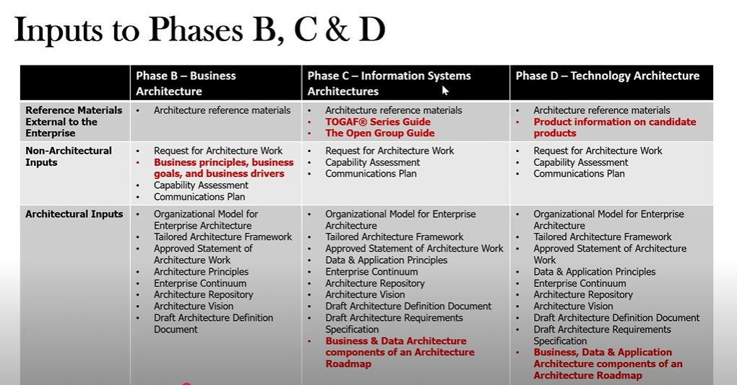

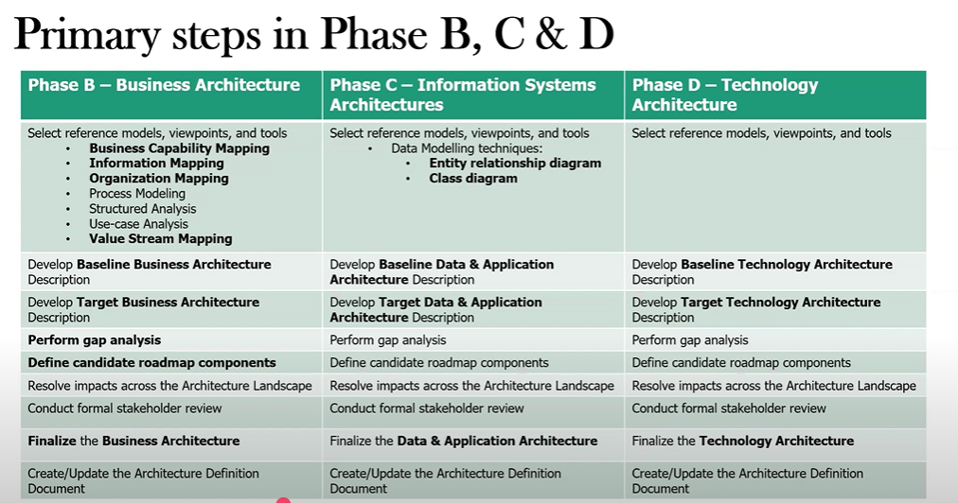

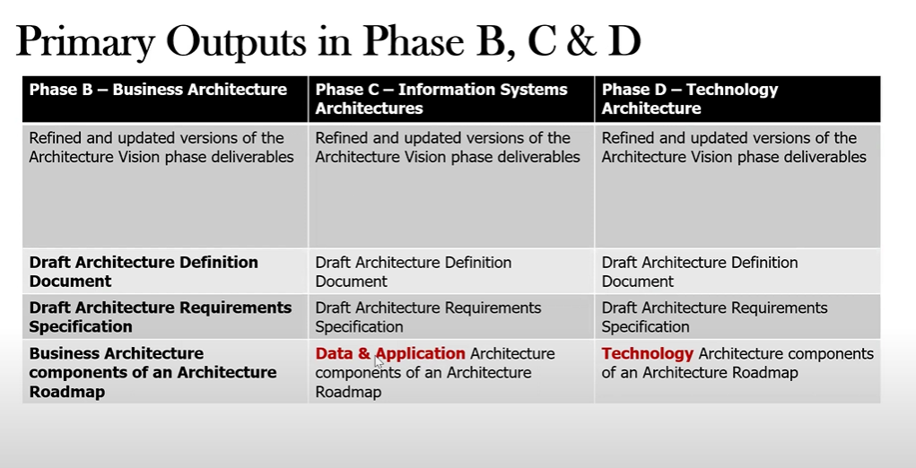

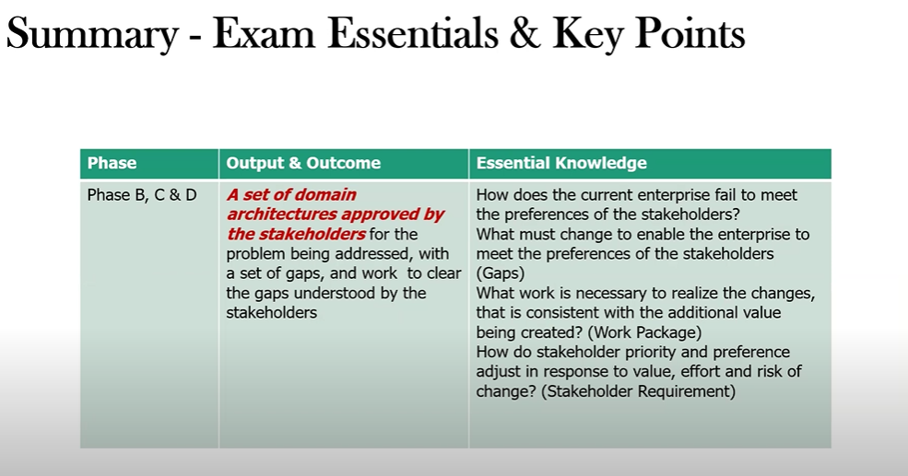

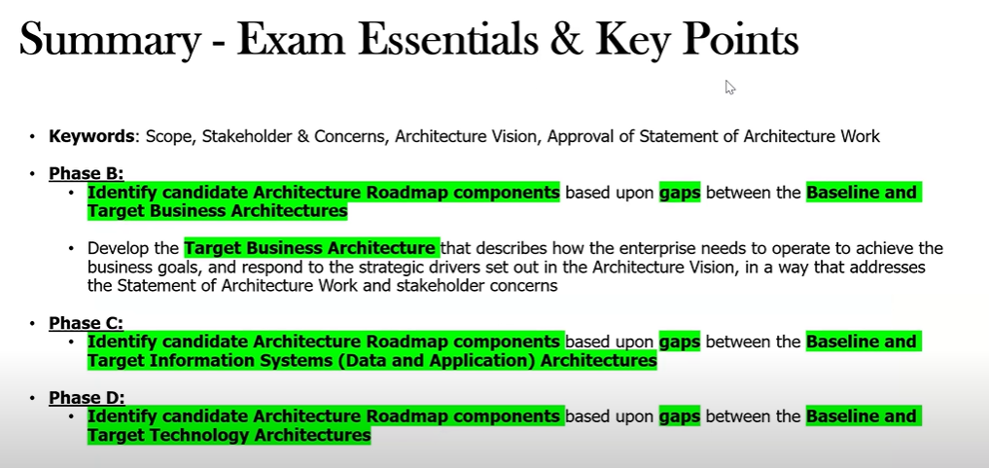

Business Capabilities – Value Stream Analysis

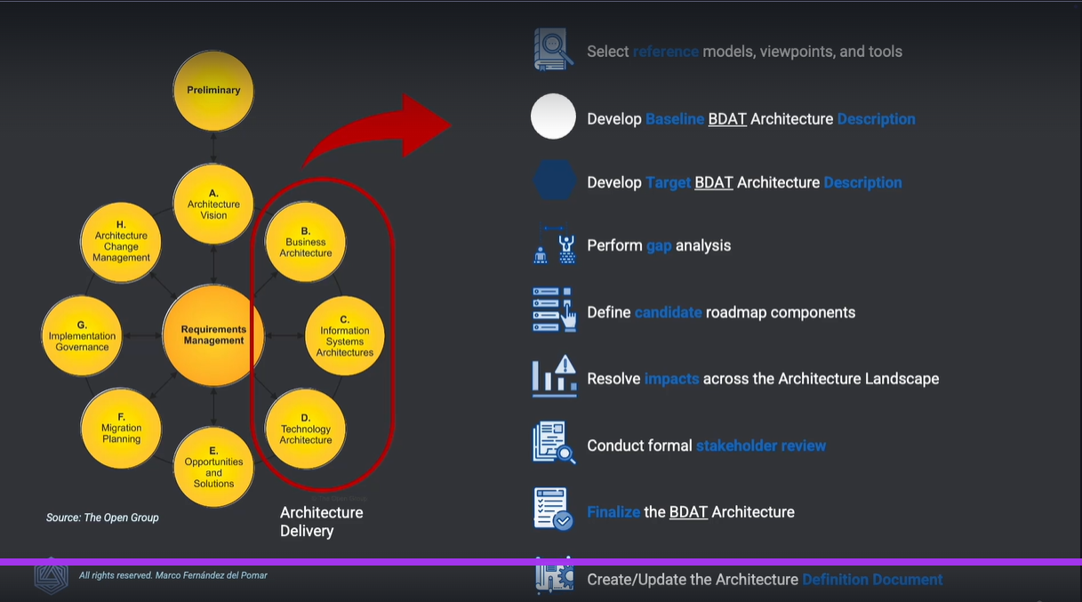

**Phase E – Opportunities and Solutions**

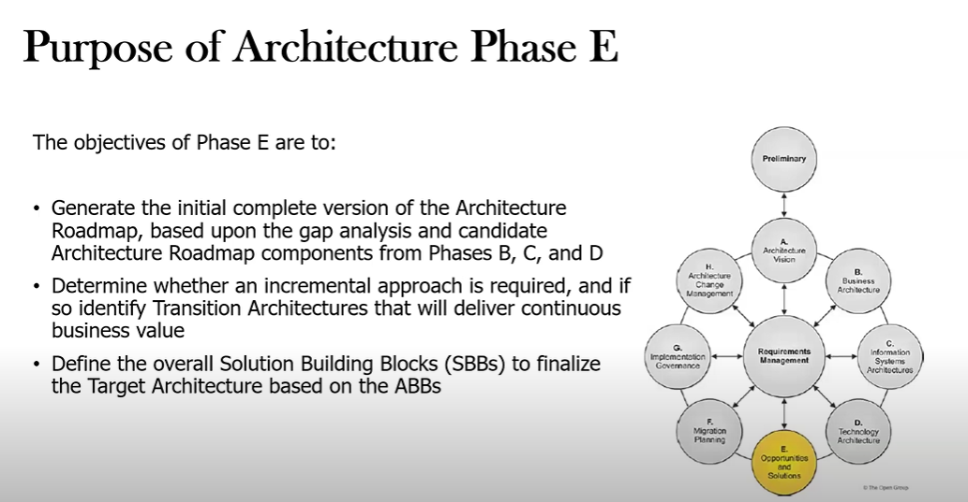

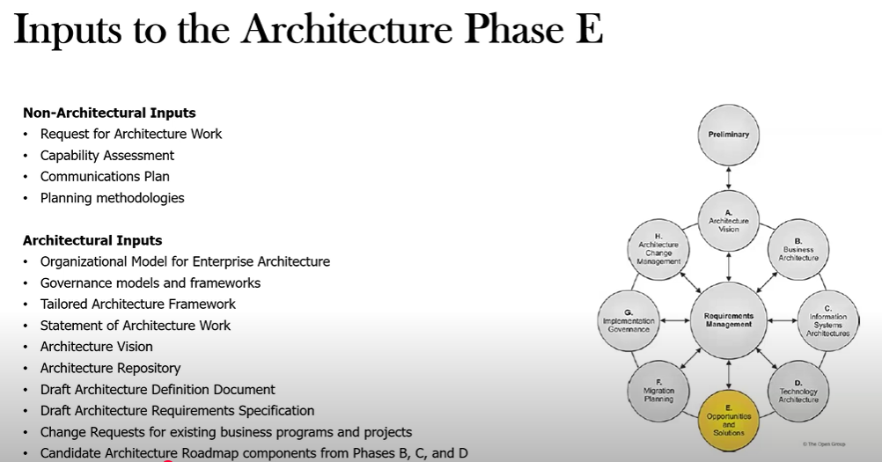

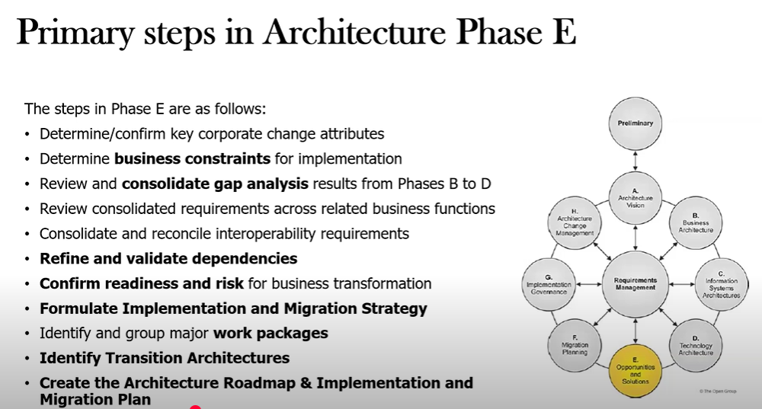

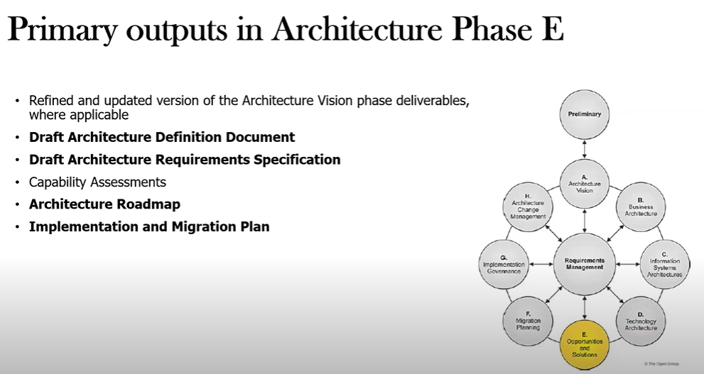

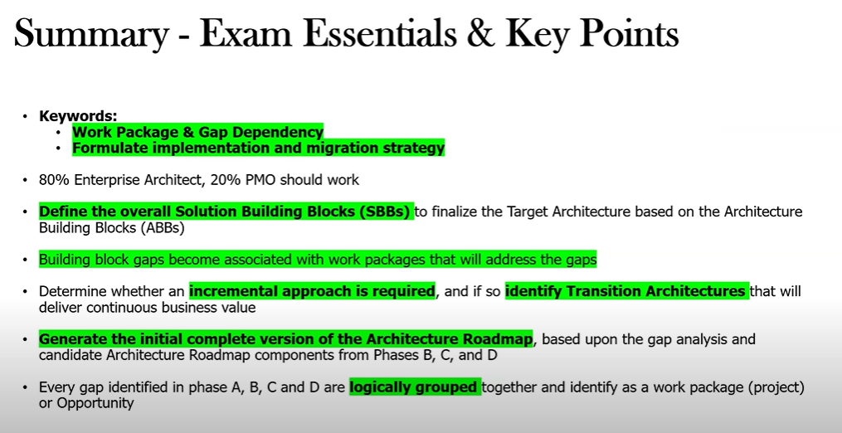

***A set of work packages that address the set of gaps***

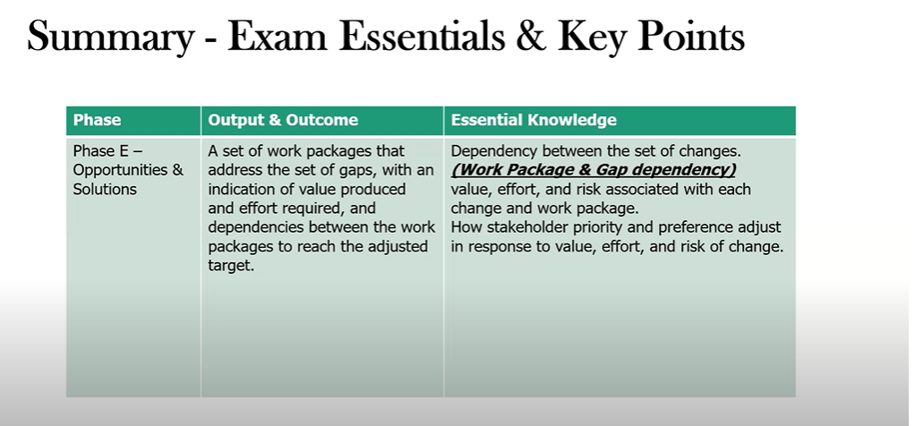

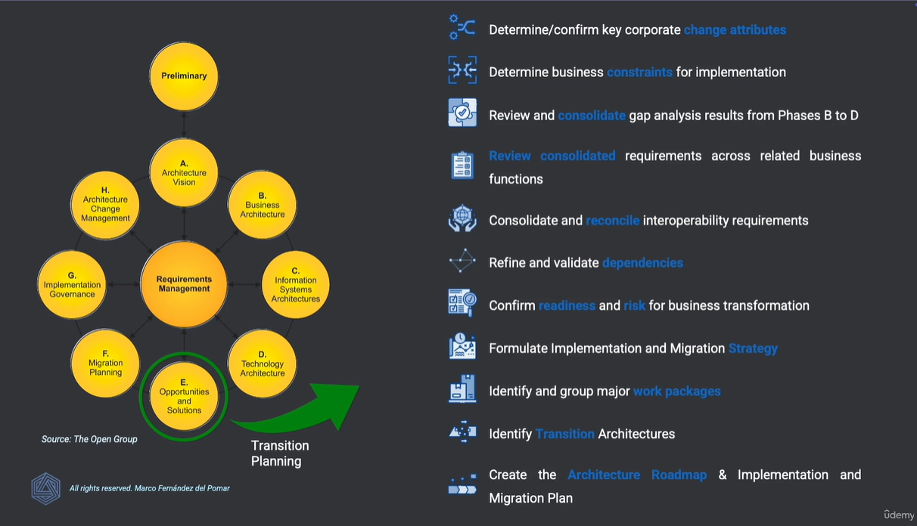

**Phase F – Migration Planning**

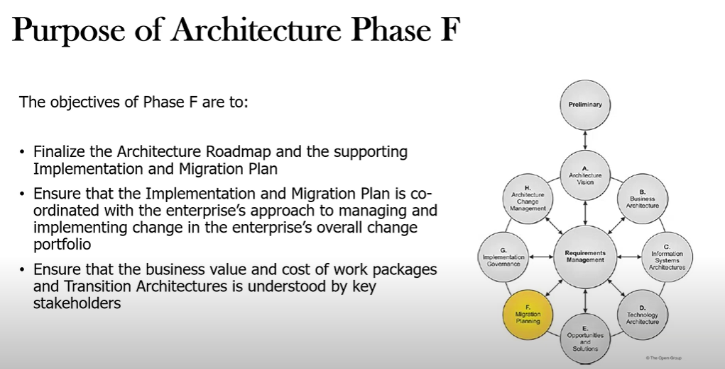

s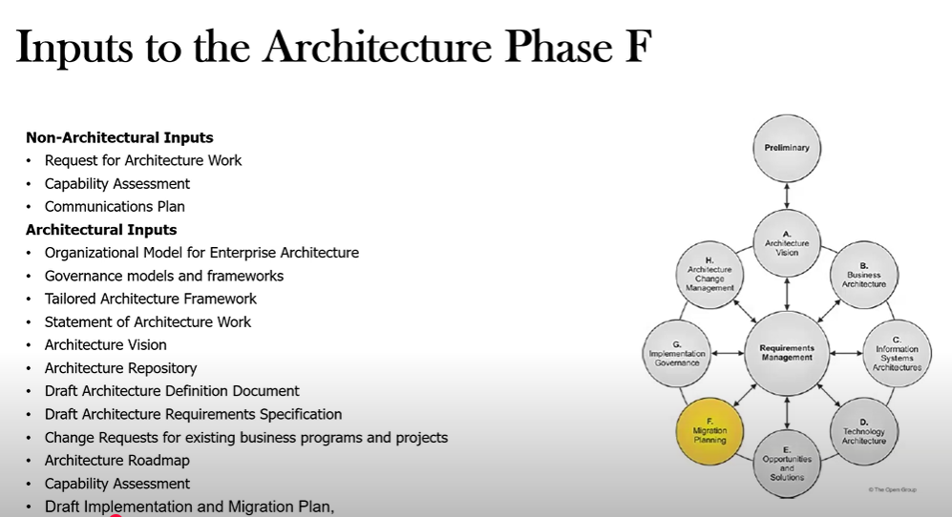

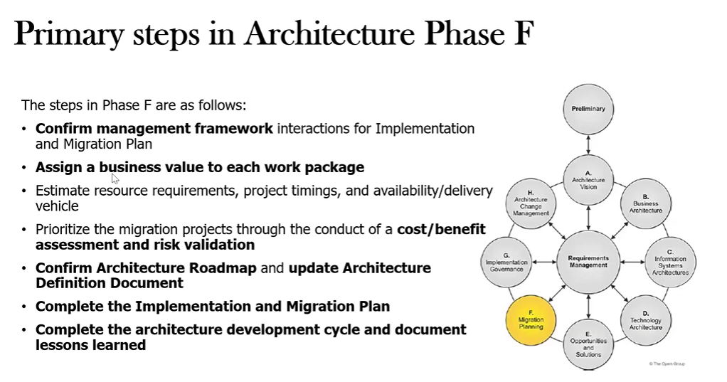

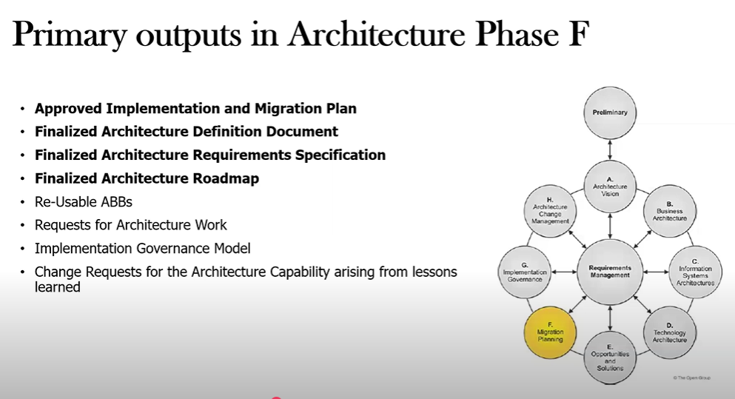

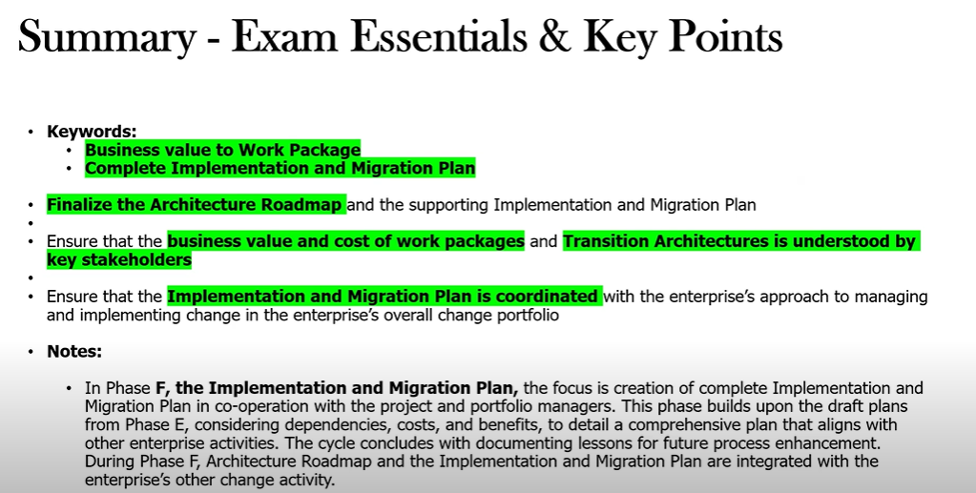

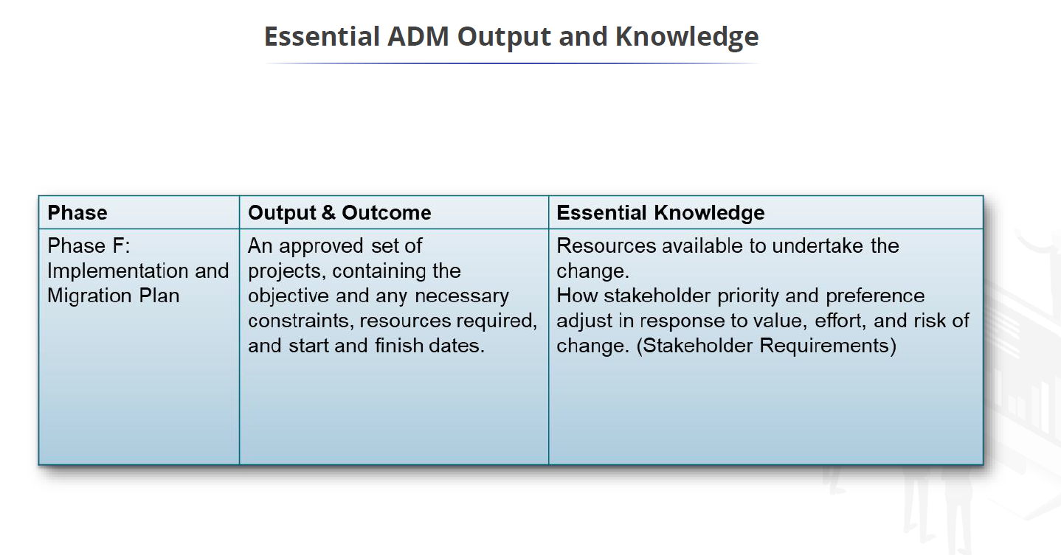

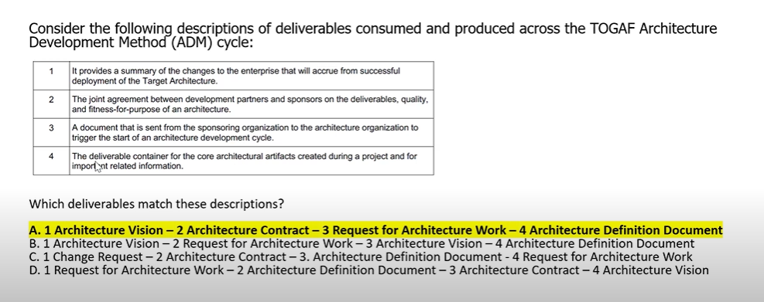

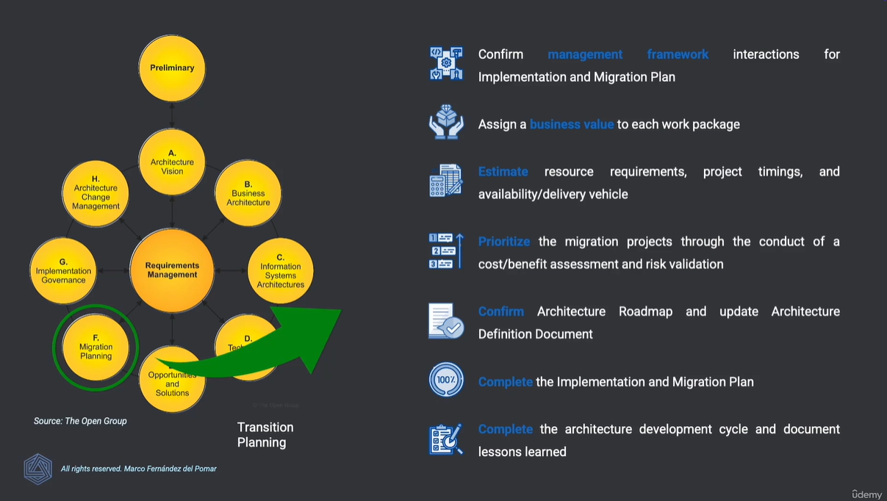

**Implementation Governance**

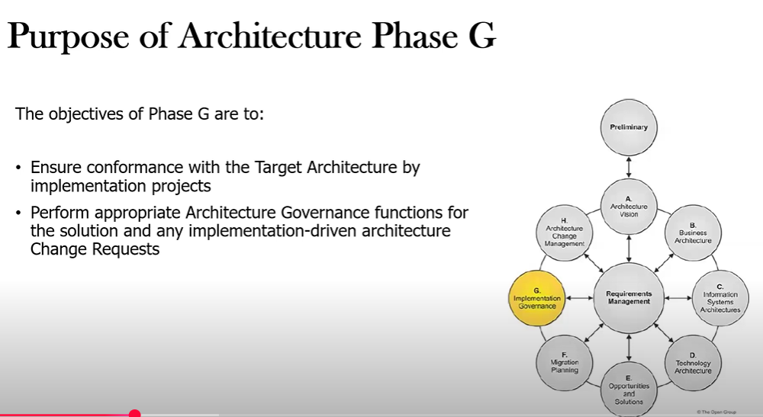

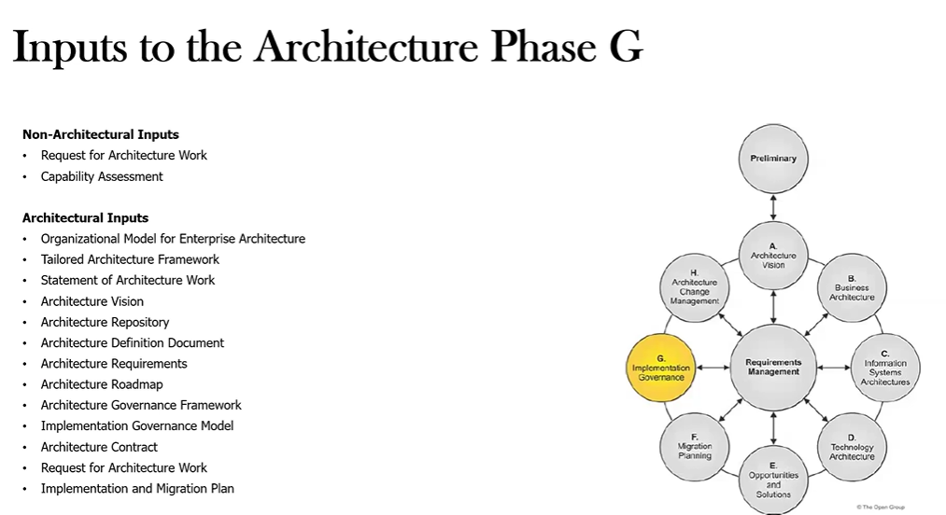

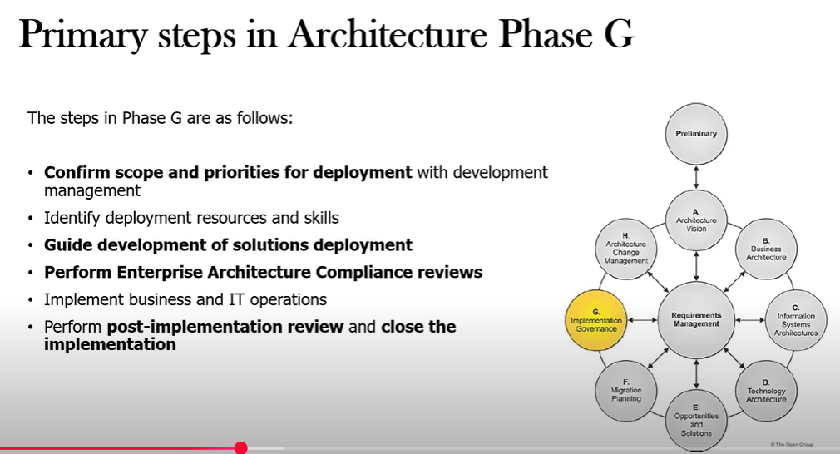

**Agile Methodologies – Phase G**

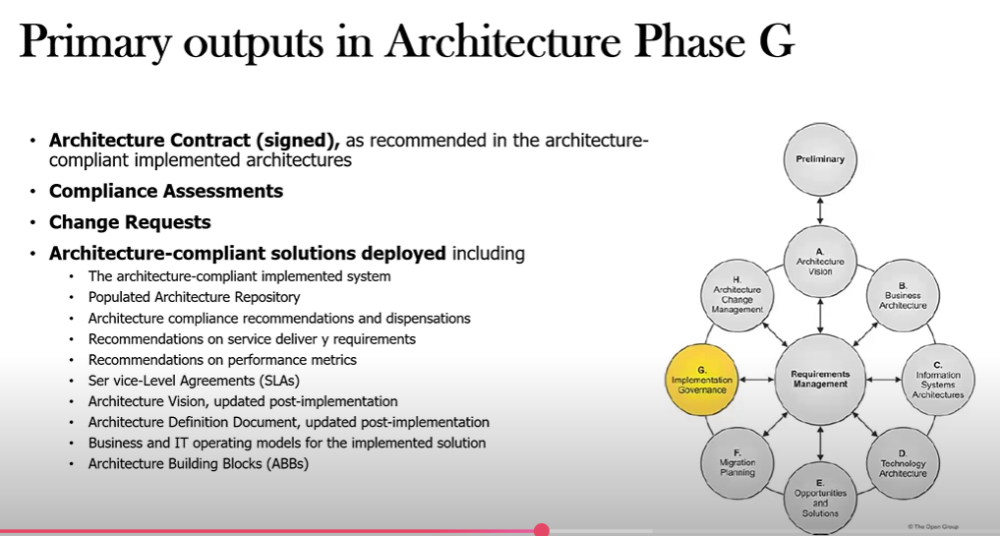

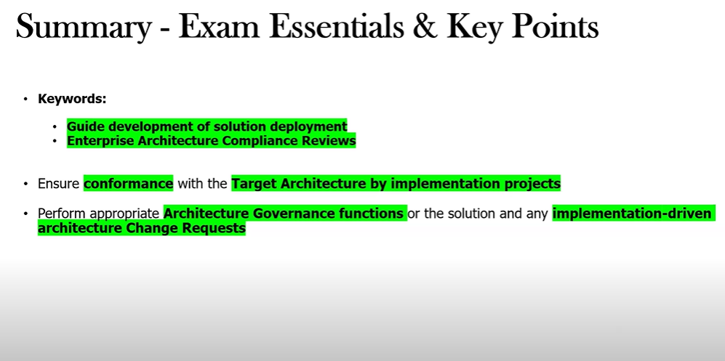

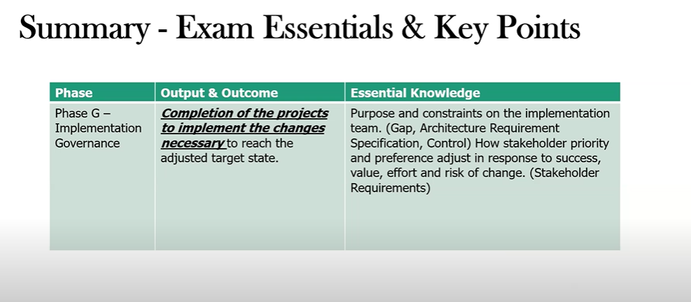

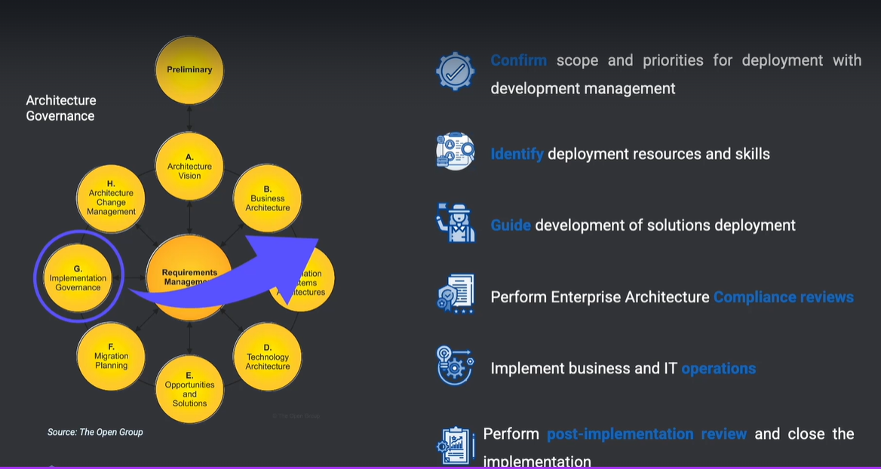**s**

**Architecture Change Management**

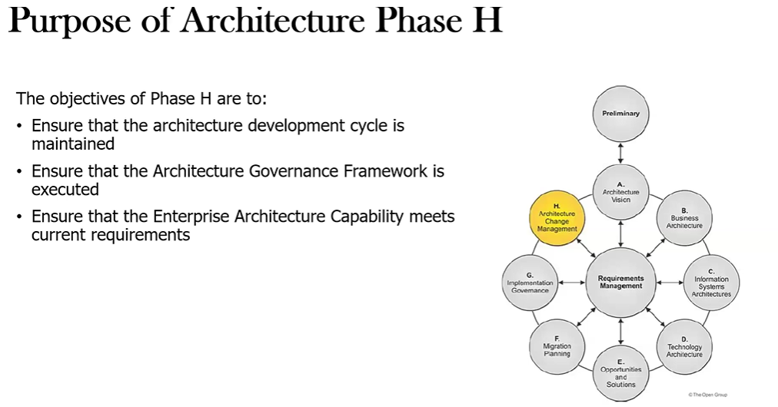

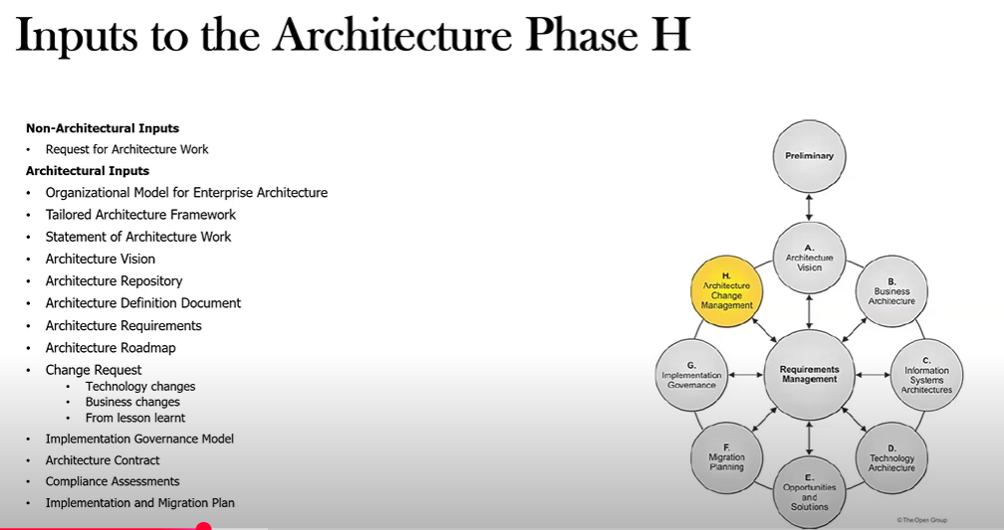

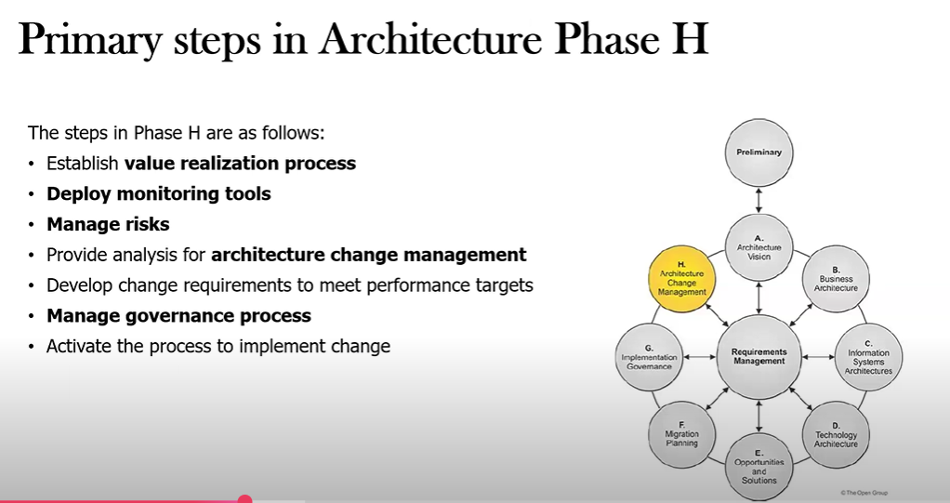

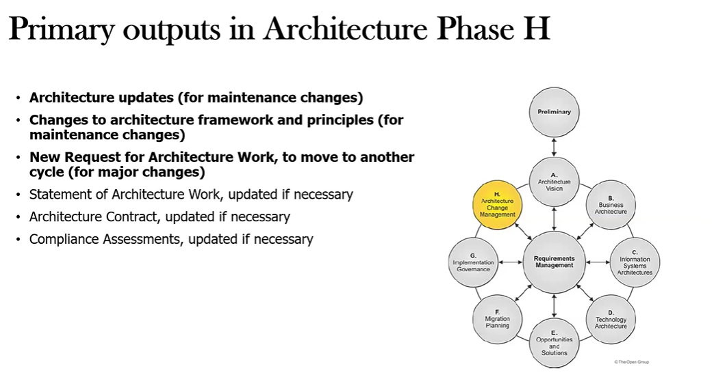

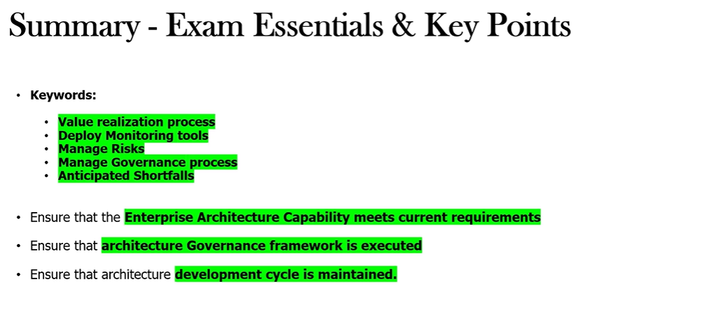

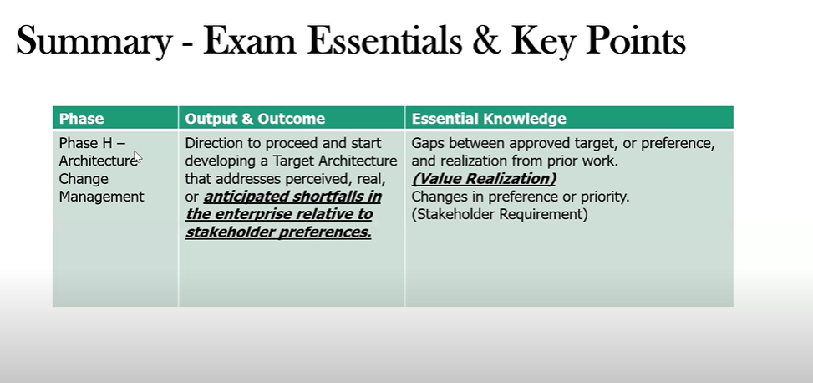

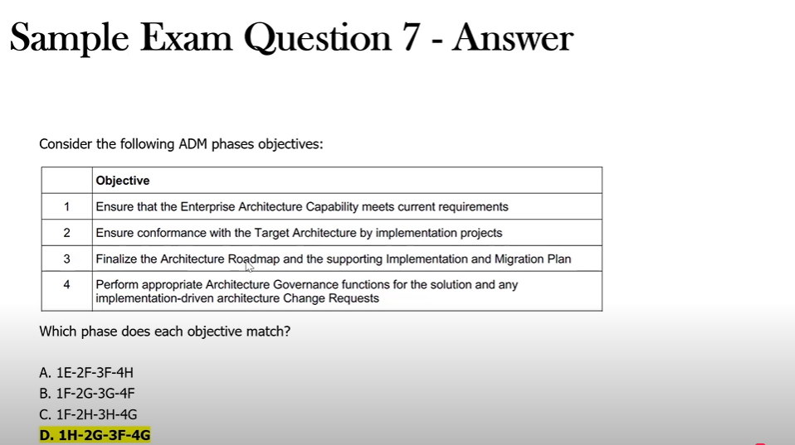

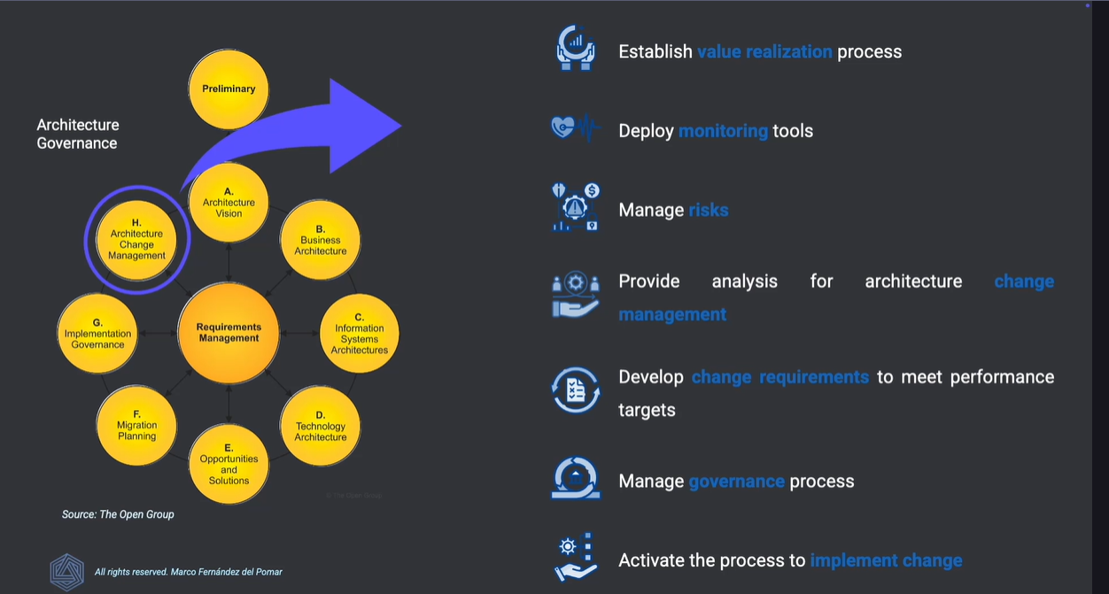

**Architecture Requirements Phase**

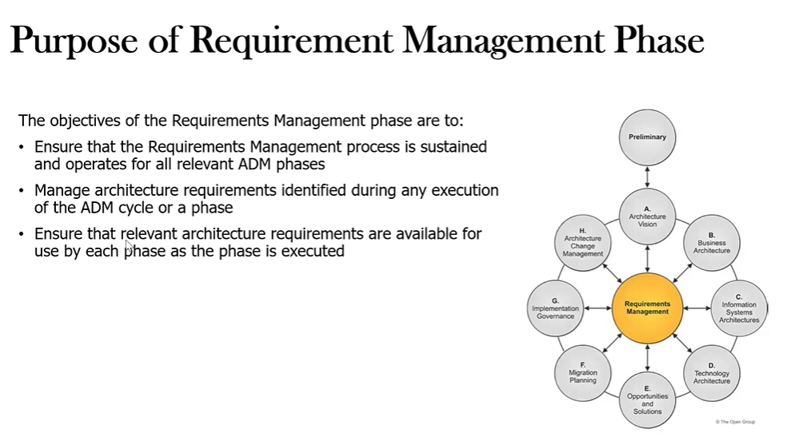

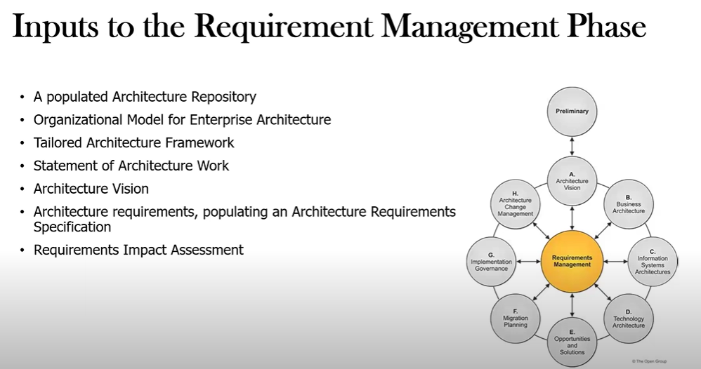

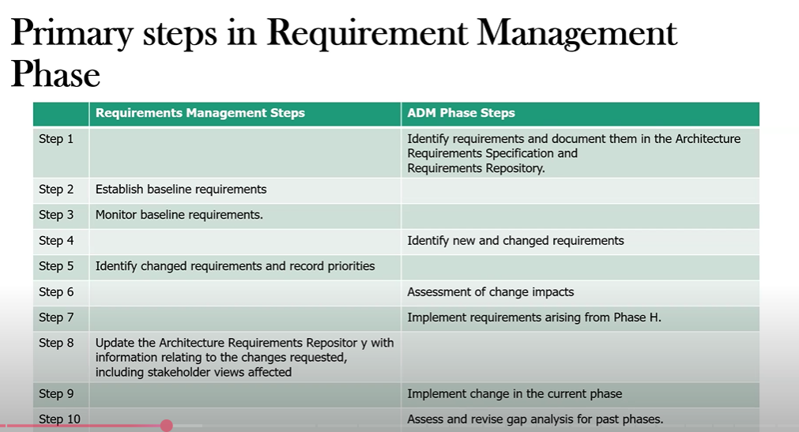

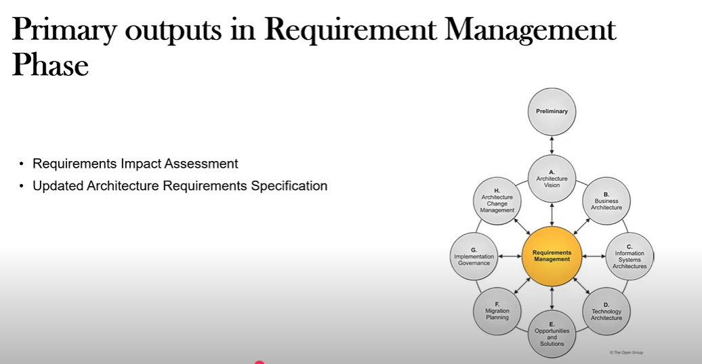

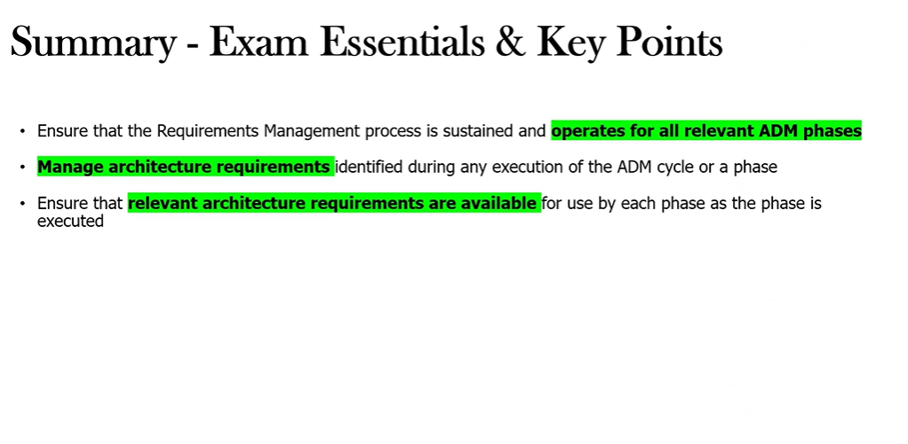

1. **ADM Techniques**

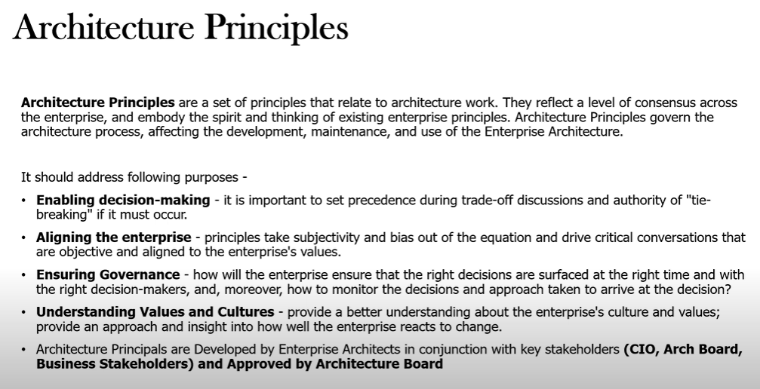

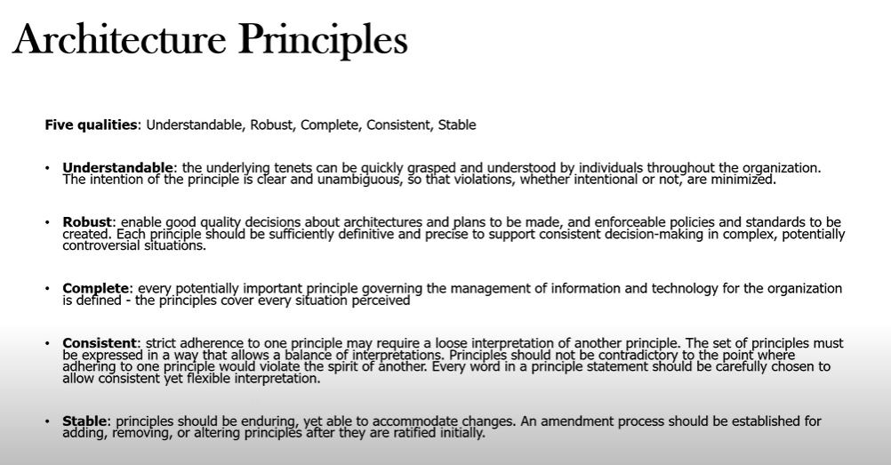

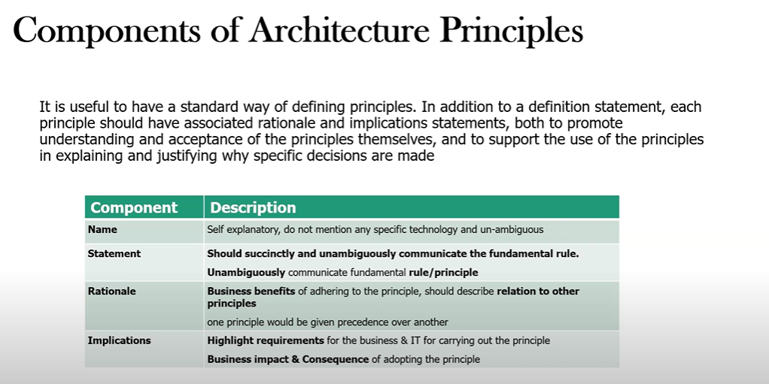

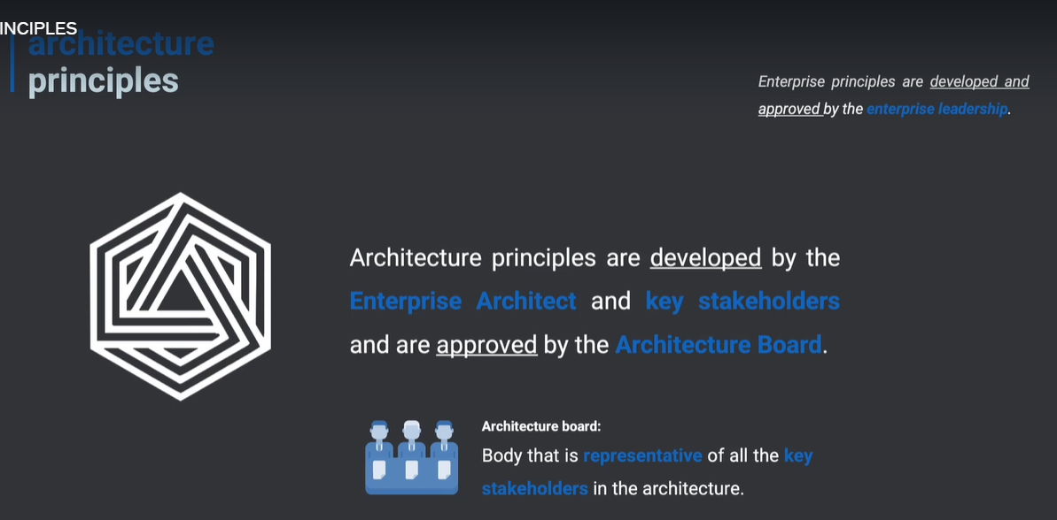

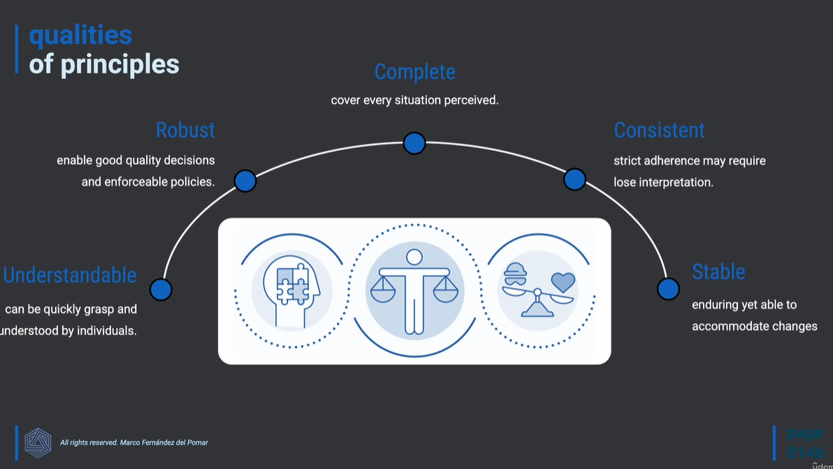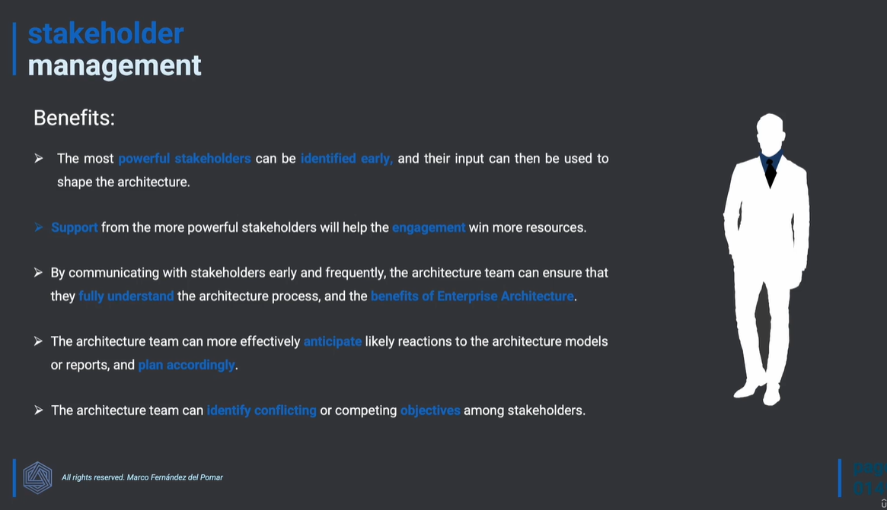

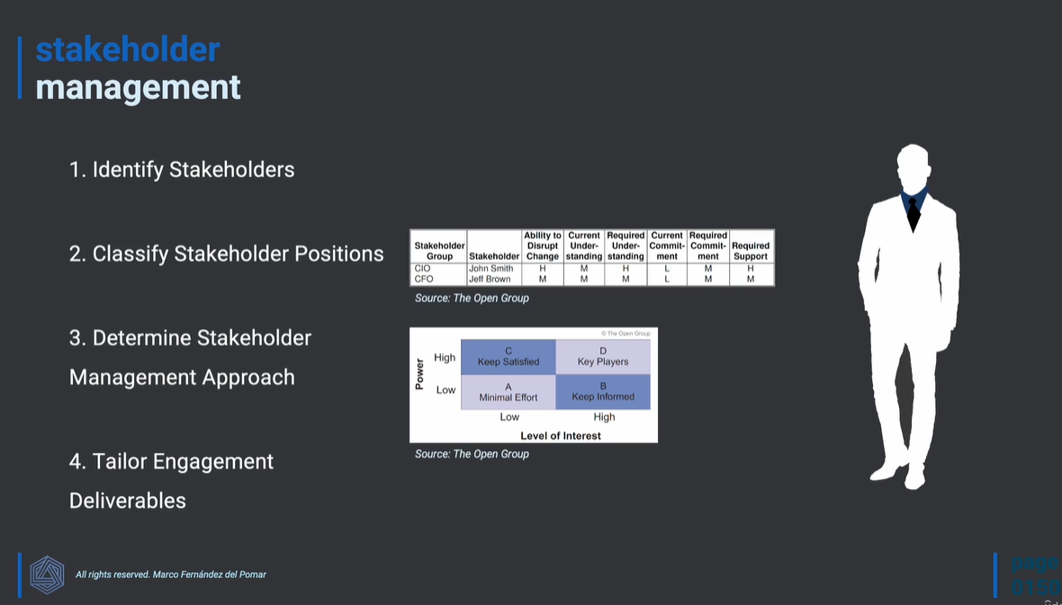

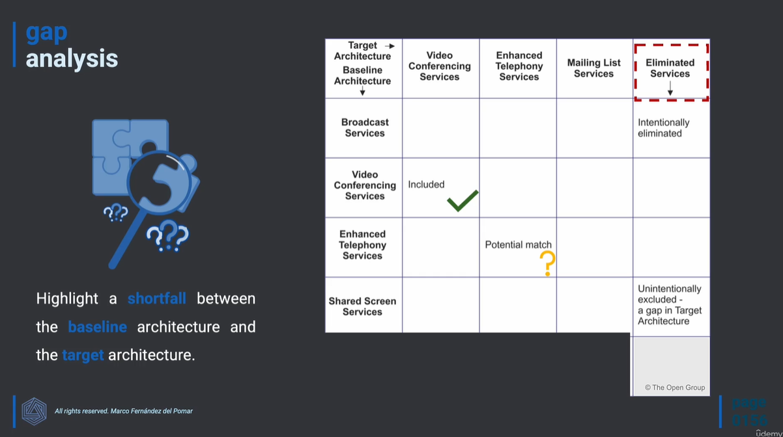

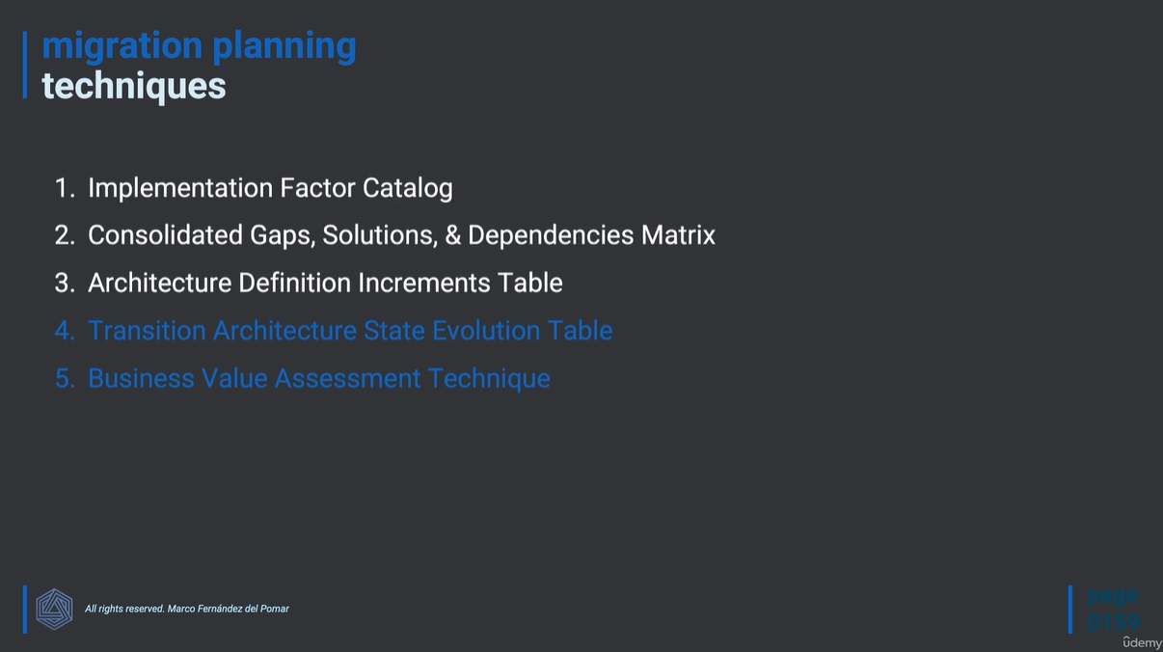

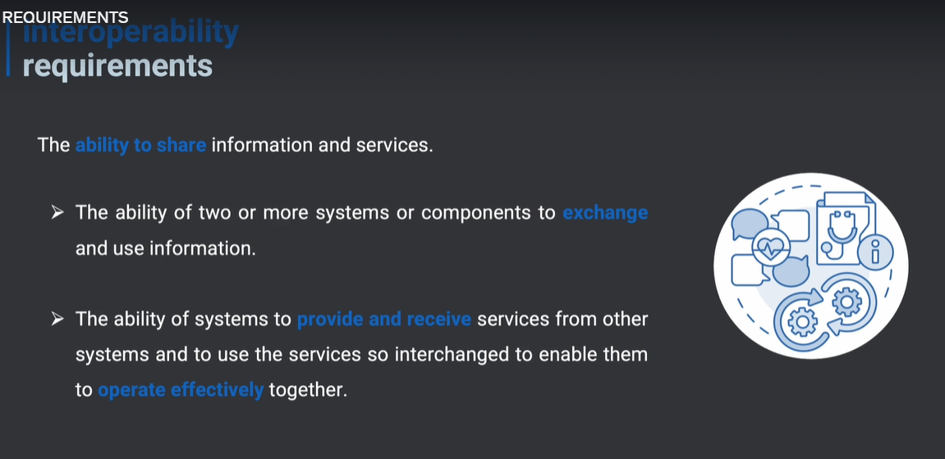

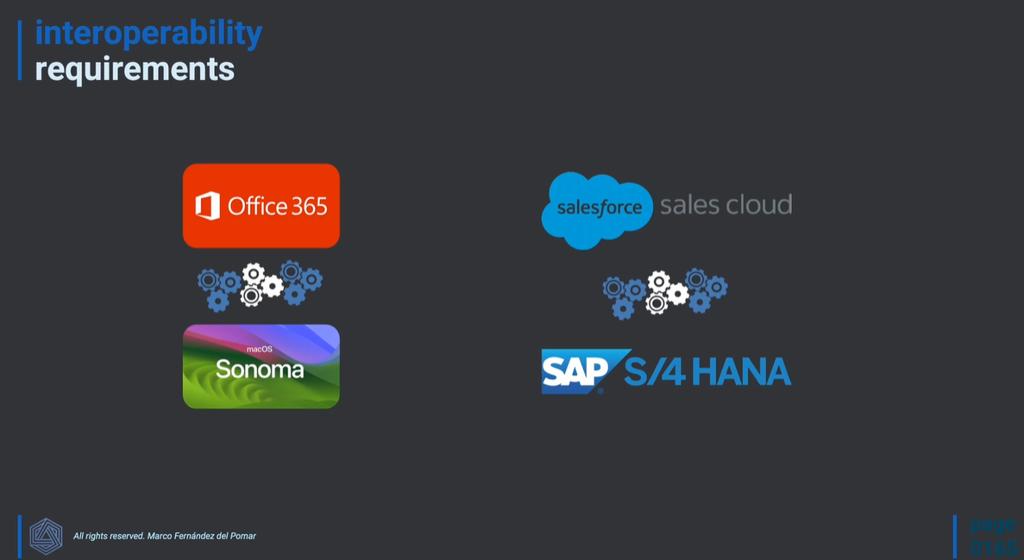

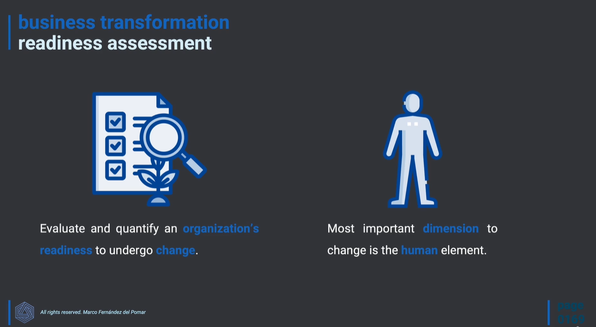

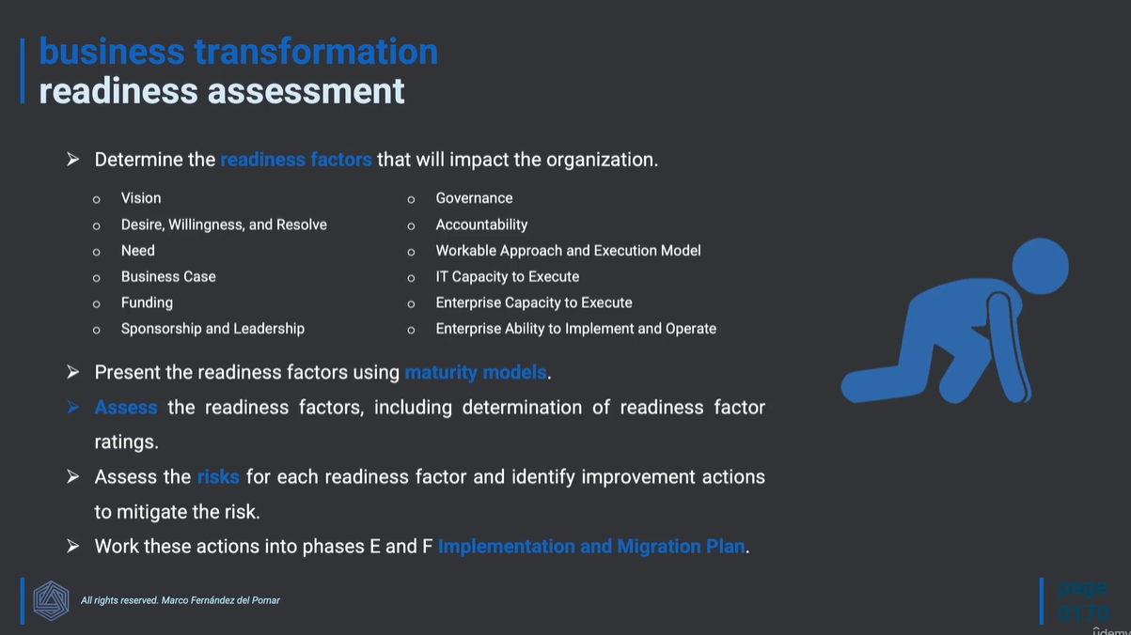

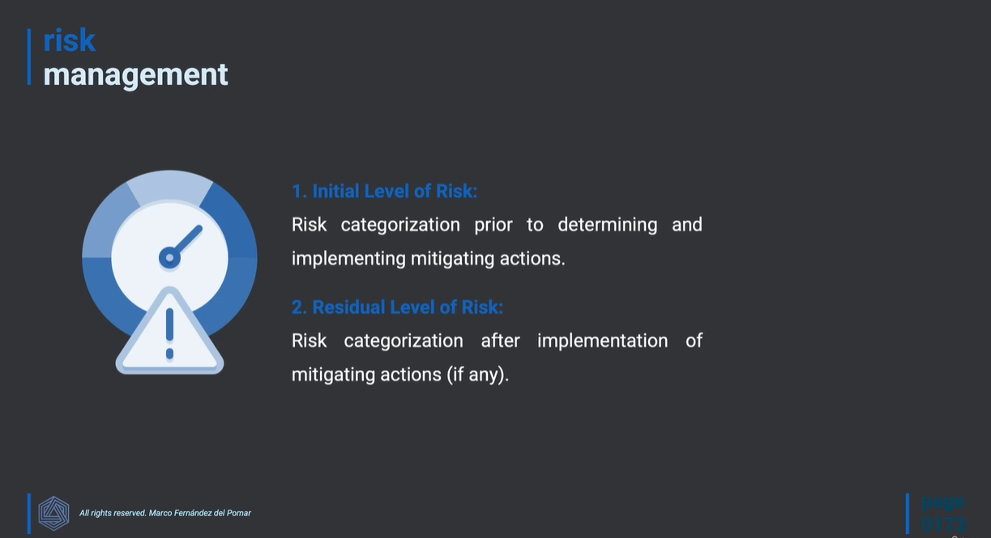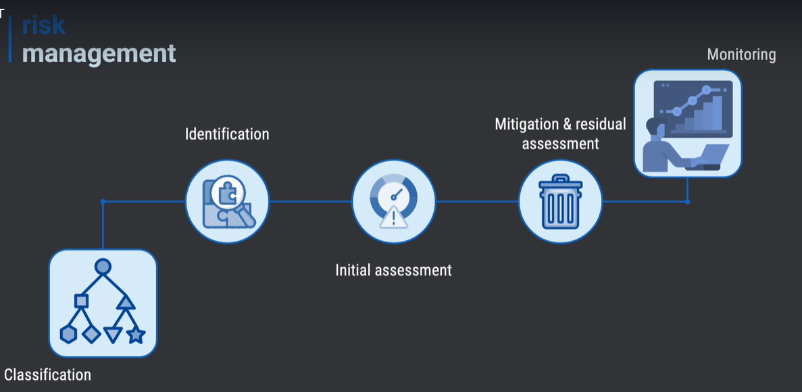

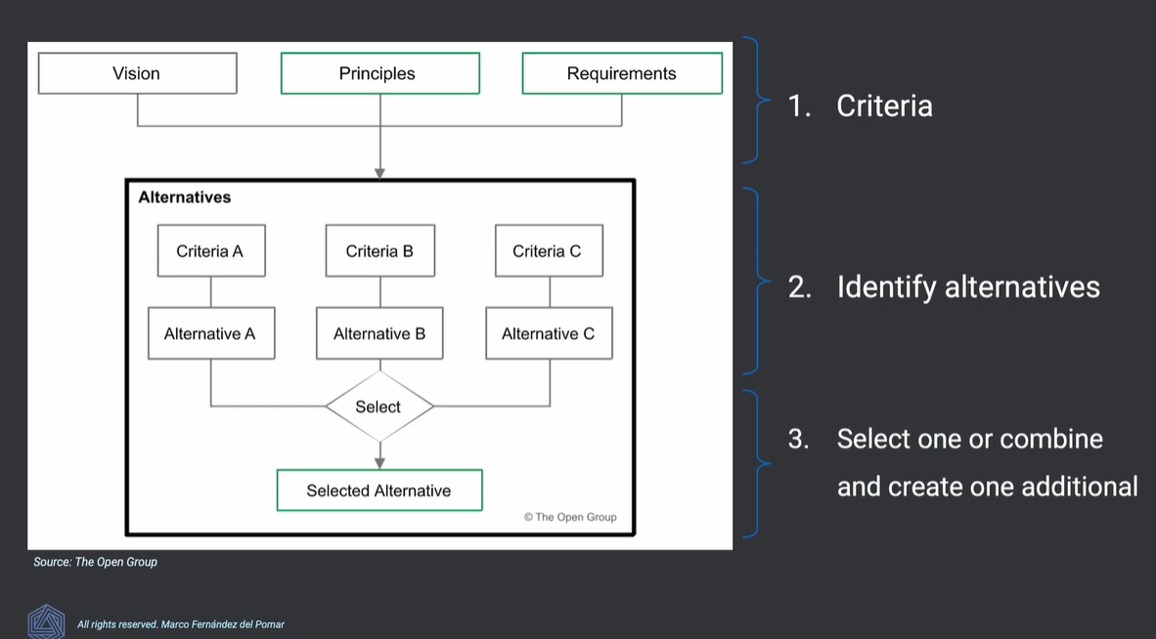

1. **Applying the ADM**

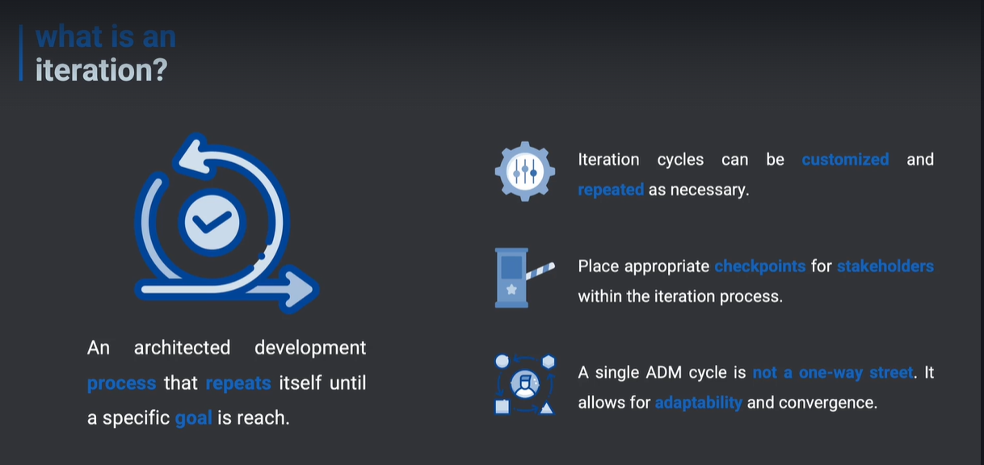

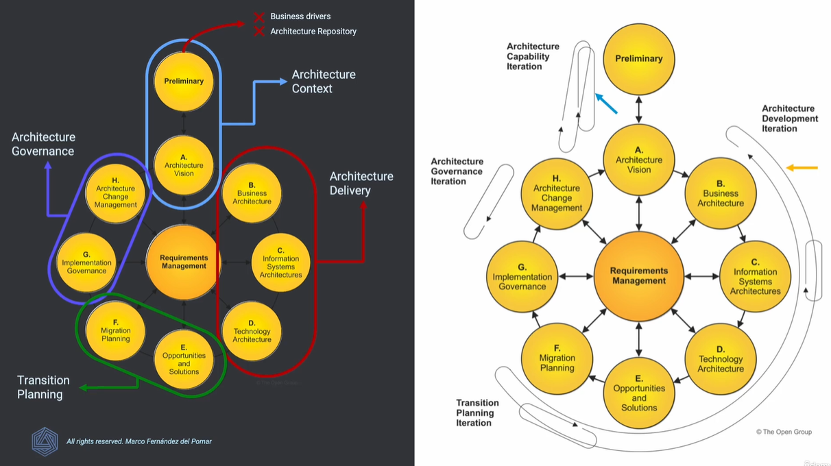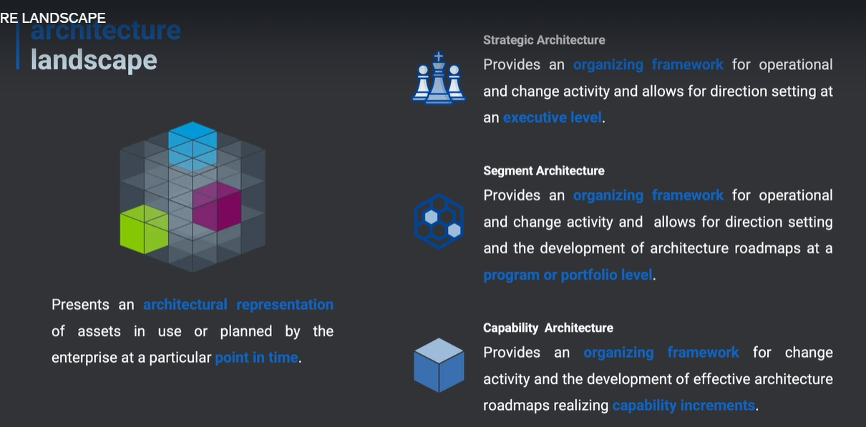

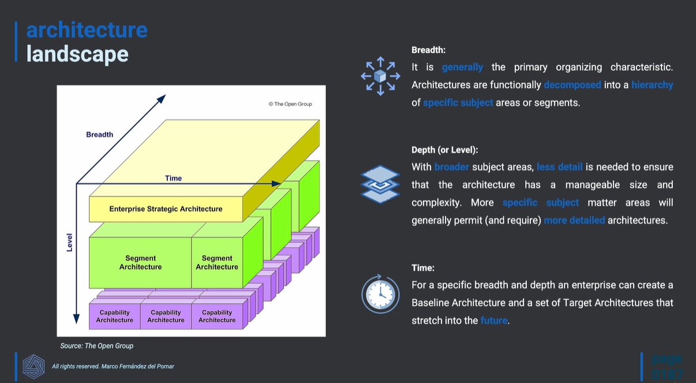

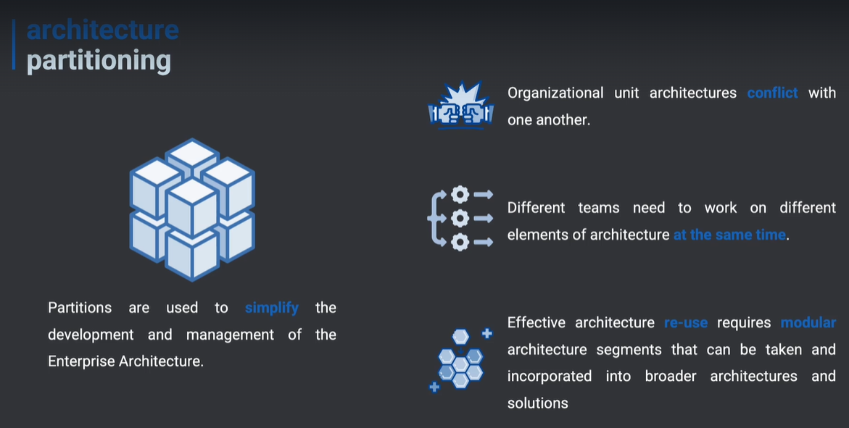

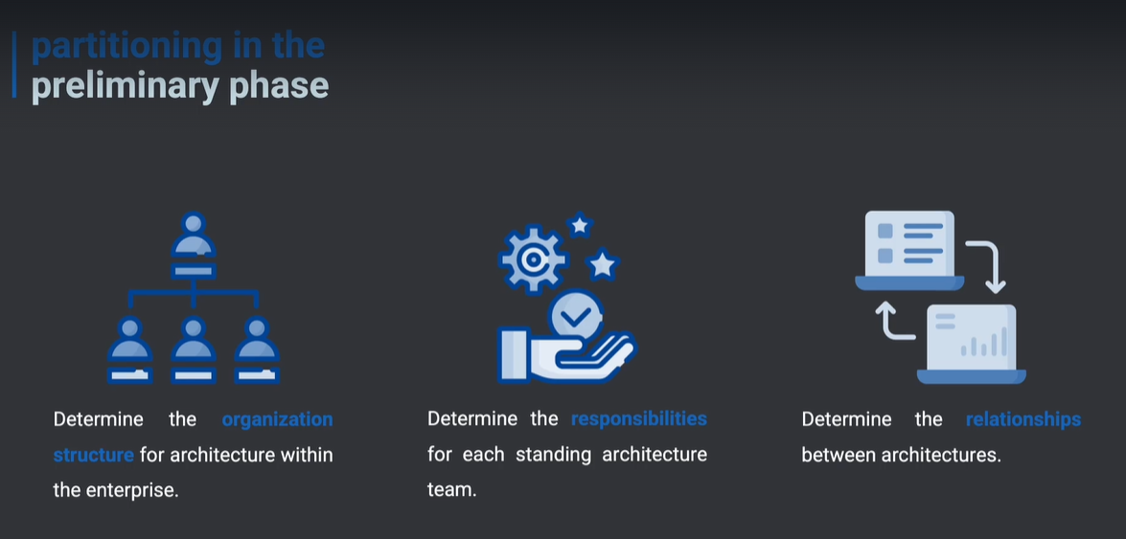

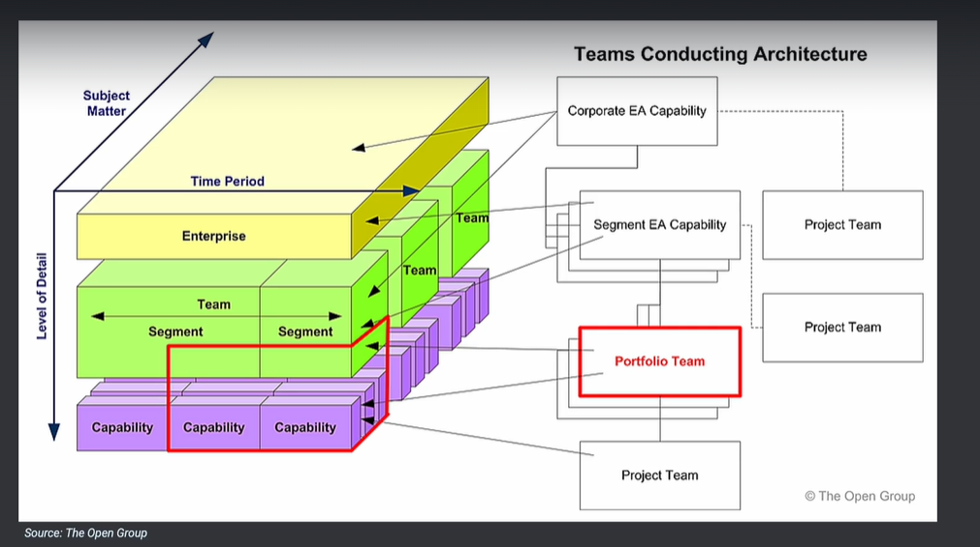

**Architecture Repository**

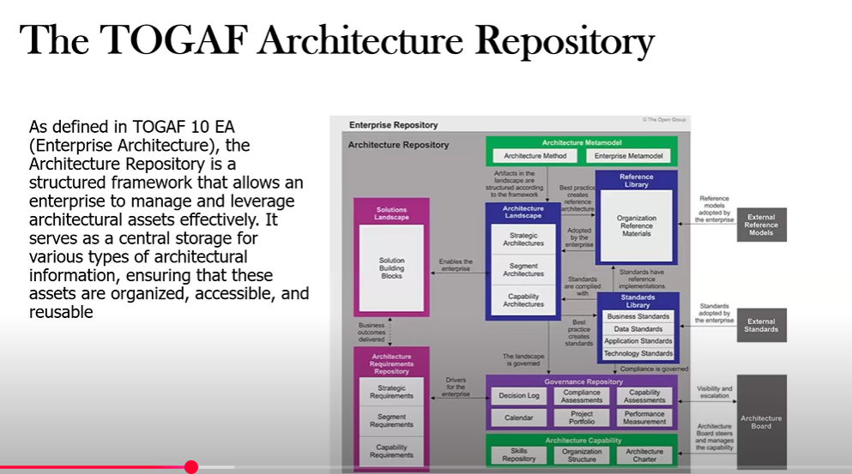

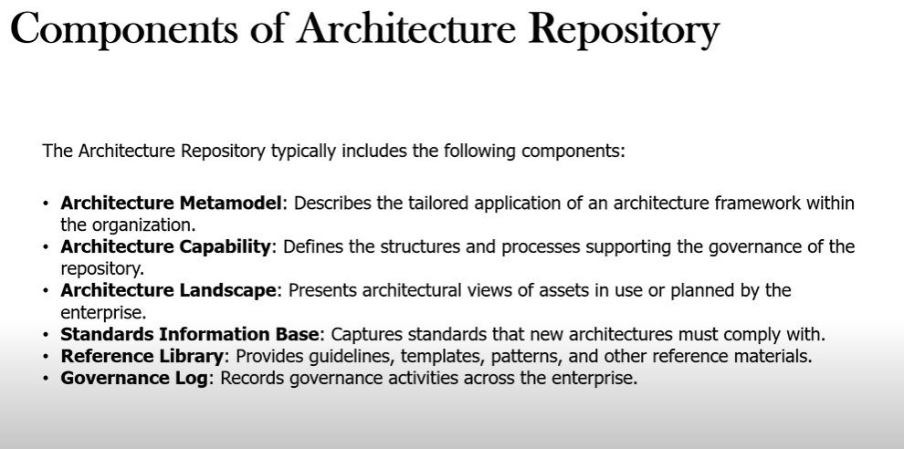

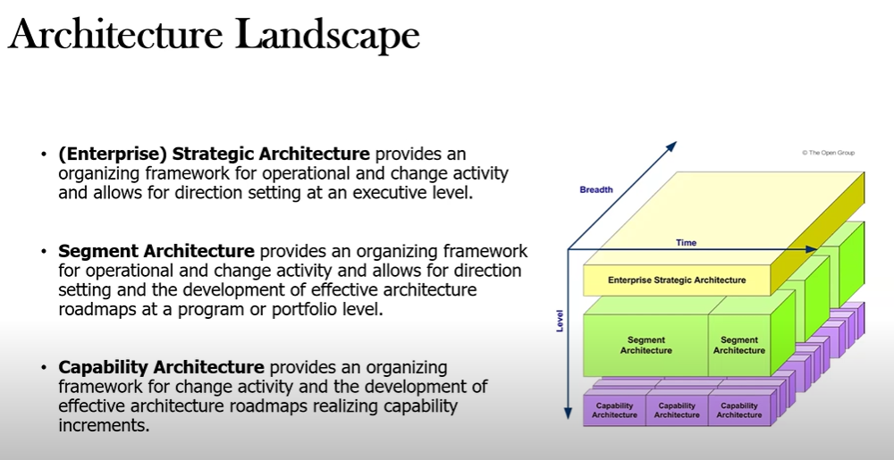

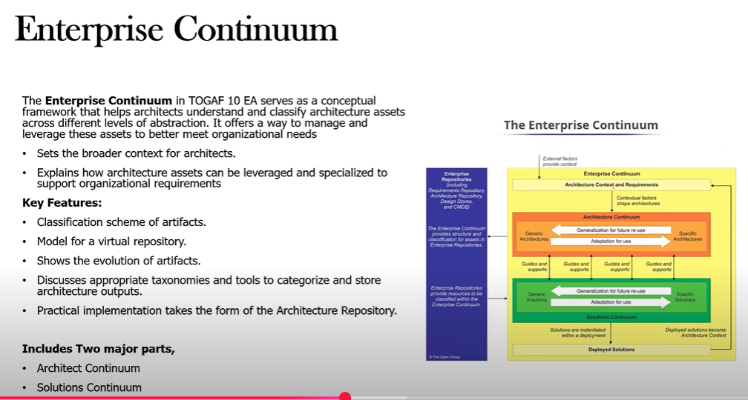

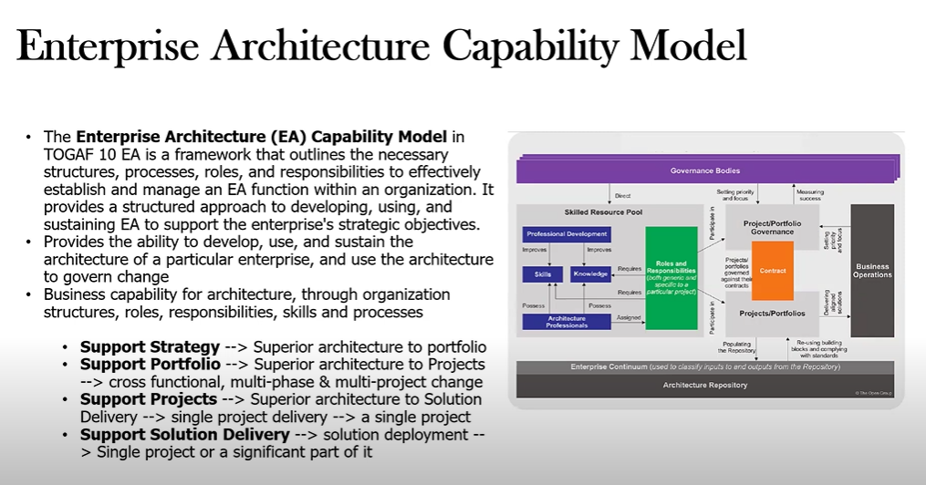

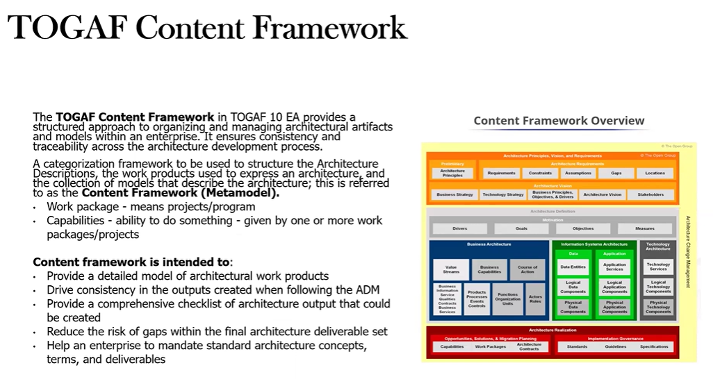

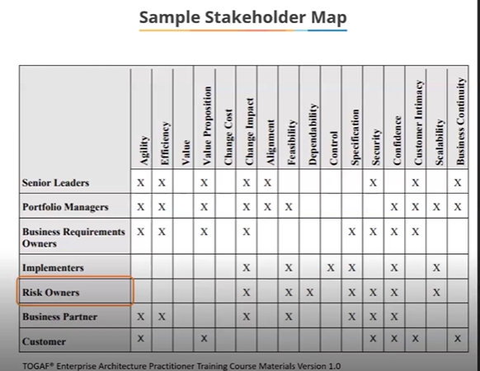

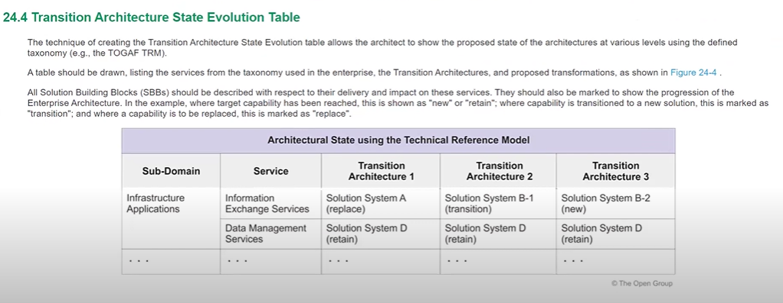

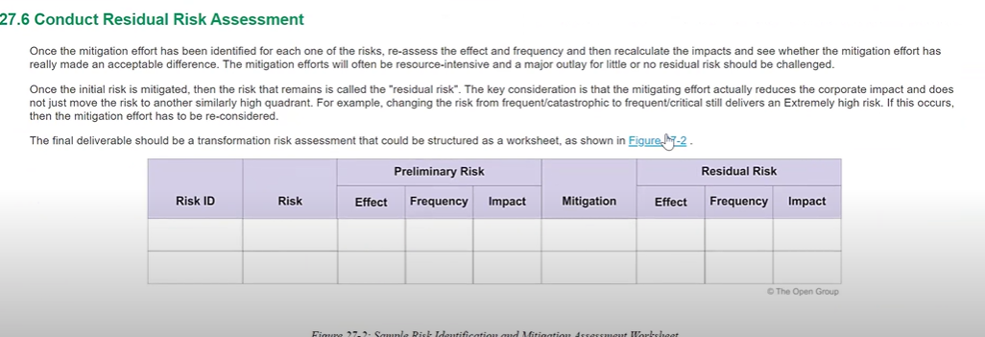

1. **Introduction to Architecture Governance**

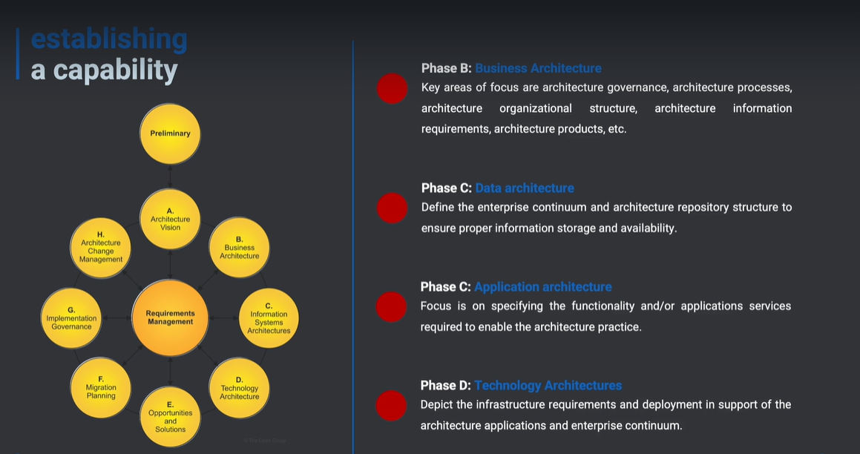

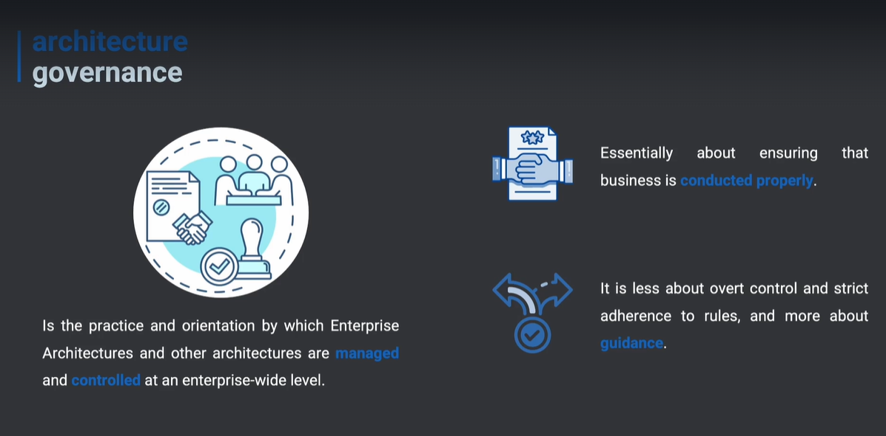

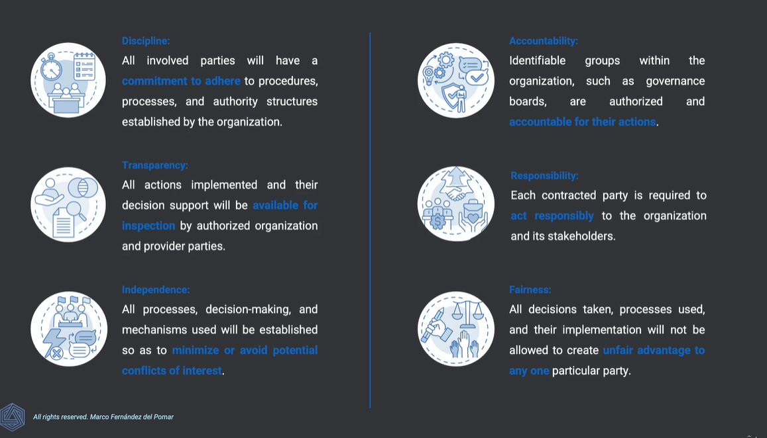

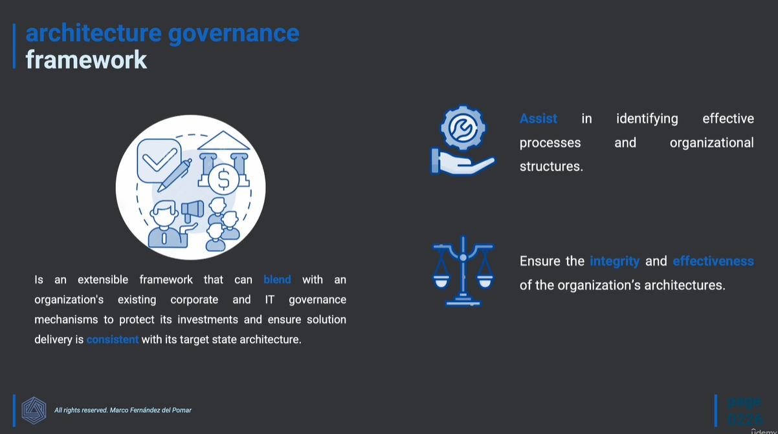

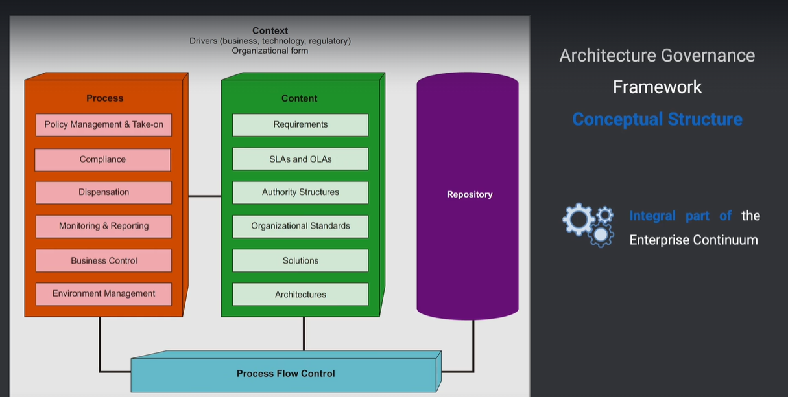

**s**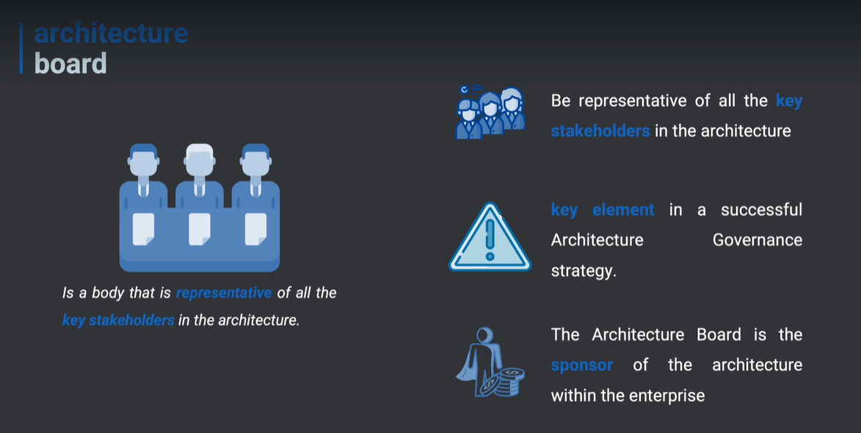

**Roles of Architecture Board**

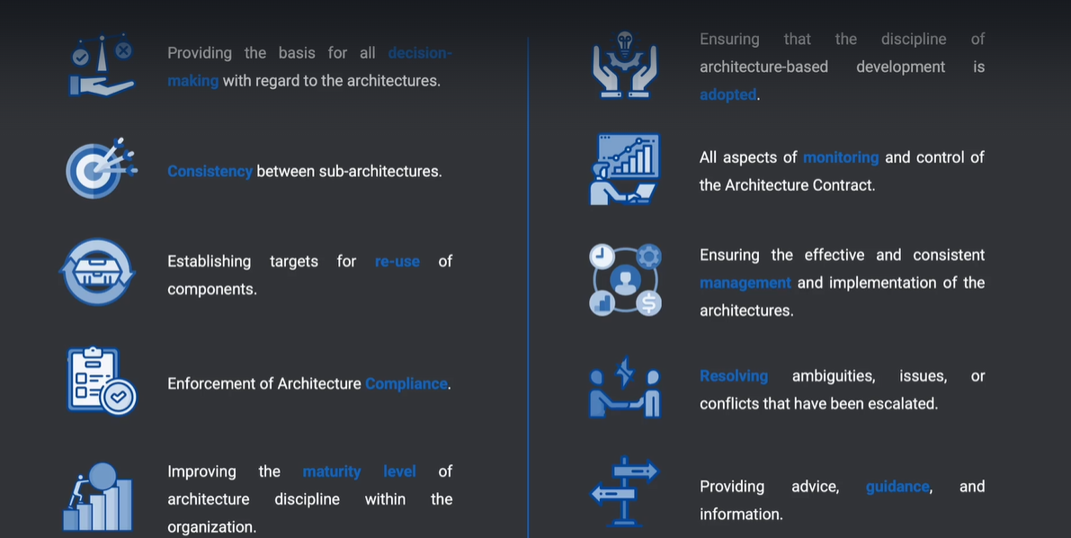

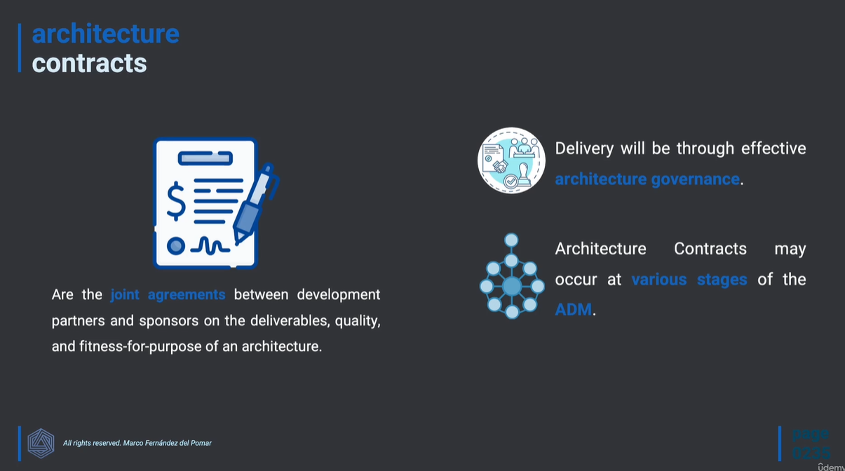

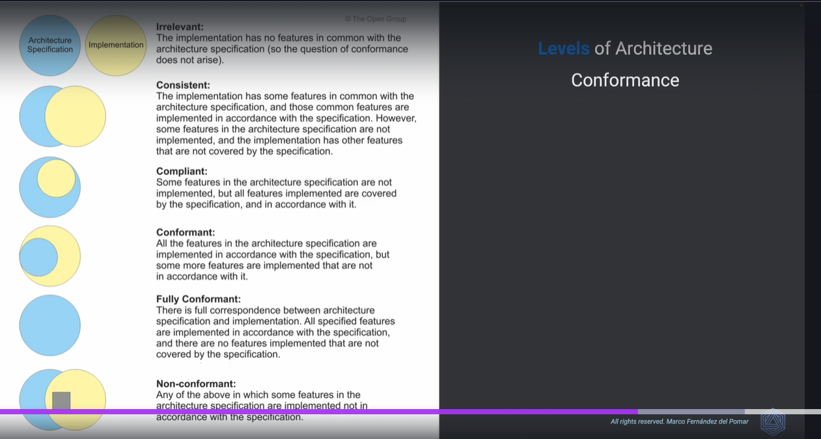

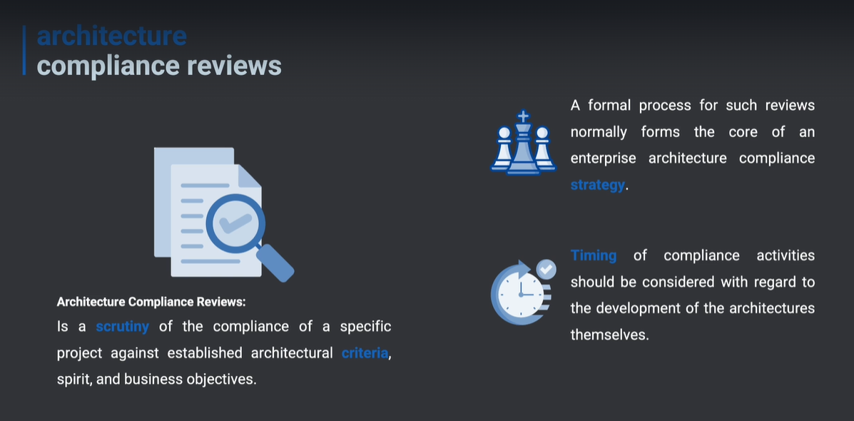

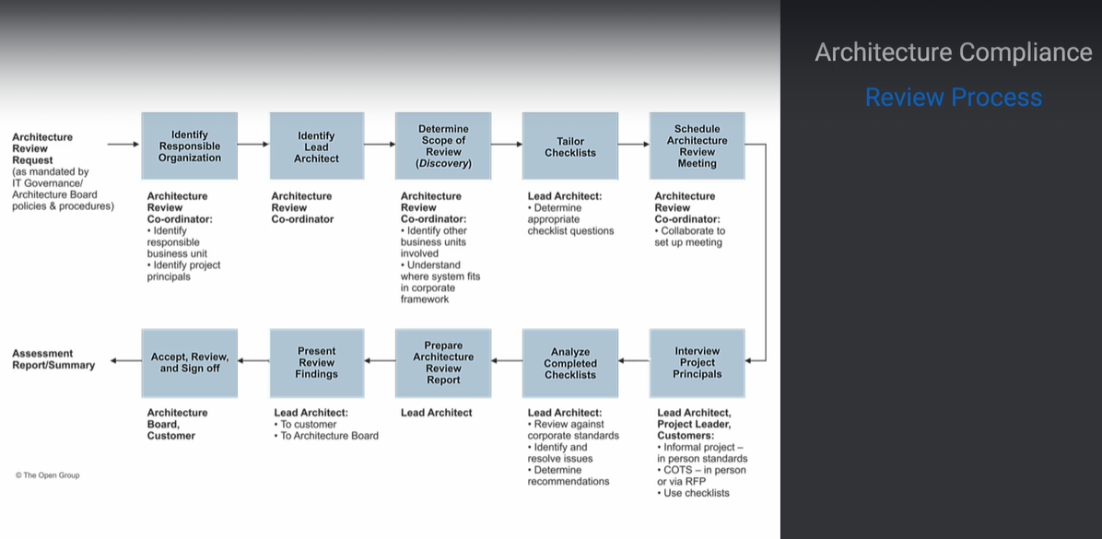

1. **Architecture Content**

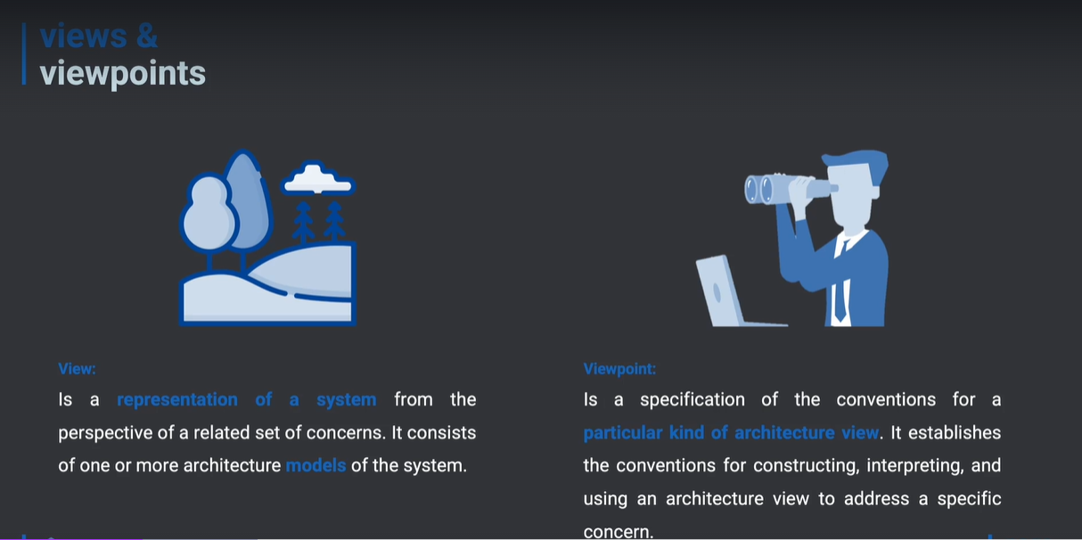

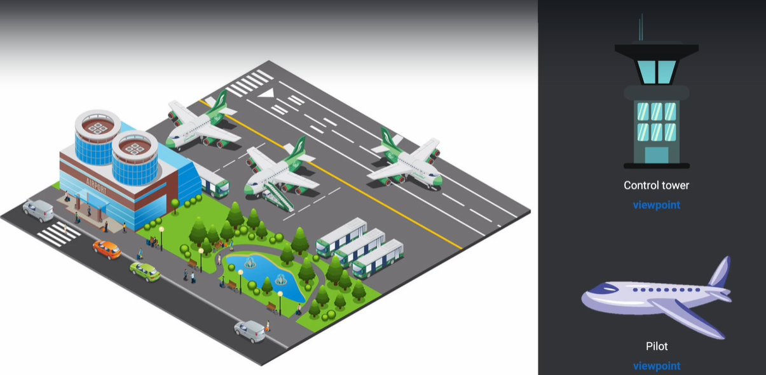

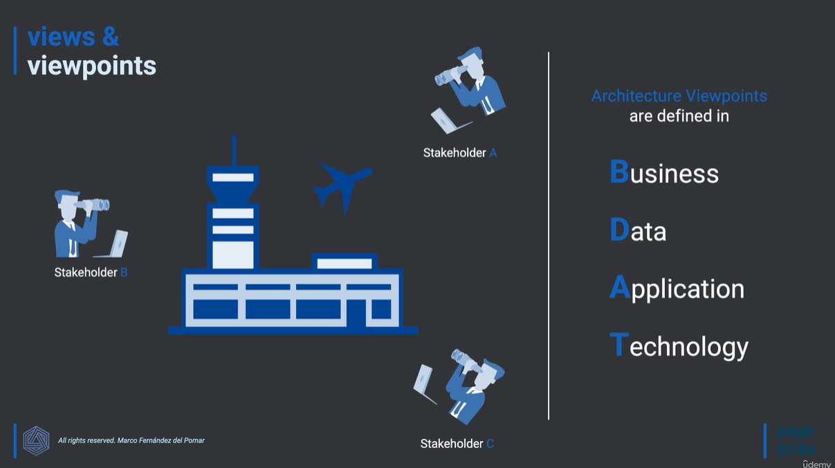

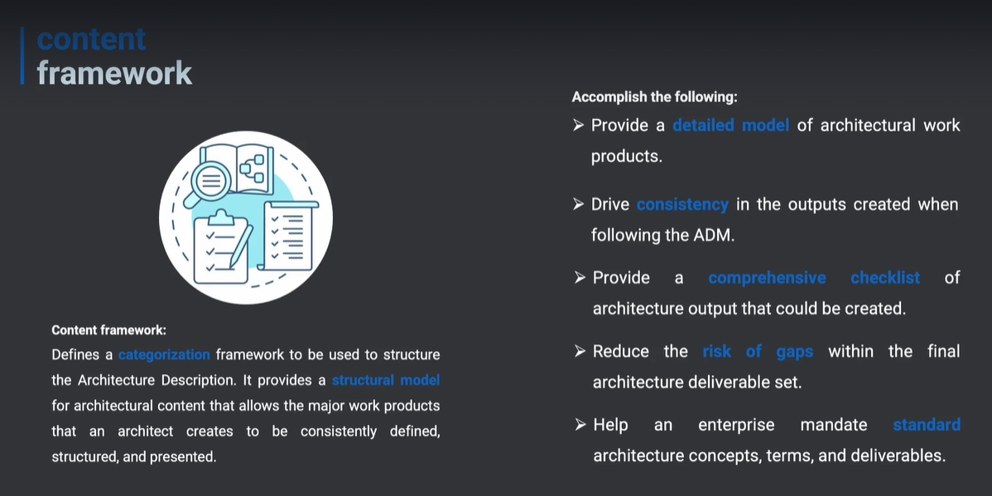

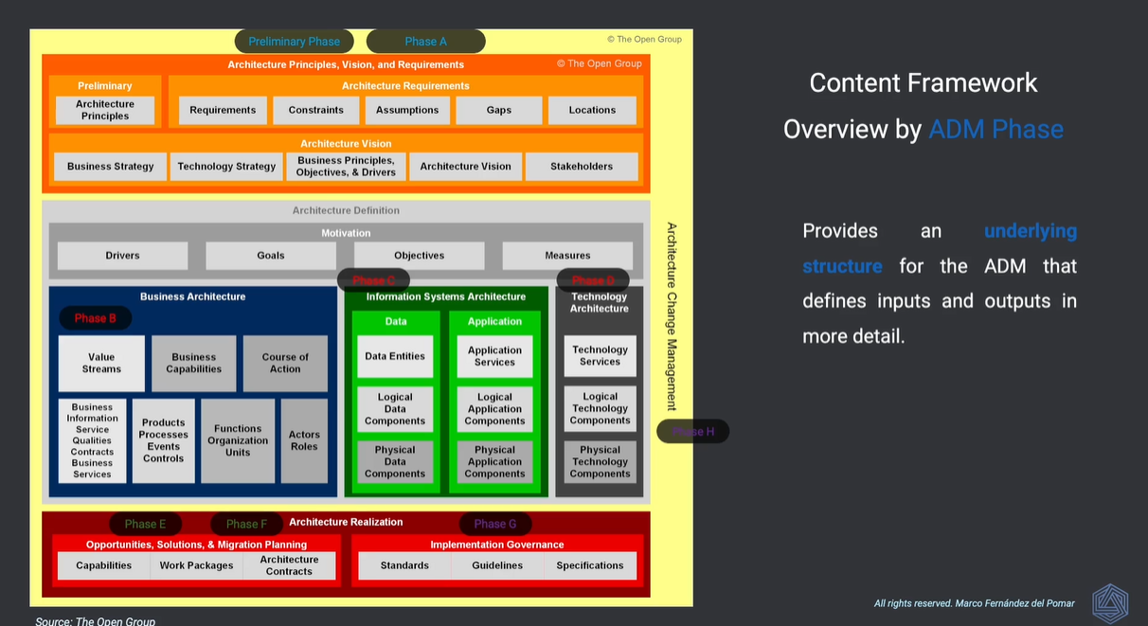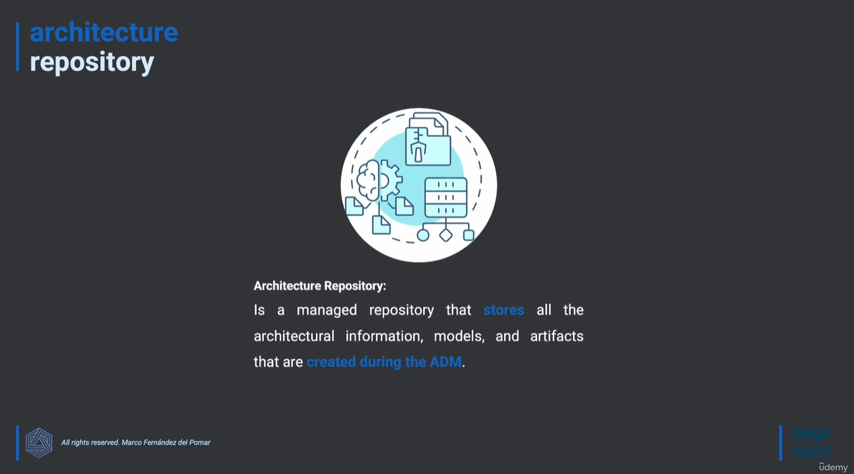

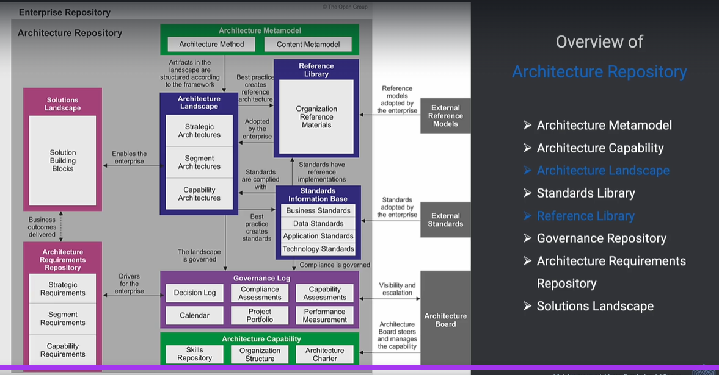

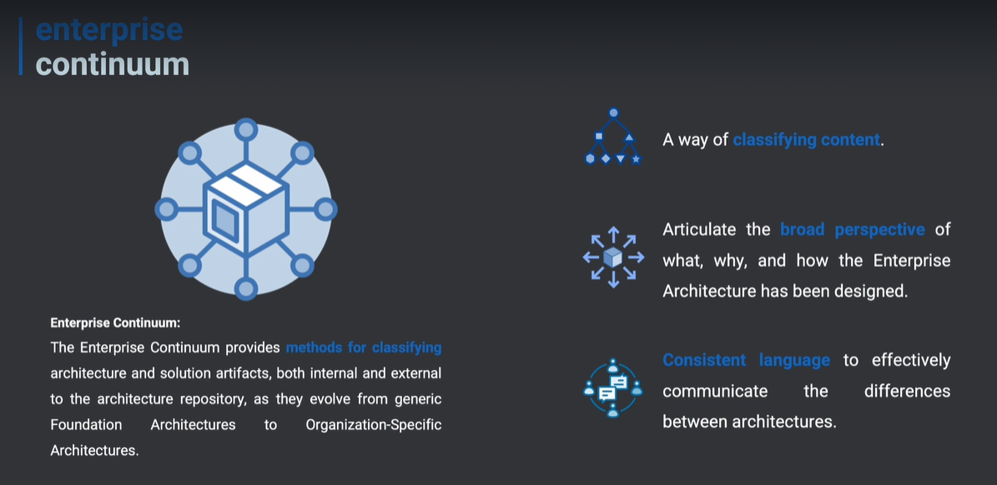

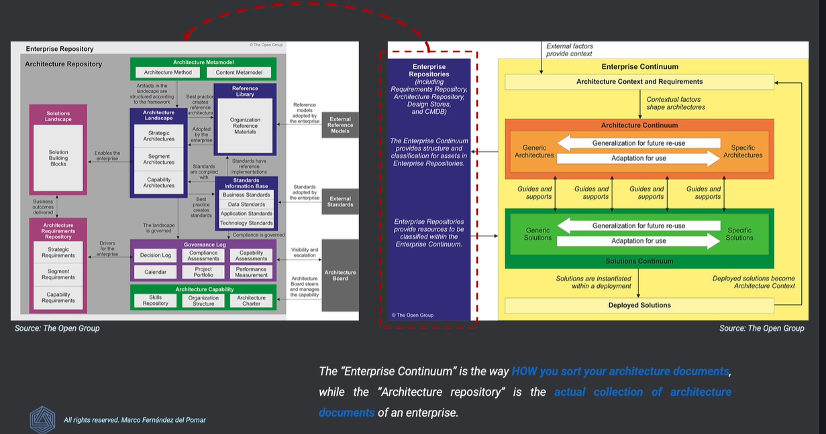

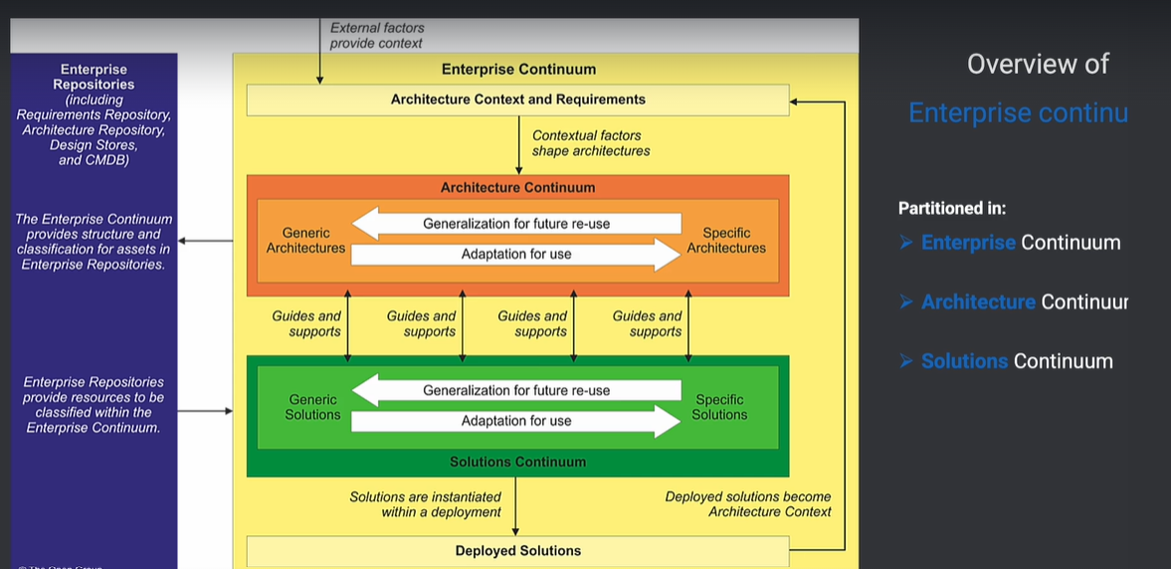

**Reading Material 2**

**Link:** [**https://www.youtube.com/watch?v=JMb2jt1K3Js&list=PLiKi2fmsDHN6vBv9c5QjtctIin8jpFYM9&index=1**](https://www.youtube.com/watch?v=JMb2jt1K3Js&list=PLiKi2fmsDHN6vBv9c5QjtctIin8jpFYM9&index=1)

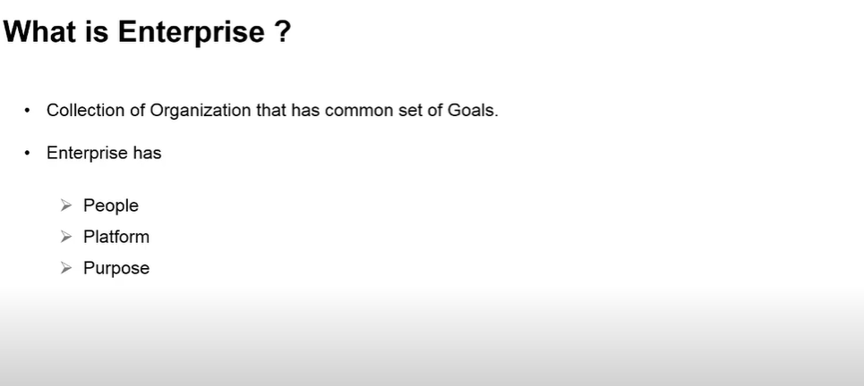

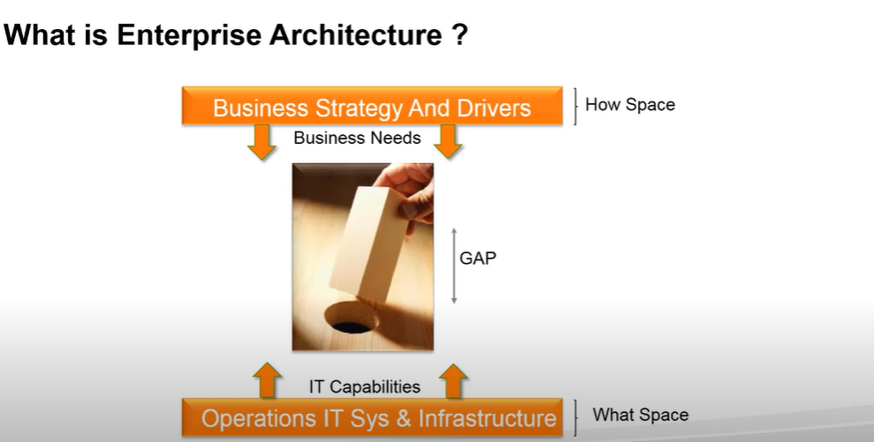

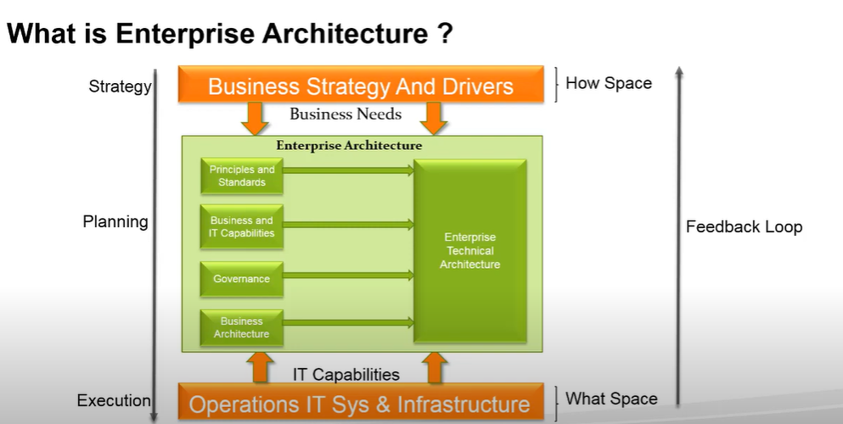

**EA must do less with Technology and more with methodology**

**Best Example:**

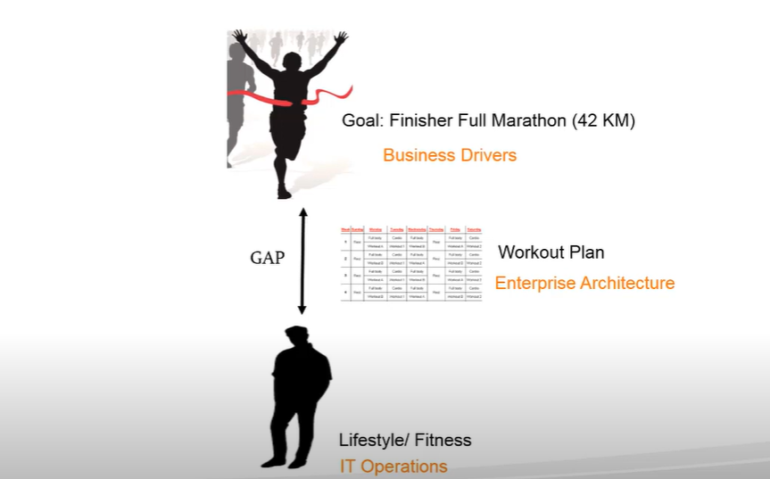

Enterprise architecture is about identifying and addressing the gaps between the capabilities and the business goal.

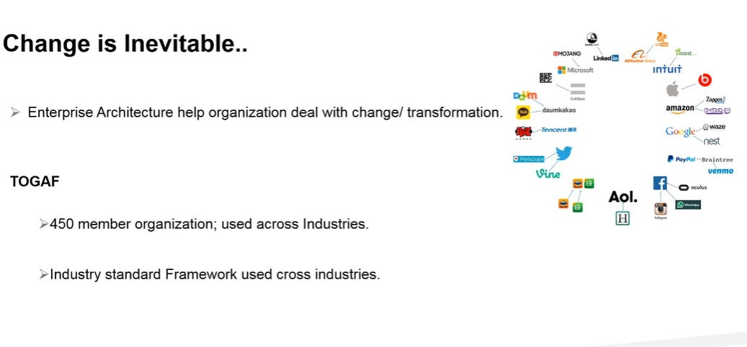

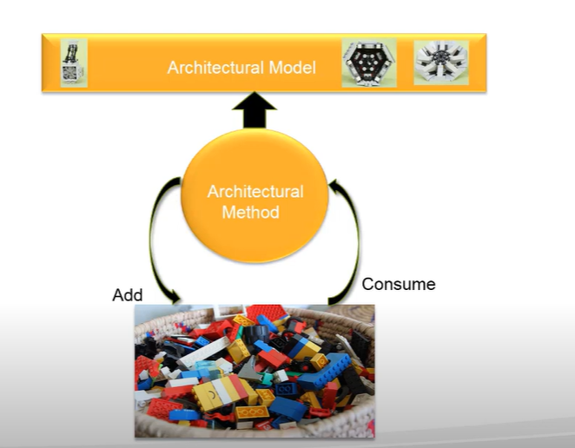

TOGAF it's about a framework it has a building block which are in enterprise continuum a architecture development method and an architecture model in the process it gives you tools and guidance along the way but essentially TOGAF contains container method and deliverables.

**Enterprise Architecture Certification Training - Basic Concepts**

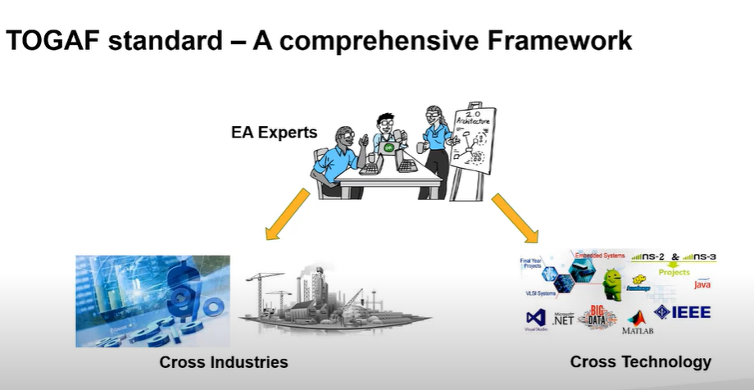

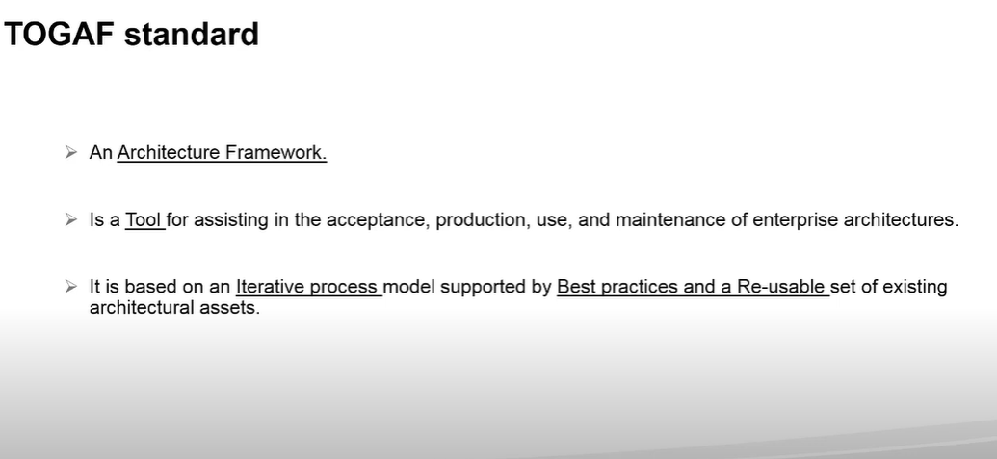

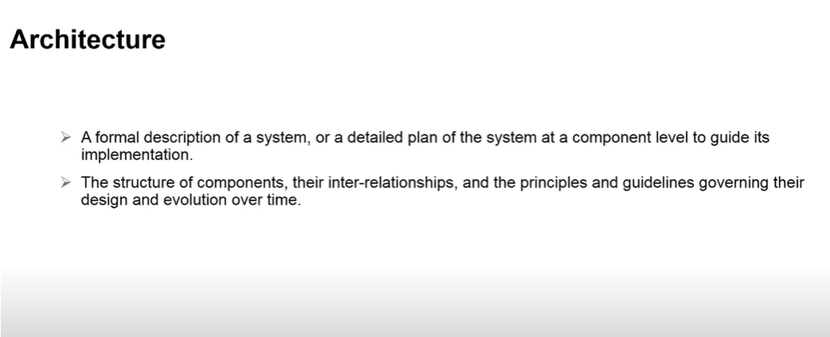 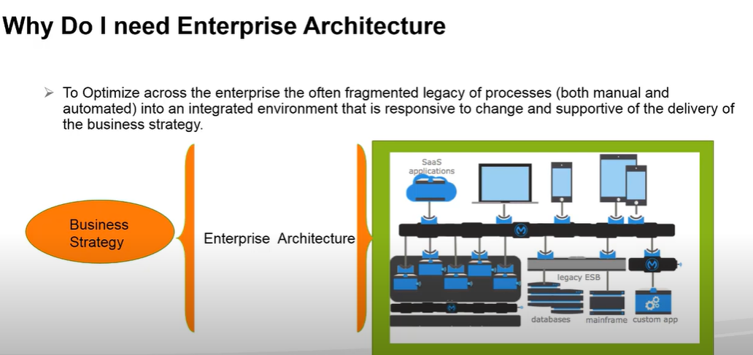

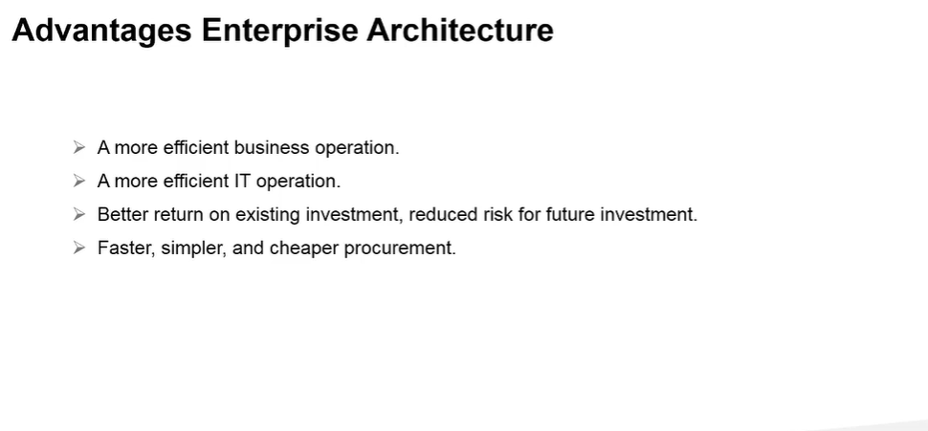

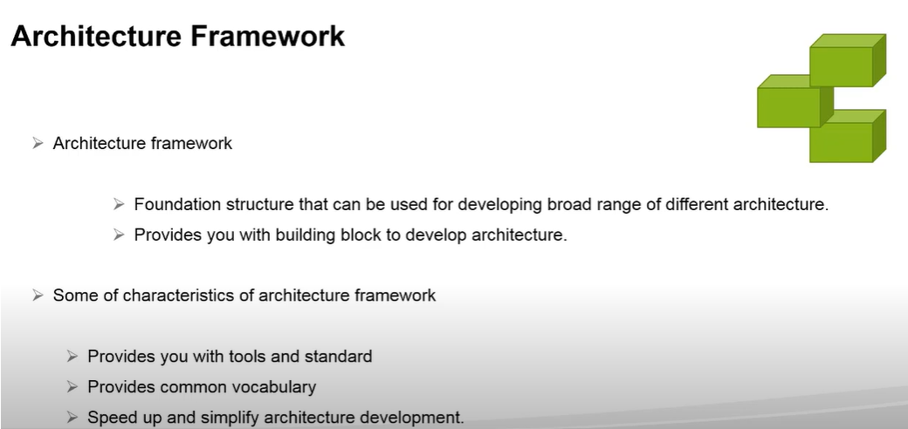

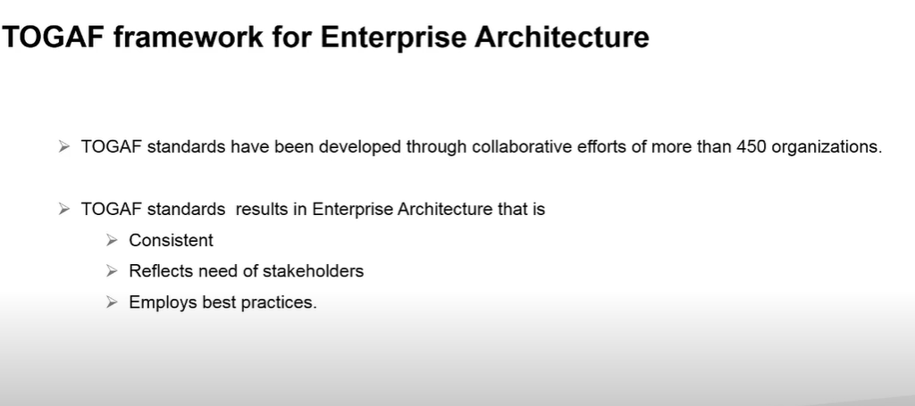

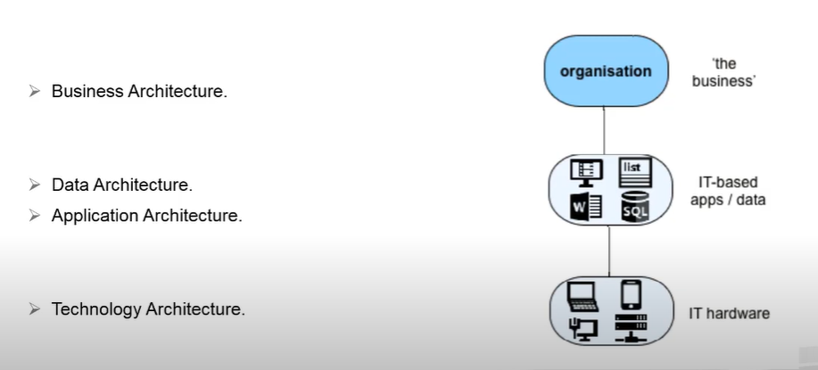

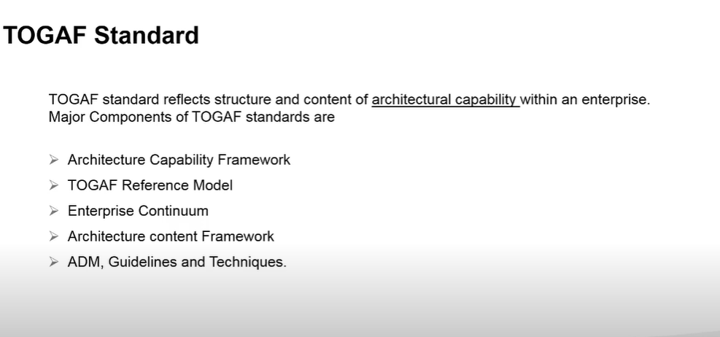

**TOGAF Standard is a framework and method for architecture development**

**Questions** :

|  |  |
| --- | --- |
|  | s |
| s |  |

**Enterprise Architecture Certification Training - Understand Enterprise Continuum**

**Enterprise Continuum is a view of Architecture Repository**

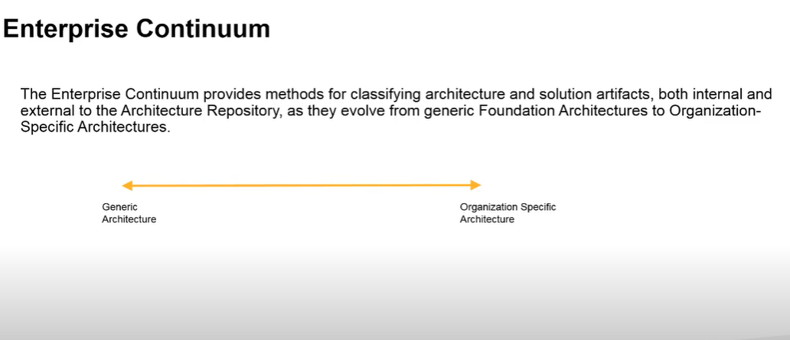

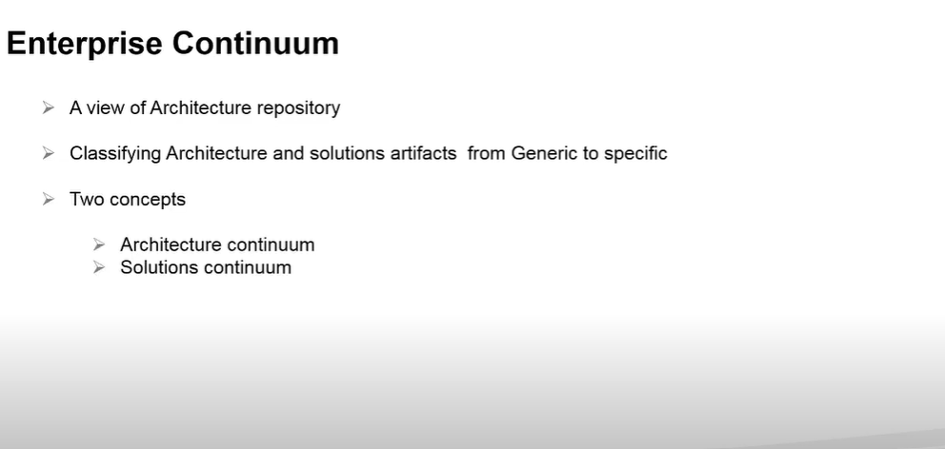

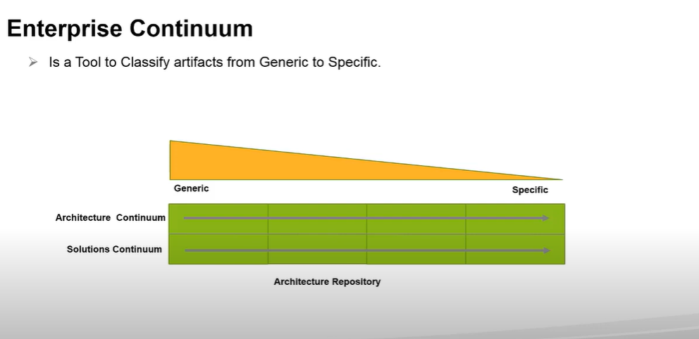

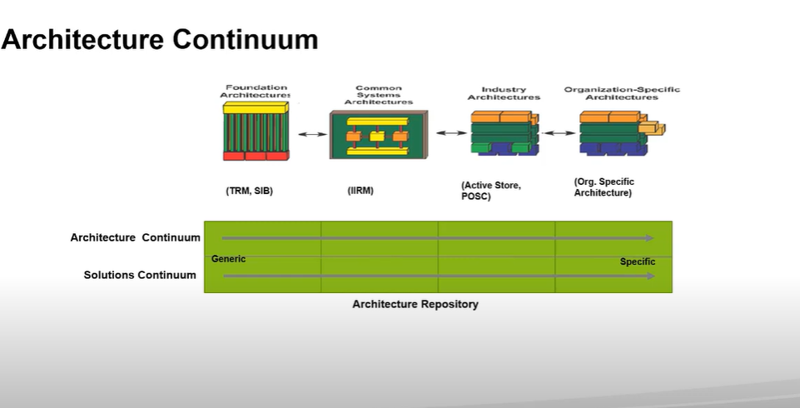Architecture Continuum is the requirement and Solution Continuum in the actual implementation

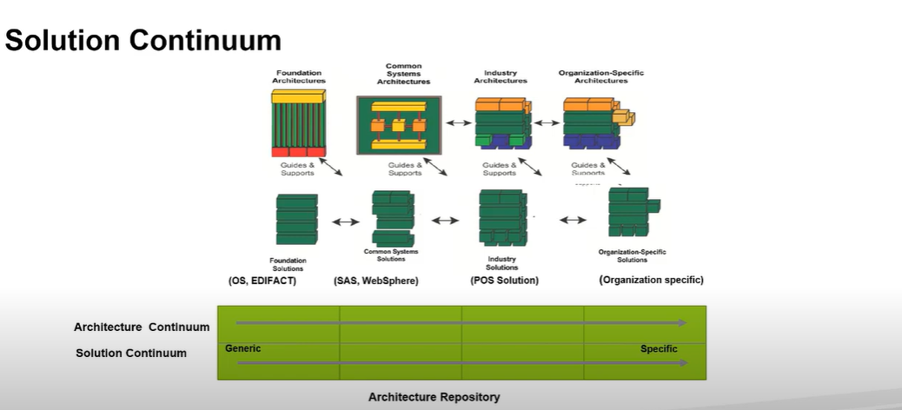

**Questions:**

|  |  |
| --- | --- |
|  |  |
|  |  |
|  |  |

**Enterprise Architecture Certification Training - Intro to Architecture Development Iteration**

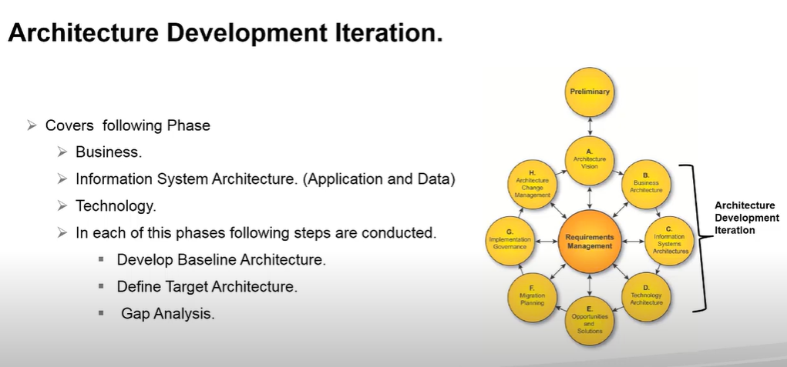

**Enterprise Architecture Cert Training - Architectural development method (ADM) -TOGAF course**

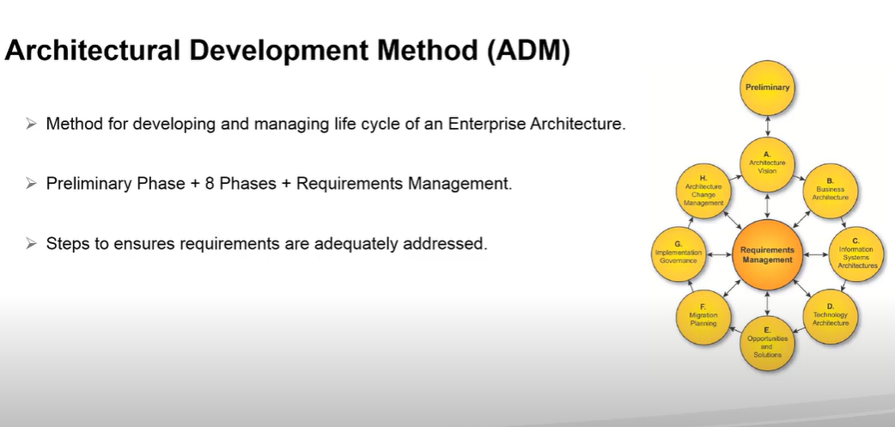 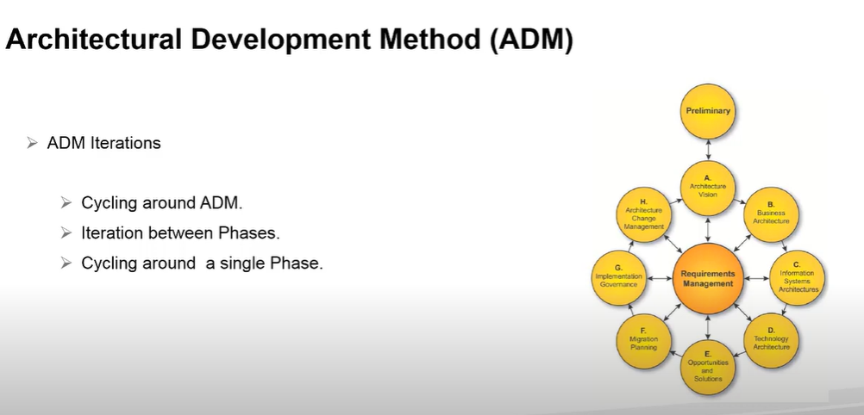 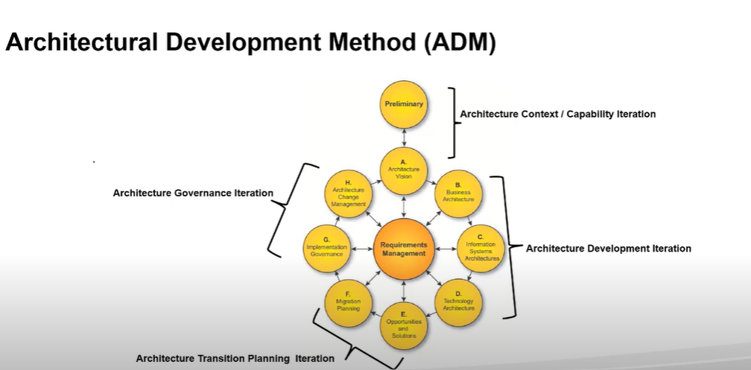

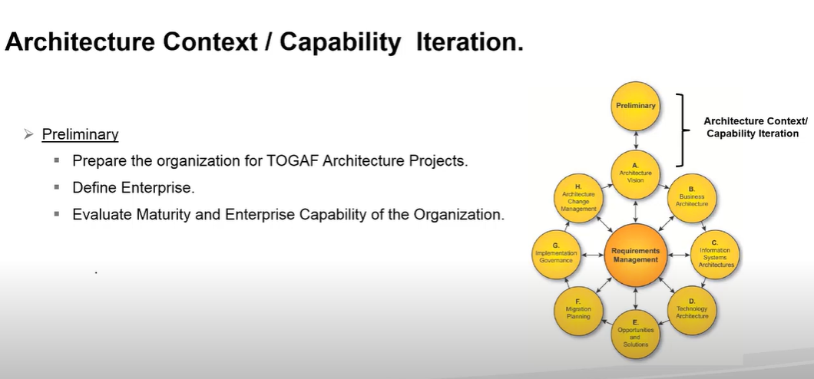 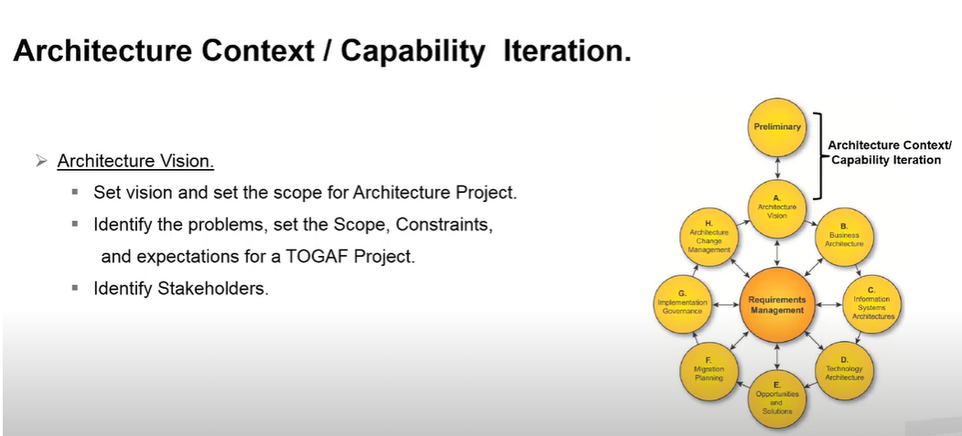

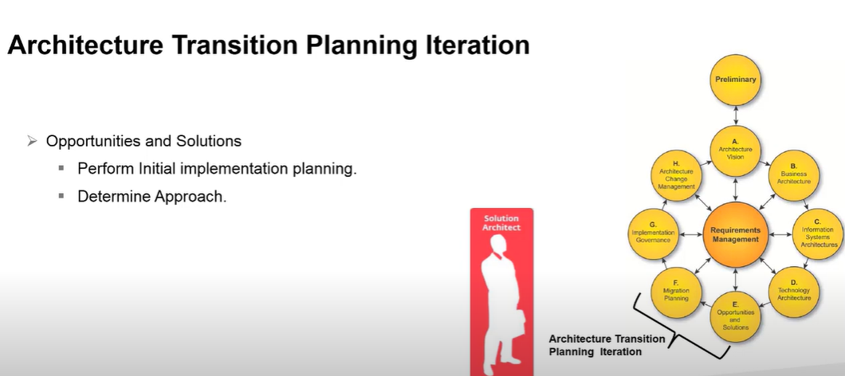 s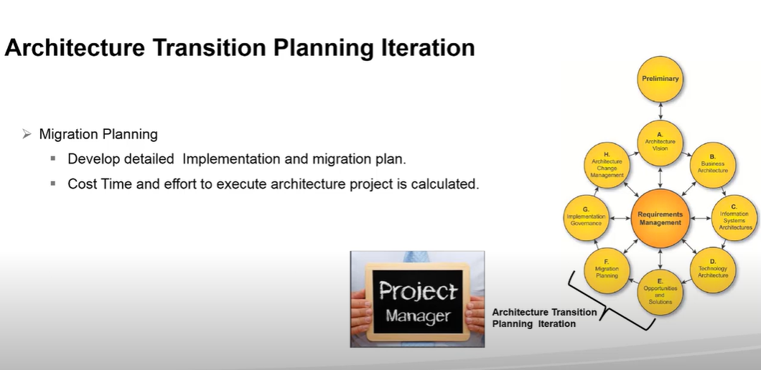 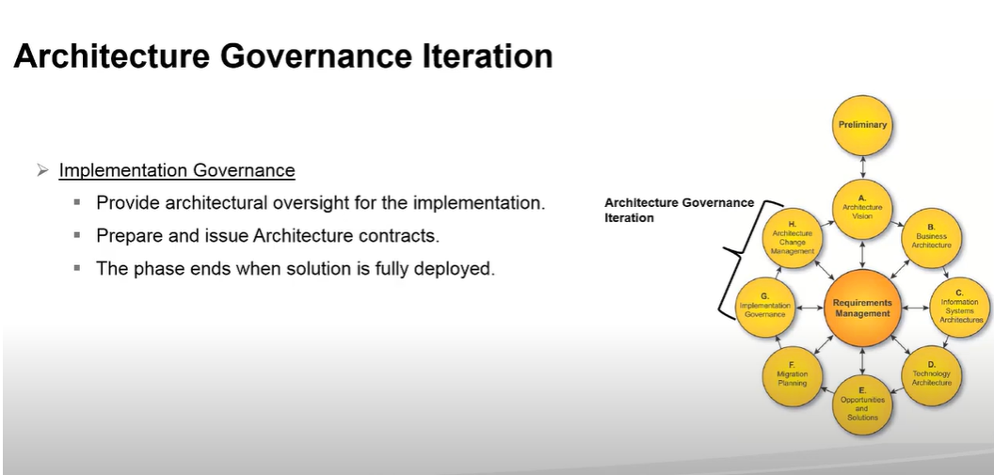 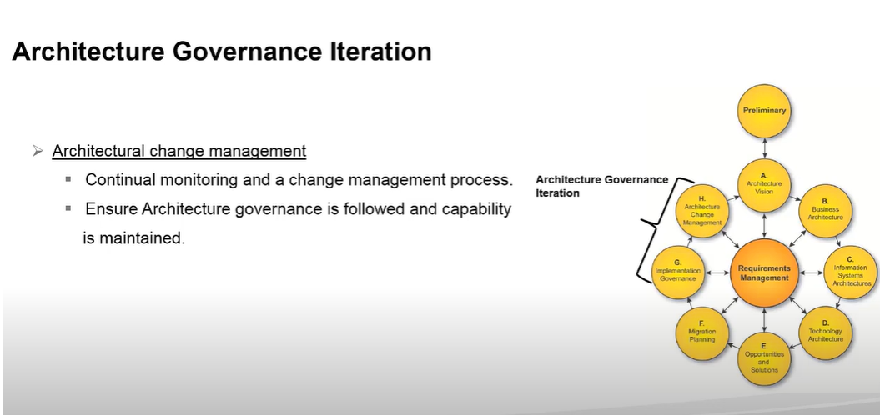

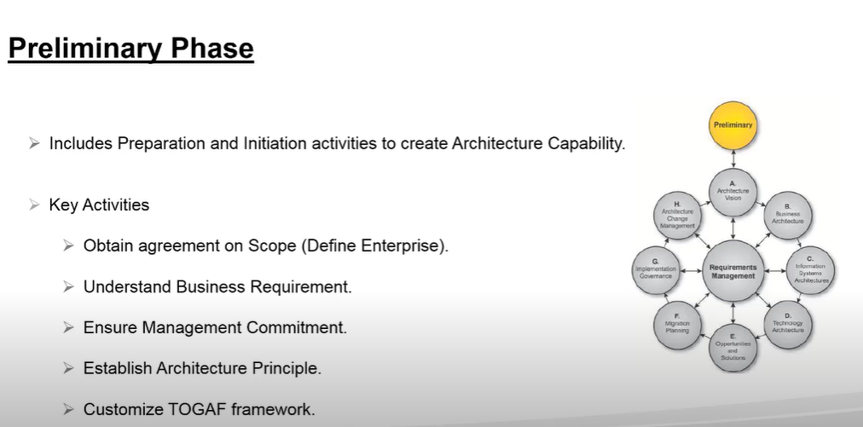

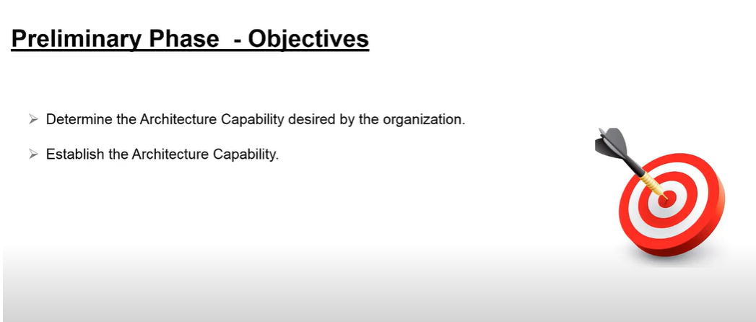

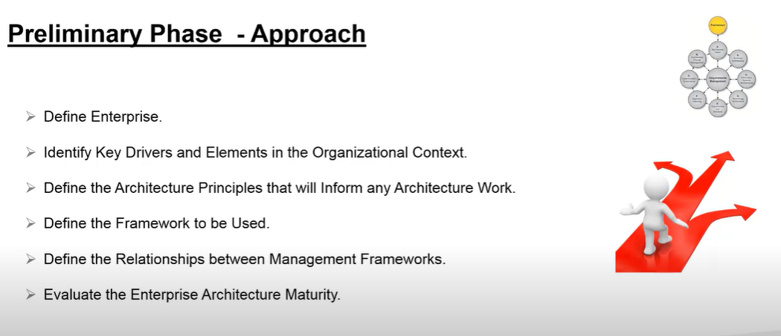

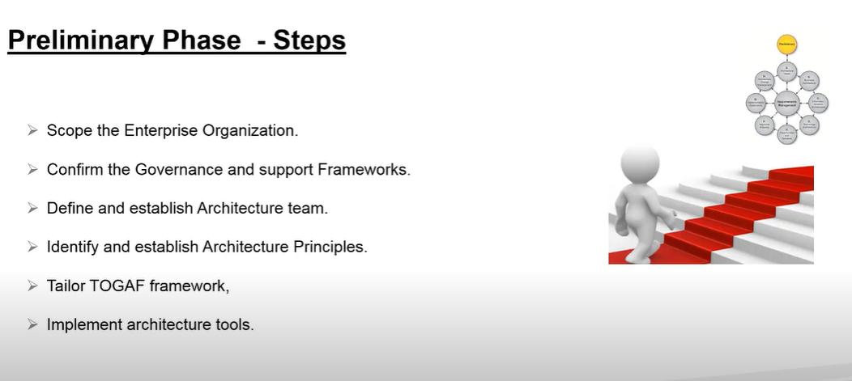

**Architecture Vision**

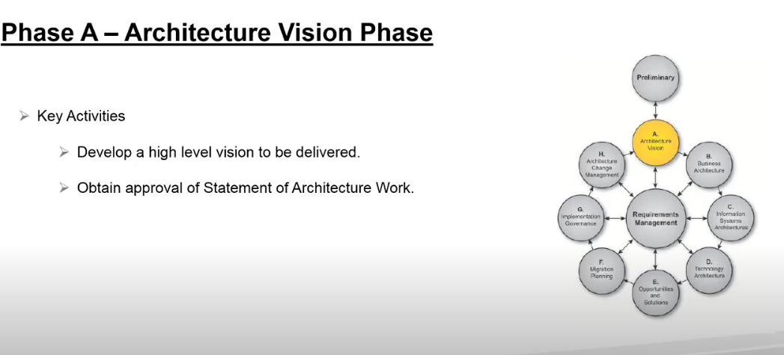

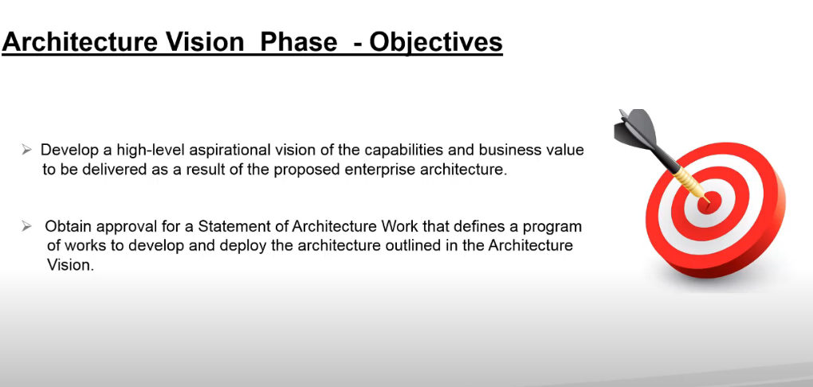

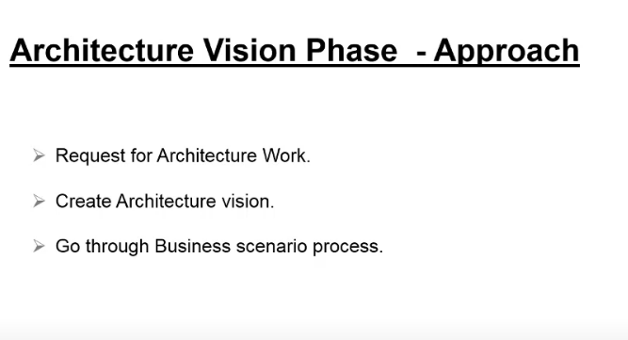

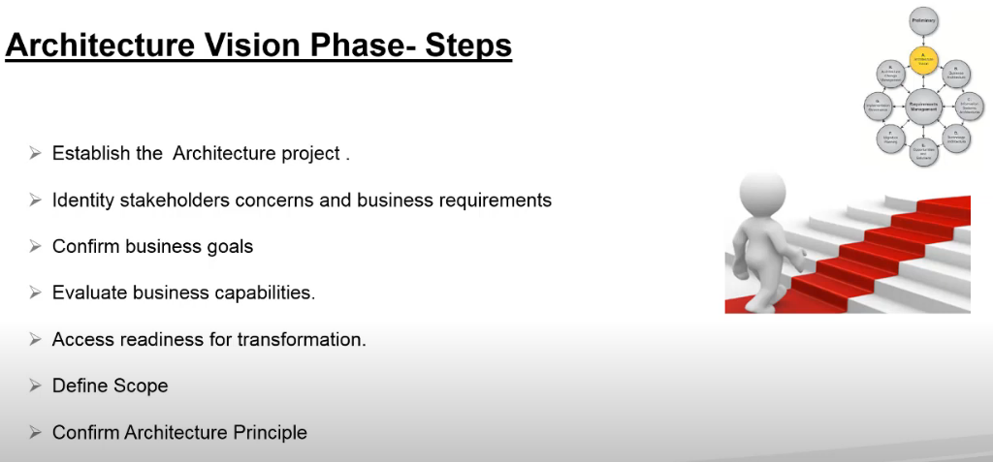

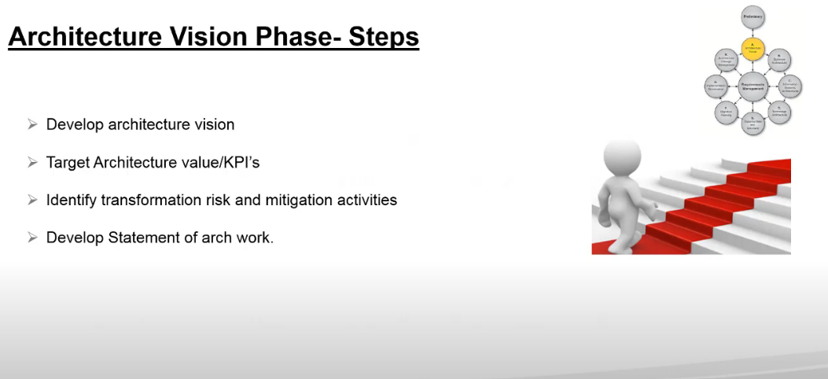

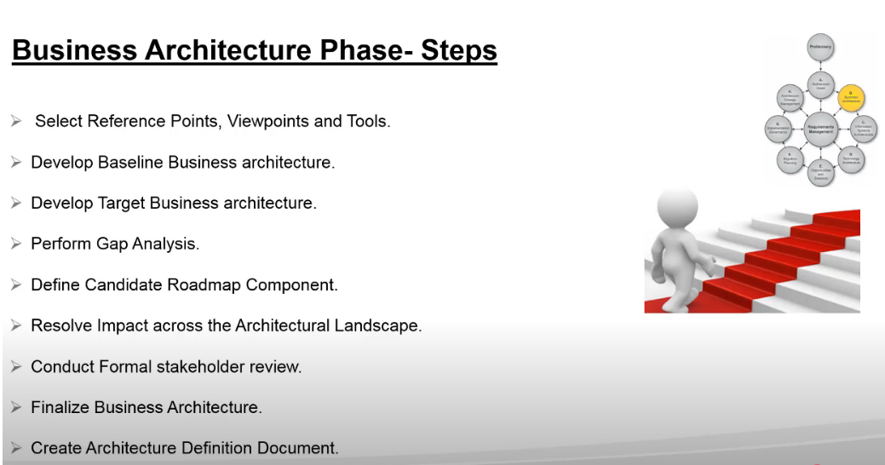

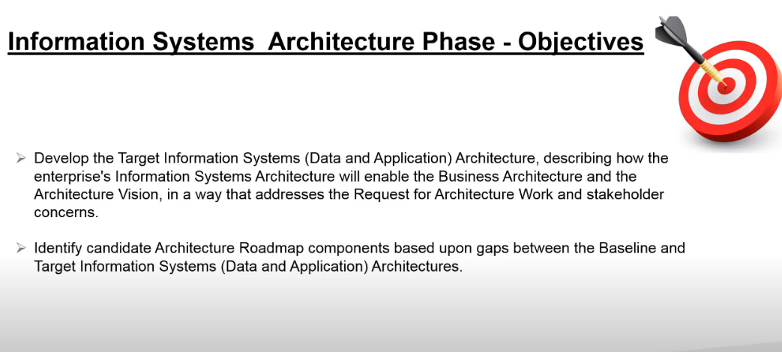

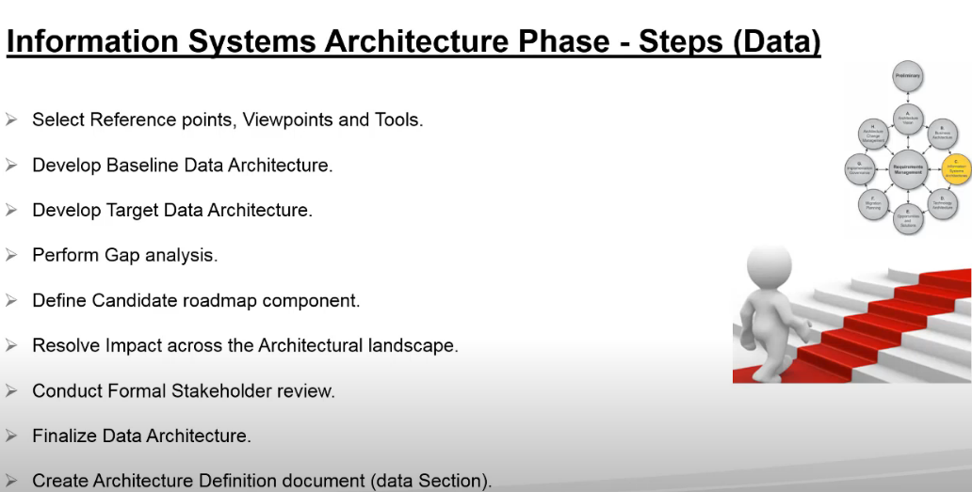

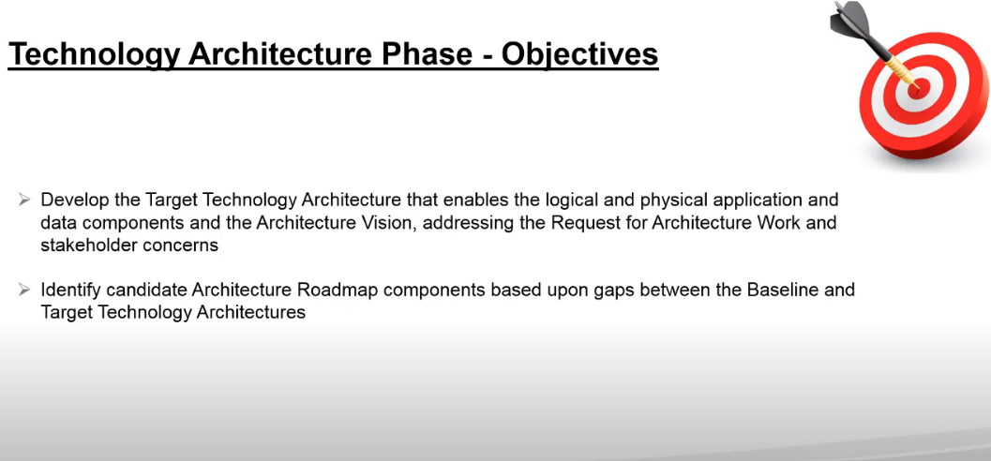

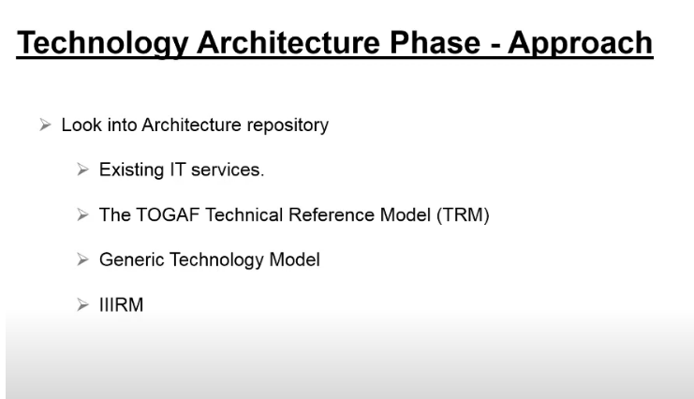

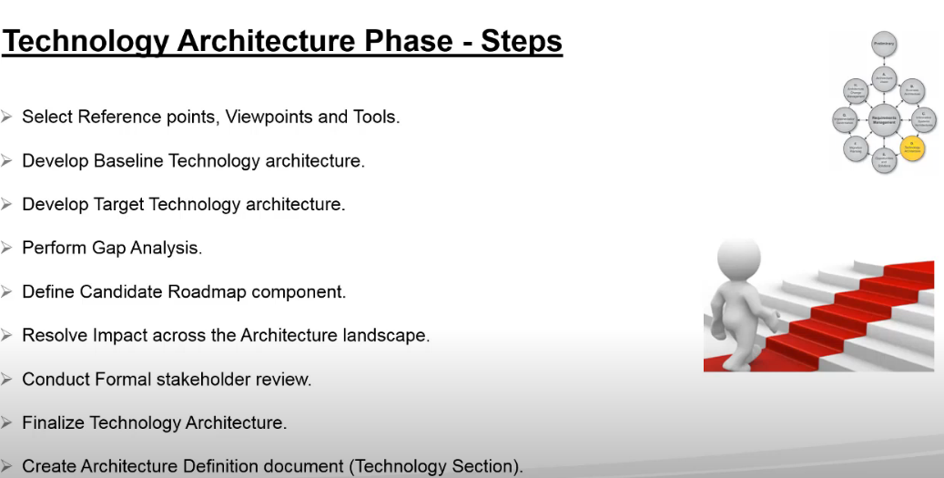

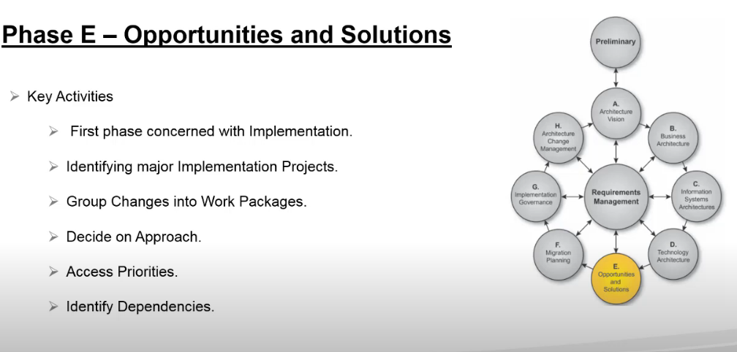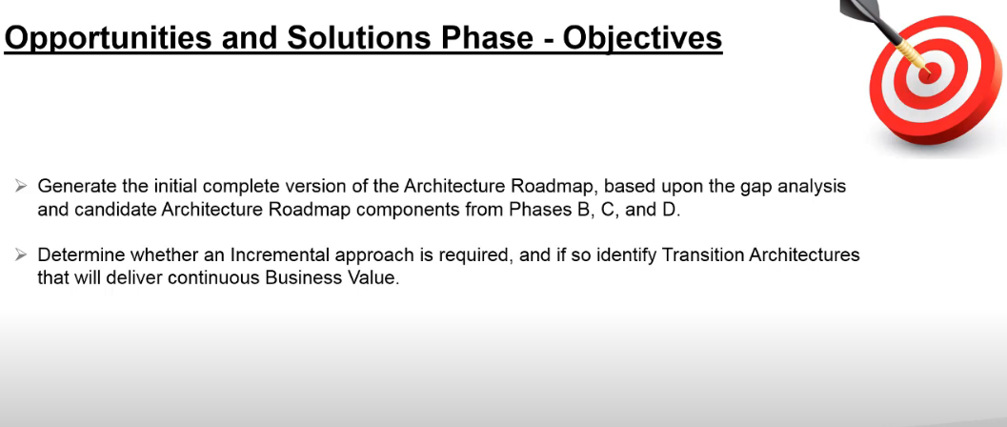

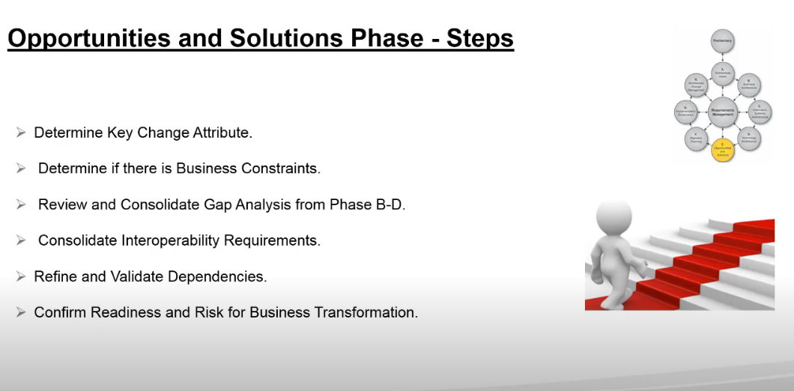

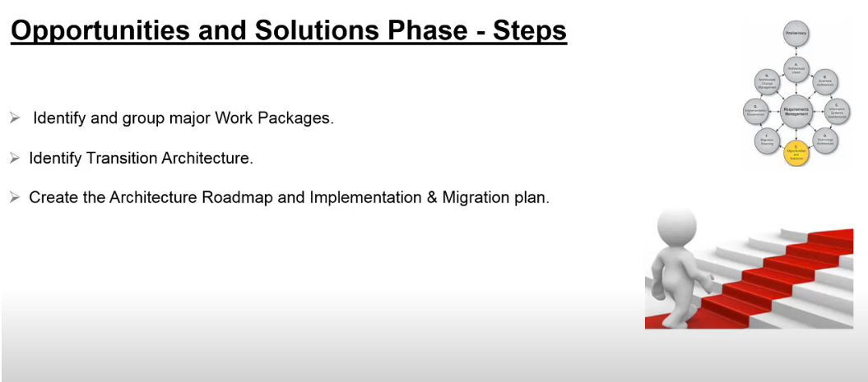

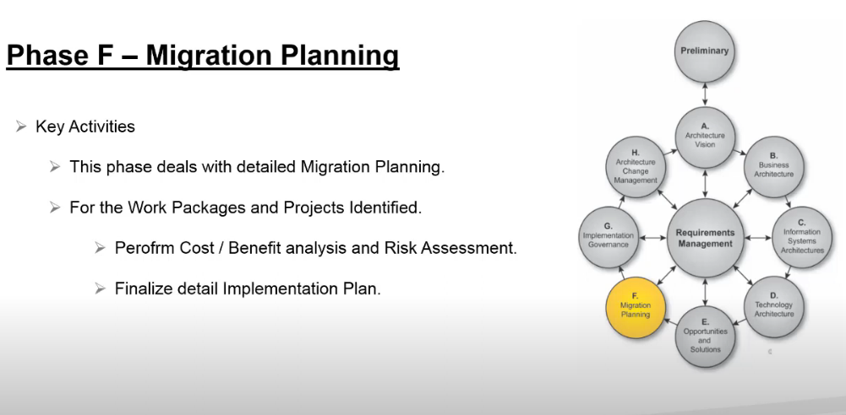

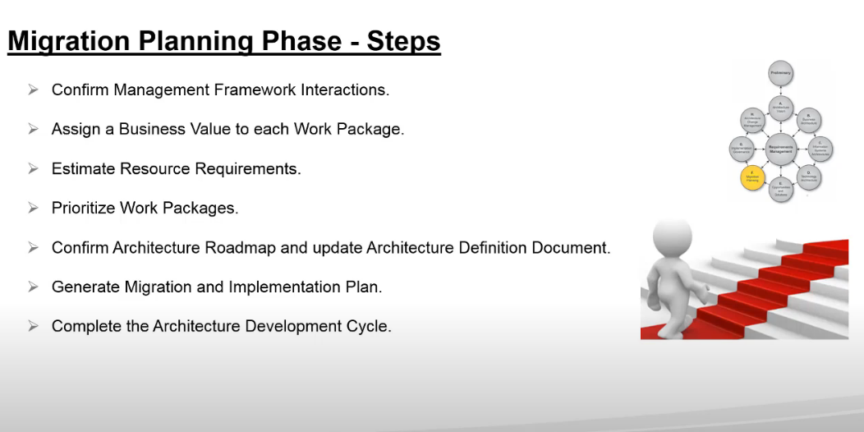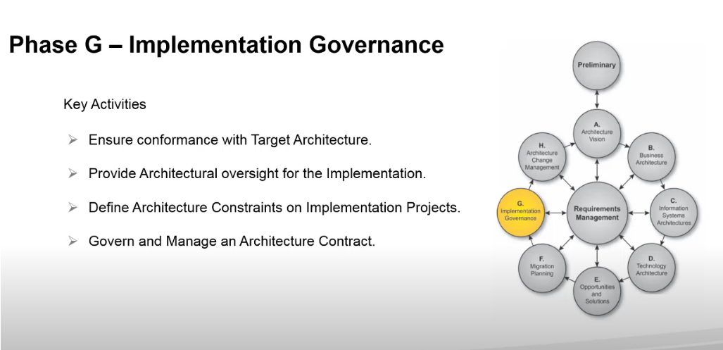

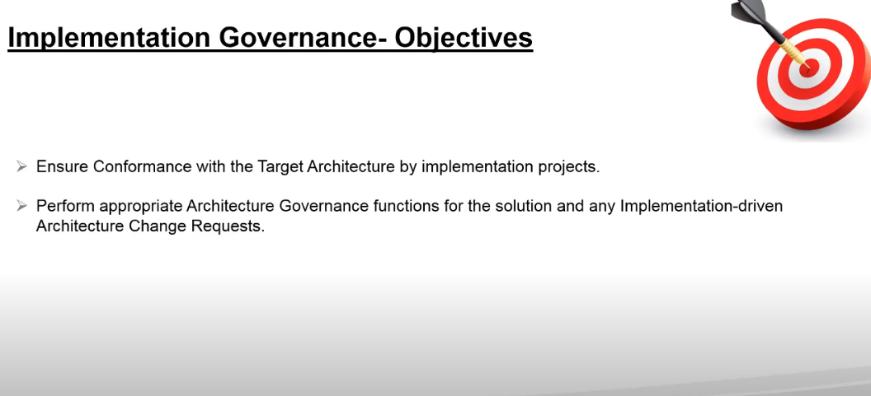

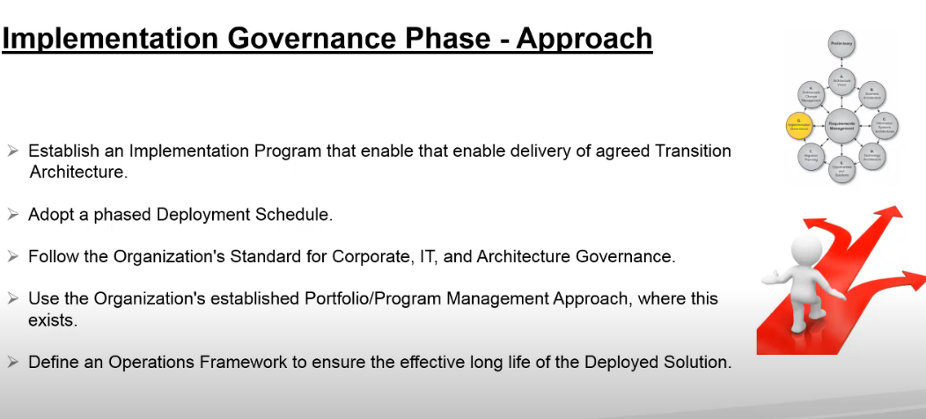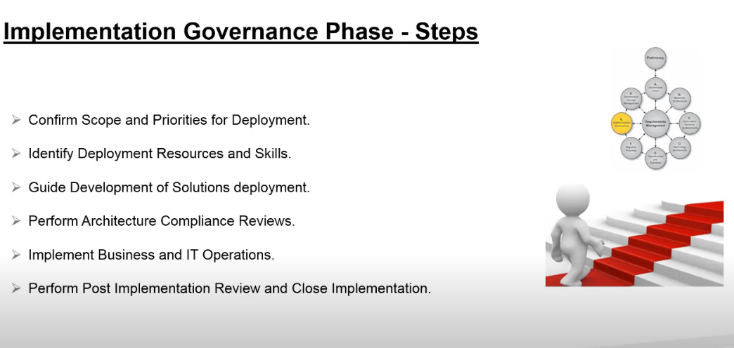

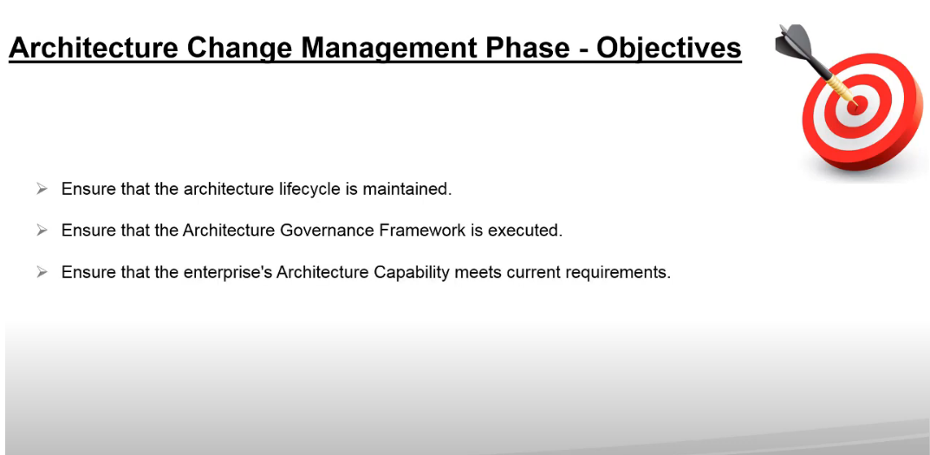

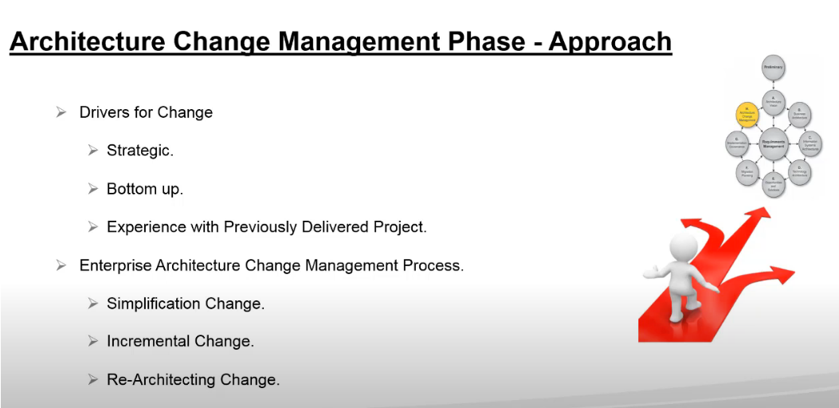

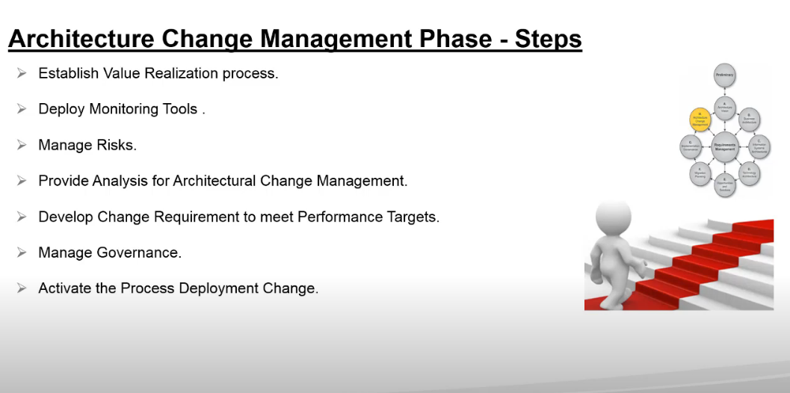

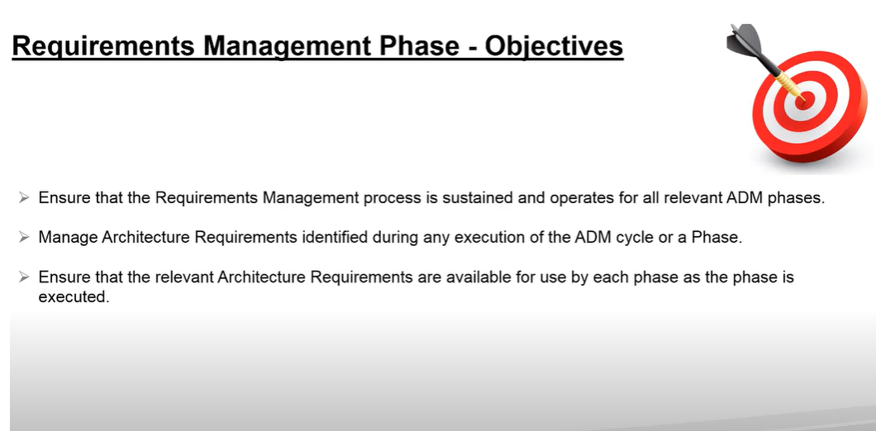

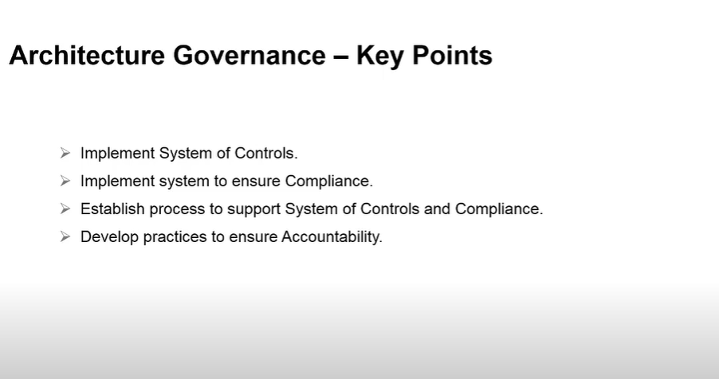

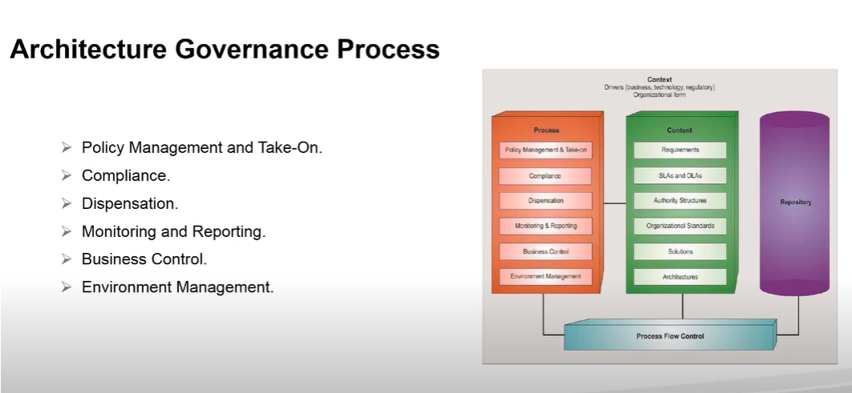

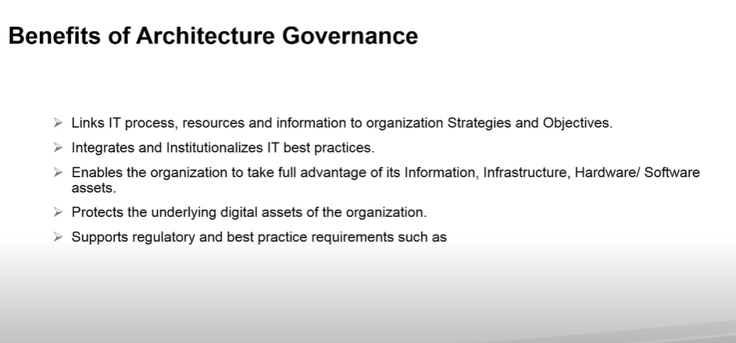

**Architecture Governance**

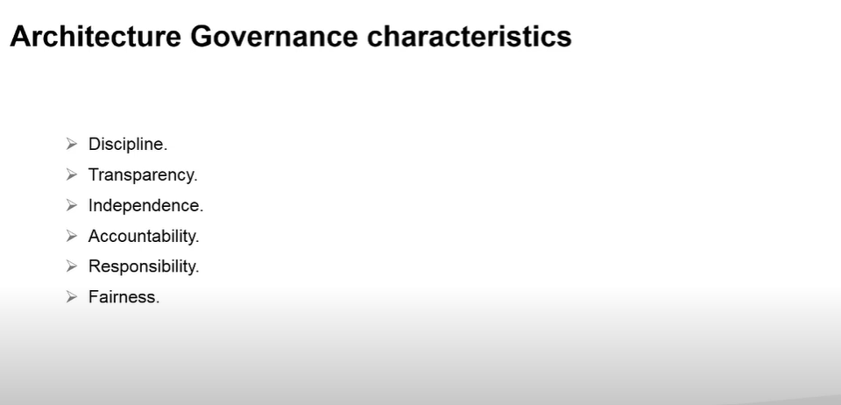

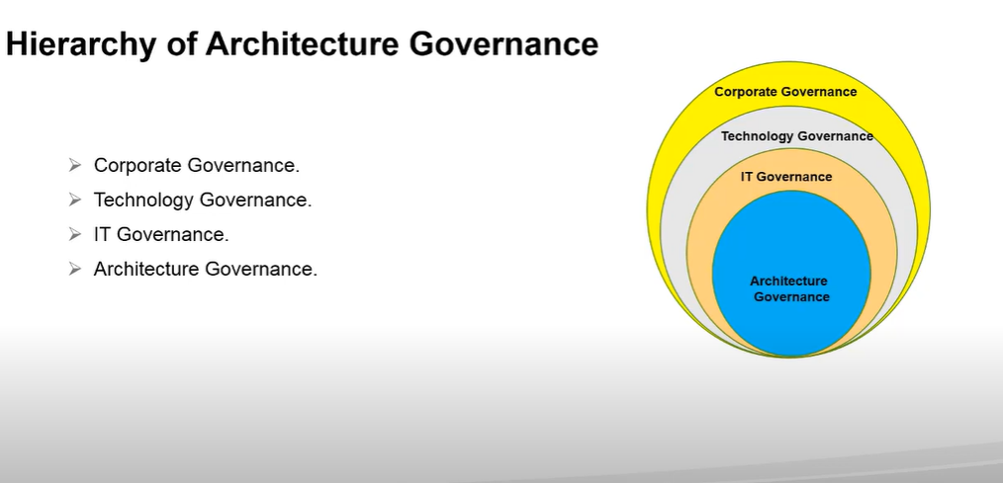

**Views and View Points**

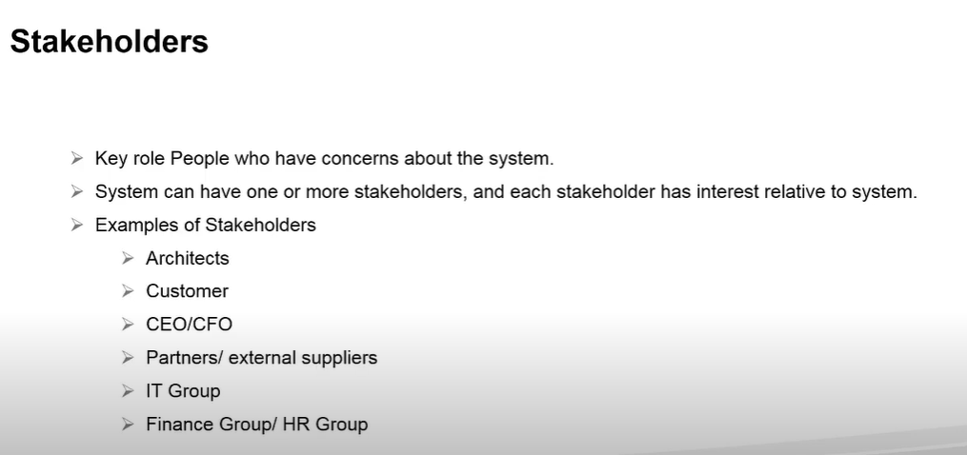 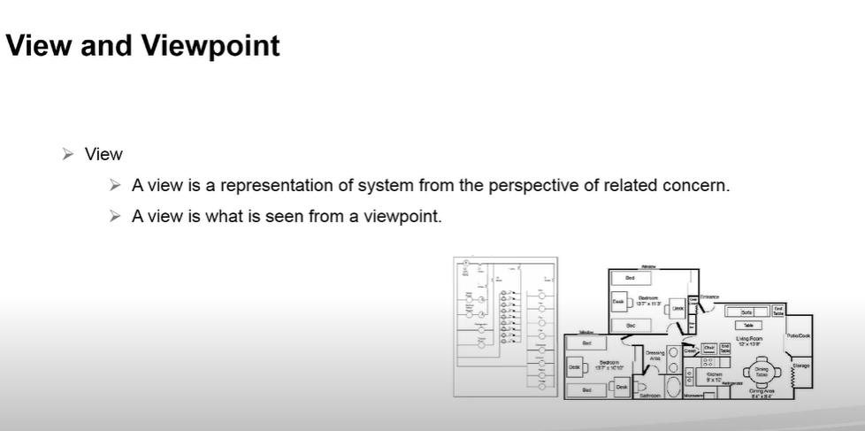

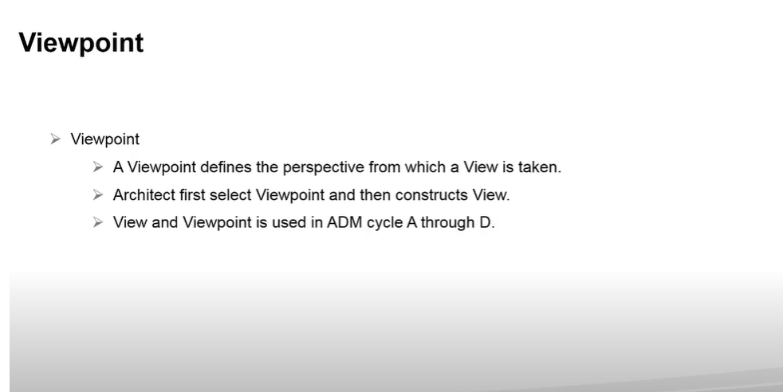 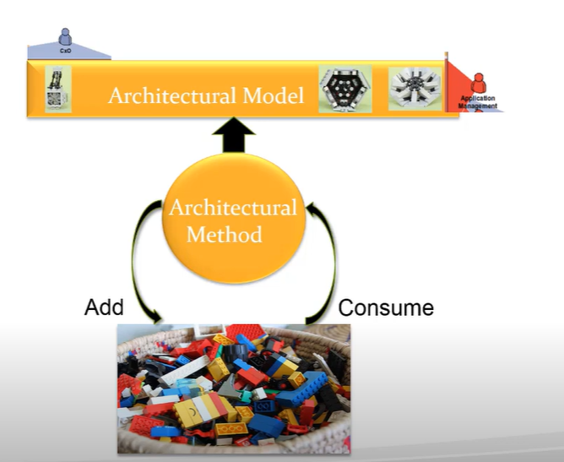

**Building Blocks**

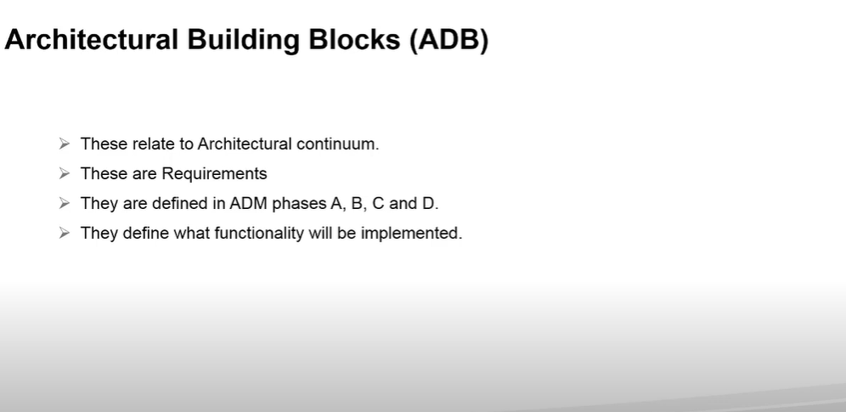

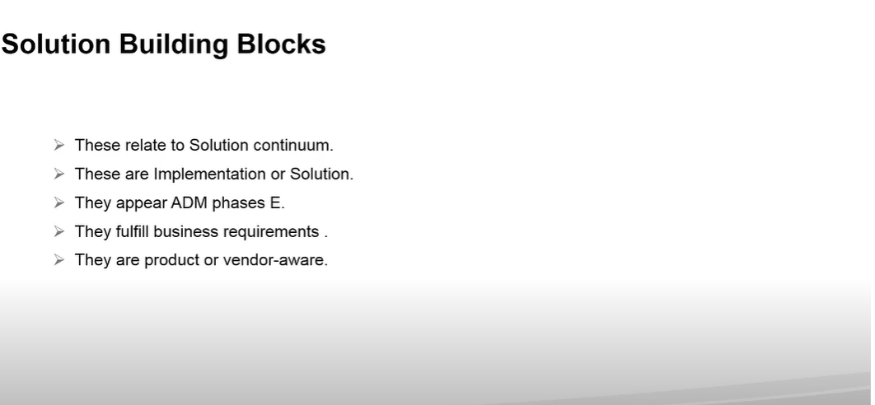

**TOGAF reference Models**

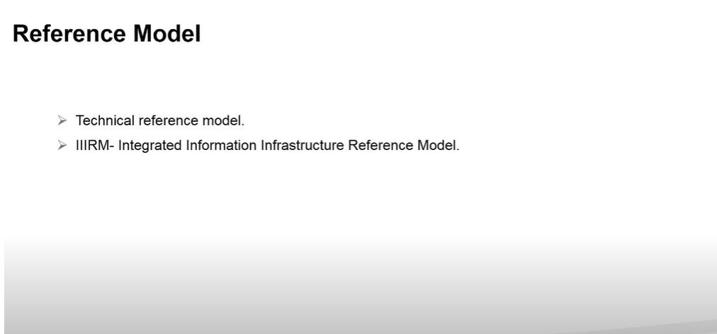

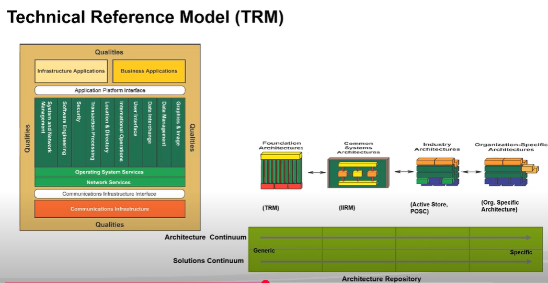

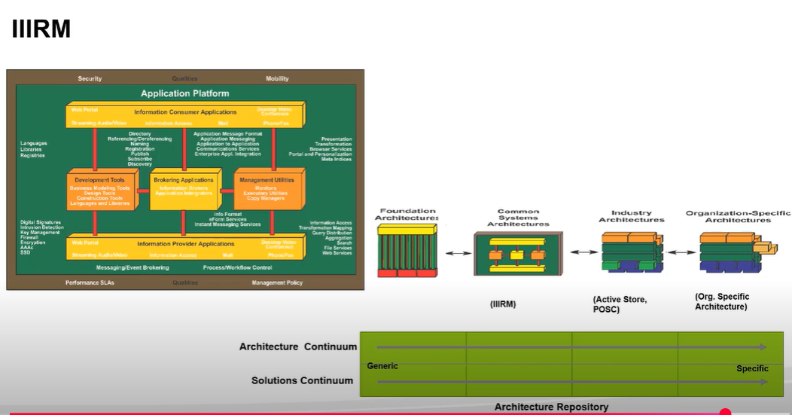

**Applying the ADM Across the Architecture Landscape**

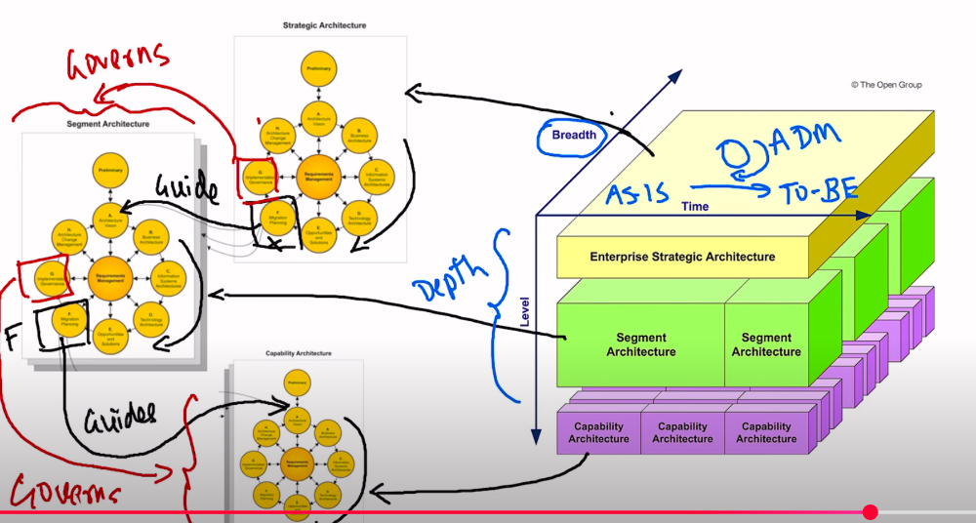

**Additional Notes:**

1. In TOGAF**, architecture patterns** provide a contextual solution to a problem, describing how different elements (often represented by building blocks) work together. Building blocks, on the other hand, represent specific components or functionalities that can be part of a pattern.

Reference: <https://pubs.opengroup.org/togaf-standard/adm-techniques/chap04.html>, <https://pubs.opengroup.org/togaf-standard/architecture-content/chap05.html>

1. Building blocks represent specific architectural components, and they can be assembled or organized in a manner that fits specific architectural patterns.
2. Reference: https://pubs.opengroup.org/togaf-standard/architecture-content/chap05.html
3. https://pubs.opengroup.org/togaf-standard/adm-techniques/chap04.html
4. The Enterprise Continuum supports the ADM by providing a structured way to leverage existing architectural assets during the architecture development process.
5. The Enterprise Continuum is a view of the Architecture Repository that provides methods to classify architecture and solution artifacts. It's not just a database or a lifecycle process, but a comprehensive view of all architectural assets.
6. The Architecture Repository in TOGAF is a structured way to capture and manage outputs throughout the ADM. It stores both the current (baseline) and future (target) states of the architecture. Reference: https://pubs.opengroup.org/togaf-standard/architecture-content/chap07.html
7. Non-architectural documents can provide valuable external input to the architectural process. These might include market studies, regulatory standards, or other documents not inherently architectural but still influential.
8. A viewpoint defines the perspective, and a view is the representation of the system from that perspective.
9. Matrices are used to show relationships between different architectural components, often in a two-dimensional format.
10. The Architecture Capability Framework is essential for establishing, maintaining, and using an architecture capability that aligns with business goals and operates effectively.
11. The Implementation Factor Catalog in TOGAF serves to document a comprehensive list of factors that could impact the architecture implementation and migration plan, thereby aiding in the formulation of a more effective and realistic plan that accounts for various contingencies and dependencies.
12. The TOGAF TRM is a fundamental architecture that provides a foundational structure upon which more specific, tailored architectures can be developed.
13. Generic Skills, Business Skills & Methods, Enterprise Architecture Skills, Program or Project Management Skills, Legal Environment, IT General Knowledge Skills."  
    This choice is correct and aligns closely with the categories defined in the TOGAF Architecture Skills Framework, covering a comprehensive range of skills necessary for an Enterprise Architect. Reference: <https://pubs.opengroup.org/togaf-standard/architecture-skills-framework/index.html#_Toc95293209>
14. Phase G: Implementation Governance oversees the implementation of the architecture, ensuring that the realization of the architecture conforms to the defined specifications.
15. Phase H: Architecture Change Management ensures that the architecture remains relevant and responsive to the changing needs of the business. It manages changes to the architecture in a cohesive and architected way.
16. The Architecture Definition Document provides a high-level representation of the architecture, often serving as a contractual means between stakeholders.
17. The Architecture Requirements Specification provides a set of quantitative statements that outline what an implementation project must do in order to comply with the architecture. An Architecture Requirements Specification will typically form a major component of an implementation contract or contract for more detailed Architecture Definition.
18. GRM (Governance Reference Model) and MSA (Microservices Architecture) are foundational reference models included in the TOGAF standard. They provide a foundation for guiding and developing an organization-specific architecture
19. Diagrams are used to provide a visual representation of various aspects of the architecture, often capturing the high-level structure and relationships.
20. The Preliminary Phase in ADM is all about preparing for the architecture development by defining the framework, tools, principles, and more.
21. Establishing architecture governance in the Preliminary Phase ensures that there's a structured approach to overseeing and guiding the architecture development. It's crucial for the effective operation of the architecture function.
22. Phase E, Opportunities and Solutions, involves identifying and defining Transition Architectures that provide a clear path and intermediate steps between the current state (Baseline Architecture) and the desired future state (Target Architecture).
23. Building blocks in TOGAF typically go through a lifecycle of Proposal, Evaluation, Adoption, and eventually Obsolescence
24. What is a viewpoint library?: A viewpoint is a specification of stakeholder's perspective, so a viewpoint library is a collection of them.
25. While technology can play a role in business transformation, the Business Transformation Readiness Assessment focuses more on organizational, cultural, and strategic factors rather than specific technology choices.
26. **Catalog Definition**: A structured **list of architectural elements** relevant to a specific architecture domain (business, application, data, or technology).
27. **Matrix Definition**: A **2-dimensional table** showing **relationships between architectural elements** in catalogs.
28. **Diagram Definition**: A **graphical representation** of architectural elements and their interrelationships.
29. Architecture Maturity Models in TOGAF are used to evaluate the maturity level of architecture capabilities, helping organizations understand their current state and areas for improvement.
30. Architecture principles should be defined in Preliminary Phase. They should provide clear, enduring guidance that can adapt to changes and support decision-making.
31. In the context of ADM iterations, 'depth' pertains to how detailed or granular the iteration is, while 'breadth' refers to its scope across the organization.
32. Deliverables are contractually specified and contain artifacts. Artifacts represent specific classes of architectural output, and building blocks represent architectural components at various levels of abstraction.
33. Artifacts in TOGAF are a means of describing the architecture in a form that provides a guide for stakeholders, and which enables a clear understanding, governance, and evolution of the architecture. They can be in the form of diagrams, specifications, tables or compilations and can be at varying levels of detail
34. Architecture landscapes: The Strategic Architecture provides a long-term view of the organization's architecture, often looking several years into the future. It is not focused on detailed designs or specific projects.
35. A Business Scenario is a uniform description of: - Real business problems - The business and technology environment in which those problems occur - Value streams enabled by capabilities - The desired outcome(s) of proper execution - The human and computing components (the “actors”) who provide the capabilities
36. In which phase(s) of the ADM would you deal with the actions resulting from a transformation readiness assessment? -- Initial Transformation Assessment done in Phase A Further review and confirm into in Phases E then F
37. Strategy Portfolio Project Solution Delivery are the four purposes that typically frame the planning horizon, depth and breadth of an Architecture Project.
38. **Business, Data, Application, Technology** – These are the **architecture domains**, not the scoping dimensions themselves.
39. **Strategy, Portfolio, Project, Solution Delivery** – These refer to the **purposes of architecture** (as per TOGAF Series Guides), not scoping dimensions
40. Four dimensions used to scope an architecture. **Breadth, Depth, Time Period, Architecture Domains**

* To define the initial implementation plans -- ADM Phase E
* To perform architectural oversight for the implementation – ADM Phase G

Implementation Governances

* Validation of business principles, goals, and strategic drivers- ADM Phase A -Architecture Vision

1. Architecture Principles in TOGAF provide a set of general rules and guidelines that govern the architecture process. Their primary purpose is to guide decision-making by establishing an objective framework, reducing subjectivity and bias.
2. Risk Management - Striking a balance between positive and negative outcomes resulting from the realization of either opportunities or threats.
3. There is often more than one possible Target Architecture that would conform to the Architecture Vision, Architecture Principles, and Requirements. It is important to identify alternative Target Architectures and build understanding of different possibilities and identify trade-offs between the alternatives. Creating an architecture normally requires trade-offs among competing forces. Presenting different alternatives and trade-offs to stakeholders helps architects to extract hidden agendas, principles, and requirements that could impact the final Target Architecture. **What can architect present to stakeholders to extract hidden agendas, principles, and requirements that could impact the final Target Architecture? -- Alternatives and Trade-offs**
4. Understanding the readiness of the organization to accept change, identifying the issues, and then dealing with them in the Implementation and Migration Plans is key to successful architecture transformation in Phases E and F. This will be a joint effort between corporate (especially human resources) staff, lines of business, and IT planners.
5. Which of the following best describes the purpose of an Architecture Definition Document? --**To act as a deliverable container for artifacts created during a project.**
6. Architecture Requirements Specification: . It provides a set of statements that outline what a project must do to comply with the architecture
7. Architectural oversight of the implementation --. Phase G

**Phase Structure Example (applies to B, C, D):**

* **Select reference models, viewpoints and tools**
* Develop Baseline Architecture
* Develop Target Architecture
* Perform Gap Analysis
* Define Roadmap Components
* Resolve Impacts Across the Architecture Landscape
* Conduct Formal Stakeholder Review
* Finalize the Architecture
* **Create Architecture Definition Document**

1. **In which ADM phase is the goal to ensure that the architecture achieves its original target business value? - Phase H**

**Lessons Learnt and Best Practices:**

**Understanding the TOGAF 10 - Level 1 Exam Format**

|  |  |
| --- | --- |
| **Aspect** | **Details** |
| **Type** | **Multiple Choice Questions (MCQ)** |
| **Number of Questions** | **40** |
| **Passing Score** | **60% (24 out of 40)** |
| **Time Limit** | **60 minutes** |
| **Open/Closed Book** | **Closed Book** |
| **Domains Covered** | **Basic TOGAF concepts, ADM, Architecture Content, EA Governance, etc.** |

**Breakdown of Questions:**

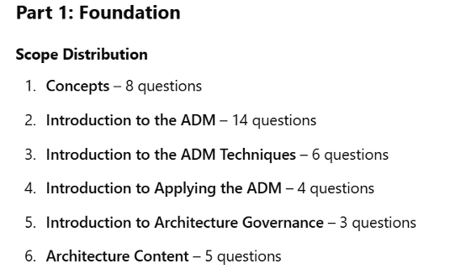

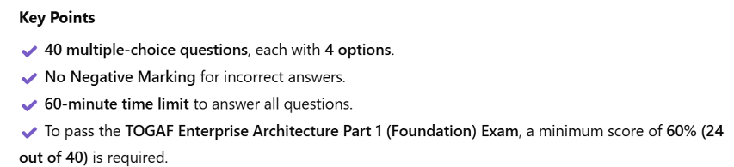

**Summary to clear the Part 1:**

|  |  |
| --- | --- |
| **No.** | **Description** |
| **1** | **Stick to TOGAF terminology – avoid paraphrased words** |
| **2** | **Eliminate obviously incorrect and distractor options** |
| **3** | **Learn and map ADM phases and deliverables** |
| **4** | **TOGAF definitions – views, viewpoints, capabilities, principles** |
| **5** | **Look for alignment with TOGAF objectives and methods, not just common sense** |
| **6** | **Practice with mock questions and read rationales for each option** |
| **7** | **Watch for scope in questions – “Which phase,” “What is the best,” etc.** |
| **8** | **Don’t overthink – choose the answer that fits TOGAF guidance** |

**Understanding the TOGAF 10 - Level 2 Exam Format**

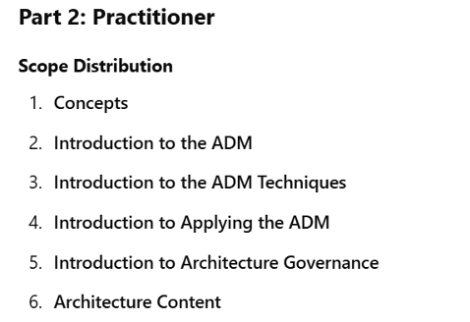

**TOGAF Level 2 doesn’t just test knowledge but:**

* *How well you apply that knowledge* in realistic situations.
* Your ability to think like an Enterprise Architect using ADM and other TOGAF artifacts and techniques.

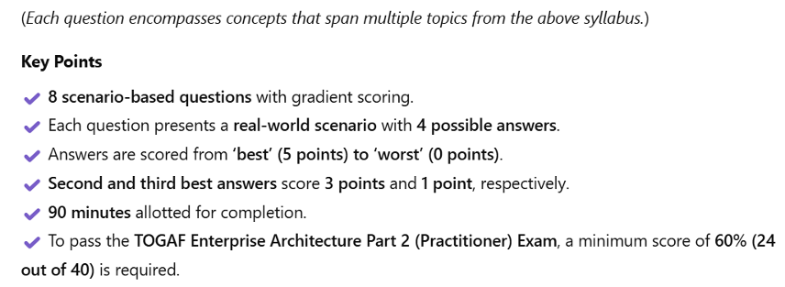

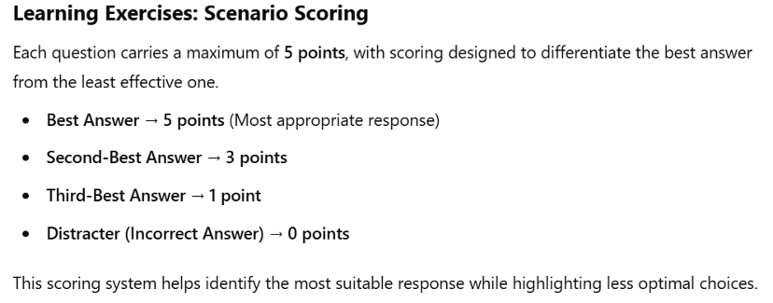

**Use the PRIME acronym to assess and validate answer choices in TOGAF scenario questions:**

| **Letter** | **Check** | **Purpose** |
| --- | --- | --- |
| **P** | **Phase Match** | **Is this the correct ADM phase/activity?** |
| **R** | **Rigorous Architecture Approach** | **Are gaps, stakeholders, and artifacts being addressed properly?** |
| **I** | **Implementation Jump** | **Is it skipping architectural steps and jumping to implementation? If yes, reject it.** |
| **M** | **Mapping to EA Role** | **Is the responsibility appropriate for an Enterprise Architect (vs. Project Manager)?** |
| **E** | **Engagement** | **Are stakeholders involved and considered in the approach?** |

**At least read once these sections:**

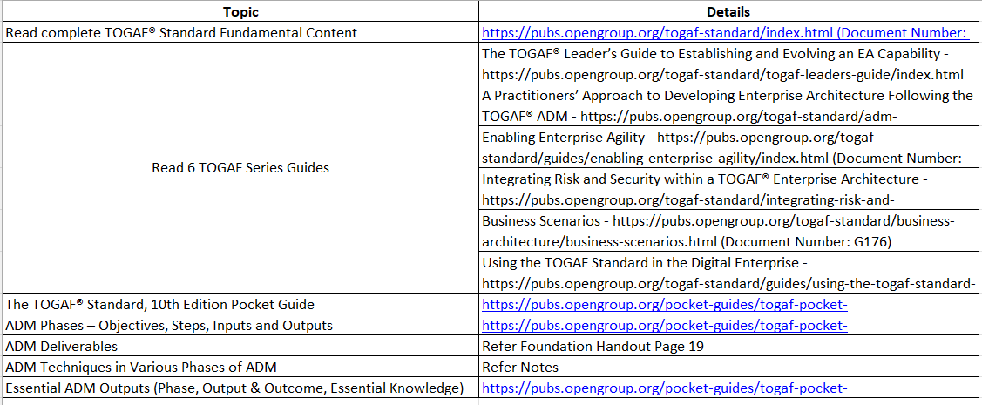

**Reference and Study Links:**

* **Enterprise Architecture Certification Based on the TOGAF® Standard, 10th Edition | Simplilearn | They will provide the Exam Vouchers**
* **Udemy:** 
  + [**https://www.udemy.com/course/eaa-framework-10th-edition-part-1-and-2-practice-tests/?couponCode=KEEPLEARNING#reviews**](https://www.udemy.com/course/eaa-framework-10th-edition-part-1-and-2-practice-tests/?couponCode=KEEPLEARNING#reviews)
  + [**https://www.udemy.com/course/togaf-10-enterprise-architecture-foundation-part-1-exam/?couponCode=KEEPLEARNING**](https://www.udemy.com/course/togaf-10-enterprise-architecture-foundation-part-1-exam/?couponCode=KEEPLEARNING)
  + [**http://udemy.com/course/togaf-10-enterprise-architecture-practitioner-part-2-exam/?couponCode=KEEPLEARNING**](http://udemy.com/course/togaf-10-enterprise-architecture-practitioner-part-2-exam/?couponCode=KEEPLEARNING)
* **YouTube:** 
  + [**https://www.youtube.com/watch?v=k-mOtG5GSLs&list=PLPfrKSRXsomIb3SlcCnGZh5X-VIGFiOut**](https://www.youtube.com/watch?v=k-mOtG5GSLs&list=PLPfrKSRXsomIb3SlcCnGZh5X-VIGFiOut) **| Watch the entire playlist-- as per TOGAF10 Standard)**
  + [**https://www.youtube.com/watch?v=JMb2jt1K3Js&list=PLiKi2fmsDHN6vBv9c5QjtctIin8jpFYM9**](https://www.youtube.com/watch?v=JMb2jt1K3Js&list=PLiKi2fmsDHN6vBv9c5QjtctIin8jpFYM9) **| Watch the entire playlist (Even though it is for Enterprise Architecture certification exam 9.2 – The topics are explained very clearly in detail)**

**Good Luck! All the best.**